**CHAPTER 1**

**INTRODUCTION**

**1.1 PREAMBLE**

The increasing cases of theft to intellectual property and leakage in the system have made many people worried regarding the security of their offices. A survey report of FBI states that “Offices without a security system are 15 times more likely to be subject to a burglary”. In the present age, Internet of things has earned a golden era of rapid growth. The Internet of things is a concept that aims to extend the benefits of the regular Internet- constant connectivity, remote control ability, and data sharing, and so on to goods in the physical world. Everyday things are getting connected with the internet. This concept can be used to manage the security concerned issues in a cost effective way.

Office security has changed a lot from past and will be changing in coming years. Since the early 20th century, many researchers have been carried out to enhance the Smart Office system. The complexity of the system depends on the intelligence of Smart Office itself. Smart Office system may utilize few sensor nodes that are connected to a server for office surveillance. Previously, the connections were made using wired transmission medium. A large number of wired sensor nodes were connected to the server. The major weakness of the wired connection is the limitation of network ranges and upgrading. Also, the system upgrading process is difficult to perform. On those consequences, researchers have come to the idea of doing it wirelessly. Wireless communication reduces the hassle of connecting and increase the network range. In wireless, the Smart Office network range can be extended with the implementation of wireless sensor network through multi-hopping technique or so called ad-hoc network. In multi-hopping technique, the signal from the source to destination is sent through fewer wireless hops. In Smart Office system, a special device is needed to control it. Now, with a single, a Smart Office system can be controlled by far from the server and sensor nodes are wirelessly connected. This will ease the user to control the Smart Office system due to the handiness and robustness of the Smartphone itself.

**1.2 NEED OF THE PROJECT**

In this modern world crime has become ultra modern too. In this contemporary world a lot of incident like robbery, stealing, unwanted entrance happens abruptly in corporate offices. So it is obvious that in today’s world leaving an office without taking any security measure is an open invitation to the burglars. This led to the need of a modern secure system which is not very easy to be broken and cracked by a normal person; a system that can be monitored, hidden and can be customized; a system that allows only specific access to the related people.

The main focus of the project is on the security of office when the user is away from the office. The project will serve this increasing need of security systems. It will also help the investor to save money as many of the insurance companies provide discount to the people who have installed security system in their office.

The recent activities of information leakage and theft at government offices showed the vulnerability of the offices. Therefore it is required to have a system to keep count of number of people in a room; a system that can be easily customized, even at a distance; a system that can alert of any intrusion and more importantly, a system that is not vulnerable to a hacker trying to change the basic functionality of cameras and sensors.

**1.3 PROBLEM STATEMENT**

To develop a reliable security and surveillance system for corporate offices, allowing the user to monitor, customized zones while maintaining user rights and allowing specific access.

**1.4 OBJECTIVES**

The main objectives of the proposed system are as follow:-

* To design and to implement a working prototype for smart security system that is cost effective, flexible and scalable and is capable of monitoring corporate offices.
* To develop a smart security system that enables office surveillance and monitoring by using raspberry pi and android devices.
* A system that is self sustainable and adaptable so as to recognize any device tampering attached to the system.
* Develop a system that counts the number of persons present in the vicinity.

**1.5 SOLUTION APPROACH**

The proposed system mainly focuses on the security of an office when the user can be away from the place. The system proposed involves the design and implementation of Smart Office Security System using Raspberry Pi for mobile devices that leverage mobile technology to provide essential security to our offices and associated control operations. The proposed office security solution includes integration of cameras and motion detectors into web/mobile application. When a motion is detected the system will send a notification to the user along with the captured image. Raspberry pi operates and controls motion detectors and video cameras for remote sensing and surveillance, streams live video as sequence of images and saves it for future playback. When motion is detected, the cameras automatically initiate capturing images and the Raspberry Pi device alerts the person associated with the responsibility of the concerned place. The system also keeps an account of the number of people currently present in the vicinity. Raspberry Pi has two main components interacting with each other: The application that executes on the mobile device and server-side scripts that run in a SD card which will be operated by the raspberry pi hardware tool component.

**1.6 ORGANIZATION OF THE PROJECT REPORT**

This report encompasses the complete system development life cycle of the project. The document is divided into chapters each corresponding to a phase in the life cycle.

**Chapter 1 Introduction** includes problem statement, need of the project and high level view of the solution to the problem. It gives a general overview of the entire project.

**Chapter 2 Literature Review** discusses the literature review and theory that is deployed in the research related to the system. It includes the study of the previous works done in this area and motivation for the proposed system.

**Chapter 3 Background Study** covers the background study done to analyze different facets of the solution approach in order to refine the approach and devise a plan of action to achieve the identified goals and objectives. Furthermore, it explores the tools and technologies that would facilitate design and development.

**Chapter 4 Analysis** explores the problem description in detail and identifies the functional and non-functional requirements. It specifies the hardware and software specifications of the project. It documents the requirement gathering, feasibility analysis and risk analysis. It also covers use case diagrams along with their descriptions and domain analysis.

**Chapter 5 Design** elucidates the architecture and the thought put into its design. It diagrammatically visualizes the architecture using UML diagrams such as Class diagrams, Sequence diagrams and Component diagrams. It also presents the database design using detailed relational model specification.

**Chapter 6 Implementation** gives the detailed specification of all the modules and their relationships with one another. It explains the functions and methods used.

**Chapter 7 Testing and Results** covers the test cases that have been written to validate the functionalities of the system. The test cases have been divided based on the module to which they correspond. It includes system’s performance and accuracy in graphical form.

**Chapter 8 Conclusion** describes the total work carried out to achieve the requirements of the system and also covers the enhancements to be carried out in future.

**CHAPTER 2**

**LITERATURE REVIEW**

The papers published in IEEE journals regarding Smart Office Security System Using Raspberry Pi has helped to develop this project by analyzing the defects and using the effective ways from all resources available. The concept of the reference papers and how it helped in designing this system is described in the following subsections.

According to the market research, the common parameters or characteristics of office security system are 24 hours monitoring of the intruder, ease of use, reliability, efficient, fast and precise notification system. Today a number of office security systems are available in market.

In paper [1], a design to access control of door by raspberry pi through Internet is presented.  In this paper work a system is being developed to connect any door with the internet, so that the access control system can be controlled from anywhere in the world. In a case that one is not at home and a visitor is at his door steps then the authorized person will be notified about the visitor via twitter and the person can see the visitor from the web through the camera from anywhere and the system will take a picture of the visitor and keep a record by sending an attachment through E-mail or tweet in twitter.

Paper [2] describes an approach to use the embedded system Raspberry Pi to serve as a communication gateway between mobile devices and home or office automation systems. This

paper manifests the possible components and potential purposes of the concept. It is shown that small embedded systems like the Pi can provide a simple and cheap solution to enable ubiquitous

Smart Home Control using existing infrastructures.

Paper [3], suggests two methods for home security system. The first system uses web camera. Whenever there is a motion in front of the camera, it gives security alert in terms of sound and a mail is delivered to the owner. The second method sends SMS which uses GSMGPS Module (sim548c) and Atmega644p microcontroller, sensors, relays and buzzers.

In paper [4], a design which contains an office network including a GPRS/GSM gateway and three kinds of wireless security sensor nodes is presented. This system has a user interface and it can respond quickly to alarm incidents.

In paper [5], a new method of moving object detection by combination of pixel illumination with its chroma in YUV color space is implemented. The algorithm of maintenance with 3 key values is discussed in this paper. In case of swaying objects, it is very robust and effective way of false alarms.

Paper [6] discuses the detection and description based on an object oriented, statistical multi feature analysis of video sequences. This paper yields some basic demands if video detection techniques are applied: (a) The detection scheme has to be robust against distortions like varying illumination conditions, small camera motion, etc. (b) The video images and/or detection results have to be transmitted to the surveillance center. (c) The calibration and installation effort of the sensor should be as simple as possible.

The system described in paper [7] monitors everything by moving cameras. The system can increase the efficiency of monitoring and can eliminate the blind spots of fixed cameras. In this system, a mobile manipulator is developed which is equipped with cameras at the arm end for purpose of monitoring.

Paper [8] presents a total remote control cum security system. The system is based on SMS technology using any GSM modem mobile. The proposed remote control system works from anywhere in the globe. This paper discusses about its implementation, its cost effectiveness, its reliability.

A low cost Short Message System (SMS) based office security system equipped with motion sensor, smoke detector, temperature sensor, humidity sensor and light sensors has been studied in [9]. The sensors are controlled by a microprocessor PIC 18F4520 through the SMS having password.

Paper [10] discusses the use of android for running security monitoring applications. Mobile devices are ideal in providing a user interface in a home automation system, due to their portability and their wide range of capabilities. They can communicate with a home automation network through an Internet gateway, but cannot directly communicate with devices in the network, as these devices usually implement low power communication protocols, such as ZigBee, Wi Fi etc.

Paper [11] focuses on the segmentation of groups of people into individuals and tracking them over time. The relevant applications of this algorithm are people counting and event detection. Experiments document that the presented approach leads to robust people counts. Therefore we are, able to count the number of people entering or leaving a particular site.

Paper [12] describes that a lot of surveillance cameras are installed around us but there are no means to monitor all of them continuously. It is necessary to develop a computer vision based technologies that automatically process those images in order to detect problematic situations or unusual behavior. Automated video surveillance system addresses real-time observation of people within a busy environment leading to the description of their actions and interactions.

Paper [13] gives some idea about human count approach, Object detection is one of the fundamental steps in automated video surveillance. Object detection from the video sequence is mainly performed by background subtraction technique. It is widely used approach for detecting moving objects from static cameras. As the name suggests, background subtraction is the process of separating out the foreground objects from the background in a sequence of video frames. The main aim of the surveillance system here is, to detect and track an object in motion by using single camera. Camera is fixed at the required place background subtraction algorithm is used for segmenting moving object.

Even if many varieties of office automation and security systems are available, current system has got a number of limitations. Currently office security systems are implemented with a large amount of hardware. The installation and maintenance of the current system is a difficult task. It also imposes a huge installation cost on the user or consumer. Current systems are also very poor in bandwidth utilization. They may either leave a large amount of bandwidth or it will be very less. In case of Zigbee the bandwidth is too low and in case of GSM it is too high. The java based office automation is very poor in security as the uses web pages to access and control the appliances. SMS based and GSM based office automation is costly for the consumer as it becomes expensive to communicate via SMS.

Many automated systems has been developed which informs the owner in a remote location about any intrusion or attempt to intrude in the house. The proposed system focuses on overcoming the limitations of the existing systems. This system looks into the development of an android application which interprets the message a mobile device receives on possible intrusion and subsequently a reply SMS which triggers an alarm/buzzer in the remote house making others aware of the possible intrusion. They can provide several useful services such as support for the elderly and disabled people, access control, environmental monitoring, and office automation. Furthermore, with the widespread diffusion of mobile devices and their integration with new auto-identification technologies, the need to control and manage the office smartly through these devices is increasing. The system showed improved searching, management, discovery, and manipulation of IP-based cameras in an office network using our system, compared to a conventional system. Users can use a mobile device to monitor the offices’ security status in real time by a remote access function. Hence, users can monitor their offices more efficiently and instantly, ensuring the safety of house members and the property.

There are many approaches for Image processing which work as per the need of the user. These different algorithms have been studied. Thorough study of research papers helped in developing an Image processing algorithm which is capable of handling all possible security breaches (for e.g. tampering devices).

Studies have suggested the use of cloud based service for sending notifications to the user to inform about the intrusion. Google Cloud messaging (GCM) is one such service.

Some background subtraction algorithms were studied. Background modeling is the heart of any background subtraction algorithm. Background model is robust against environmental changes in the background, but sensitive enough to identify all moving objects of interest. Background modeling is divided into two types: (1) Non-recursive and (2) Recursive. A non-recursive technique uses a sliding window approach for background estimation. Non-recursive is highly adaptive as they do not depend on the history beyond those frames stored in the buffer. Some of the commonly used non-recursive techniques are: Frame differencing, Median filter, Mean filter.

Human motion detection and tracking for real time security system is formulated. Video surveillance is focused on people counting and tracking mainly for real-time applications such as security system, traffic monitoring, etc. The object is detected from the live video and tracked using background subtraction, this system is proposed for real-time security purpose.

**CHAPTER 3**

**BACKGROUND STUDY**

* 1. **FUNDAMENTAL CONCEPTS**
     1. ***Machine to Machine***

Machine to Machine (M2M) refers to technologies that allow both wireless and wired systems to communicate with other devices of the same type. M2M is a broad term as it does not pinpoint specific wireless or wired networking, [information and communications technology](http://en.wikipedia.org/wiki/Information_and_communications_technology). This broad term is particularly used by business executives. M2M is considered an integral part of the [Internet of Things (IoT)](http://en.wikipedia.org/wiki/Internet_of_things) and brings several benefits to industry and business in general as it has a wide range of applications such as industrial automation, logistics, Smart Grid, Smart Cities, health, defense etc. mostly for monitoring but also for control purposes. However, modern M2M communication has expanded beyond a one-to-one connection and changed into a system of networks that transmits data to personal appliances. The expansion of IP networks across the world has made it far easier for M2M communication to take place and has lessened the amount of power and time necessary for information to be communicated between machines.

* + 1. ***Passive Infra Red Sensor***

The key of the system is Human Sensing Technology. Passive Infra Red sensor has been used to detect human. The motion sensing feature is a passive system that detects infrared energy. Infrared radiation exists in the electromagnetic spectrum at a wavelength which is longer than visible light. It can be detected though it can’t be seen. Human body generates heat as well as infrared radiation. These sensors see the infrared energy emitted by an intruder’s body heat. When an intruder walks into the field of view of the detector, the detector detects a sharp increase in infrared energy. PIR sensor generates +5v and -5v sine signal when any human or animal passes in front of the sensor or any movement is detected of human or animal in front of this the signal is detected.

* + 1. ***Push Notification***

The service provides a simple, lightweight mechanism that servers can use to tell mobile applications to contact the server directly, to fetch updated application or user data. The service handles all aspects of queuing of messages and delivery to the target application running on the target device.

The free service has the ability to send a lightweight message informing the Android application of new data to be fetched from the server. Larger messages can be sent with up to 4 KB of payload data.Each notification message size is limited to 1024 bytes, and Google limits the number of messages a sender sends in aggregate, and the number of messages a sender sends to a specific device.

Applications on an Android device don’t need to be running to receive messages. The system will wake up the application via a mechanism called Intent Broadcast when the message arrives, as long as the application is set up with the proper broadcast receiver and permissions. GCM does not provide any built-in user interface or other handling for message data. Instead, it simply passes raw message data received straight to the application, which has full control of how to handle it. For example, the application might post a notification, display a custom user interface, or silently sync data.

* + 1. ***Video as Sequence of Images***

MEncoder can convert all the formats that MPlayer understands into a variety of compressed and uncompressed formats using different codecs. Changing the frame rate is possible using the -ofps or -speed options and by using the frame step filter for skipping frames. Reducing the frame rate can be used to create fast-motion "speed" effects which are sometimes seen in films. It also makes the video stream usable for frame rate conversion, and creating slow motion scenes from streams taken at standard video/TV frame rates, e.g. using cheap consumer cameras.

* + 1. ***Document Vector***

Vector space model or term vector model is an algebraic model for representing text documents (and any objects, in general) as [vectors](http://en.wikipedia.org/wiki/Vector_space) of identifiers, such as, for example, index terms. It is used in [information filtering](http://en.wikipedia.org/wiki/Information_filtering), [information retrieval](http://en.wikipedia.org/wiki/Information_retrieval), [indexing](http://en.wikipedia.org/wiki/Index_(search_engine)) and relevancy rankings.

Document vector is being used by the system to compare an image captured by the camera in real time with a reference black/white image in order to detect any tampering with the camera like flashing a light over the lens and putting a black paper or thick object over the camera.

* + 1. ***Gray Scaling***

In [photography](http://en.wikipedia.org/wiki/Photography) and [computing](http://en.wikipedia.org/wiki/Computing), a grayscale or grey scale [digital image](http://en.wikipedia.org/wiki/Digital_image) is an image in which the value of each [pixel](http://en.wikipedia.org/wiki/Pixel) is a single [sample](http://en.wikipedia.org/wiki/Sample_(signal)), that is, it carries only [intensity](http://en.wikipedia.org/wiki/Luminous_intensity) information. Images of this sort, also known as [black-and-white](http://en.wikipedia.org/wiki/Black-and-white), are composed exclusively of shades of [gray](http://en.wikipedia.org/wiki/Grey), varying from black at the weakest intensity to white at the strongest.

Grayscale images are distinct from one-bit bi-tonal black and white images, which in the context of computer imaging are images with only the two colors, black and white (also called binary images). Grayscale images have many shades of gray in between.

* + 1. ***Stream a Video***

Streaming media is [multimedia](http://en.wikipedia.org/wiki/Multimedia) that is constantly received by and presented to an [end-user](http://en.wikipedia.org/wiki/End-user_(computer_science)) while being delivered by a provider. The [verb](http://en.wikipedia.org/wiki/Verb) "to stream" refers to the process of delivering media in this manner; the term refers to the delivery method of the medium rather than the medium itself.

Live streaming, which refers to content delivered live over the Internet, requires a form of source media (e.g. a video camera, an audio interface, screen capture software), an encoder to digitize the content, a media publisher, and a [content delivery network](http://en.wikipedia.org/wiki/Content_delivery_network) to distribute and deliver the content.

***3.2.7 Motion Detection***

[Motion](http://en.wikipedia.org/wiki/Motion_(physics)) detection is the process of detecting a change in position of an object relative to its surroundings or the change in the surroundings relative to an object. Motion detection can be achieved by both [mechanical](http://en.wikipedia.org/wiki/Mechanical_system) and [electronic](http://en.wikipedia.org/wiki/Electronics) methods. When motion detection is accomplished by natural organisms, it is called [motion perception](http://en.wikipedia.org/wiki/Motion_perception).

Motion can be detected by various methods including:

1. Infrared (Passive and active sensors)
2. Optics (video and camera systems)

**3.2 ANALYSIS OF EXISTING APPROACHES**

***3.2.1 Office Security Using GSM***

This system presents a novel, stand alone, low-cost and flexible GSM- Zigbee based system. The entire system depends on a 8 bit microcontroller named PIC (Peripheral Interface Controller) The Database equipment built around this Microcontroller and a GSM controller facilitate the heart of the system. This device is connected to a Zigbee Transceiver and it communicates with each and every node present inside office The GSM Controller facilitates for the data follow between user and microcontroller. The GSM Controller uses mobile phone technology to communicate. From the mobile phone, command can be send via SMS to the Controller, which in turn interprets the command and takes the required action. As long as there is GSM mobile phone signal coverage, it is possible to control all electrical items from anywhere in the world. The system is easy to operate, and is secure in that only pre-determined mobile numbers can operate the GSM Controller.

***3.2.2 Java Based Office Security System***

Java-based security system provides monitoring and controlling via the World Wide Web. The design is based on a standalone embedded system board integrated into a PC-based server at office. The devices are connected to the input/output ports of the embedded system board and their status is passed to the server. Office can be monitored and controlled remotely through a web browser from anywhere in the world provided that an Internet access is available.

***3.2.3 Human Count***

Numerous studies have been done based on people counting using computer vision, four fundamental aspects are identified: The detection and tracking of human motion using an extended particle filter, Use of 3-D measurements in order to increase the system’s robustness, Modified K-means algorithm is used to provide a deterministic output, People trajectories are generated in order to perform people counting. It has certain issues like detection problem, slow movement problem, deterioration problem etc.

Classification techniques have been applied to decide if a given image region contains a person. Others use Support Vector Machines, a tree based classifier to represent possible shapes of pedestrians and dynamic point distribution models. An alternative to modeling the appearance of an entire person is to design detectors for specific body parts and combine their results.

***3.2.4 Moving Object Detection***

Background subtraction algorithm is widely used for detecting moving objects. The ultimate goal is to “subtract” the background pixels in a scene leaving only the foreground objects of interest.

The first step is to construct a background model using the initial frames. We determine if the pixel is a foreground or background pixel by the statistics of the illumination effect of its neighboring pixels. A foreground object mask is generated according to this statistic. If one has a model of how the background pixels behave the “subtraction” process is very simple.

**3.3 TOOLS AND TECHNOLOGIES**

***3.3.1 PHP***

PHP is a [server-side scripting](http://en.wikipedia.org/wiki/Server-side_scripting) language designed for [web development](http://en.wikipedia.org/wiki/Web_development) but also used as a [general-purpose programming language](http://en.wikipedia.org/wiki/General-purpose_programming_language). PHP is one of the most popular web development scripting languages. PHP code is [interpreted](http://en.wikipedia.org/wiki/Interpreter_(computing)) by a web server with a PHP processor module, which generates the resulting web page. PHP commands can be embedded directly into an [HTML](http://en.wikipedia.org/wiki/HTML) source document rather than calling an external file to process data.

***3.3.2 Google Cloud Messaging***

The service provides a simple, lightweight mechanism that servers can use to tell mobile applications to contact the server directly, to fetch updated application or user data. The service handles all aspects of queuing of messages and delivery to the target application running on the target device.

The free service has the ability to send a lightweight message informing the Android application of new data to be fetched from the server. Larger messages can be sent with up to 4 KB of payload data.Each notification message size is limited to 1024 bytes, and Google limits the number of messages a sender sends in aggregate, and the number of messages a sender sends to a specific device.

Applications on an Android device don’t need to be running to receive messages. The system will wake up the application via a mechanism called Intent Broadcast when the message arrives, as long as the application is set up with the proper broadcast receiver and permissions. GCM does not provide any built-in user interface or other handling for message data. Instead, it simply passes raw message data received straight to the application, which has full control of how to handle it. For example, the application might post a notification, display a custom user interface, or silently sync data.

***3.3.3 VLC***

VLC media player (commonly known as VLC) is a [portable](http://en.wikipedia.org/wiki/Software_portability), [free and open-source](http://en.wikipedia.org/wiki/Free_and_open-source), [cross-platform](http://en.wikipedia.org/wiki/Cross-platform) [media player](http://en.wikipedia.org/wiki/Media_player_(application_software)) and [streaming media](http://en.wikipedia.org/wiki/Streaming_media) [server](http://en.wikipedia.org/wiki/Server_(computing)) written by the [VideoLAN](http://en.wikipedia.org/wiki/VideoLAN) project.

VLC media player supports many audio and video [compression](http://en.wikipedia.org/wiki/Data_compression) methods and [file formats](http://en.wikipedia.org/wiki/File_format), including [DVD-Video](http://en.wikipedia.org/wiki/DVD-Video), [video CD](http://en.wikipedia.org/wiki/Video_CD) and streaming [protocols](http://en.wikipedia.org/wiki/Communications_protocol). It is able to stream media over [computer networks](http://en.wikipedia.org/wiki/Computer_network) and to [transcode](http://en.wikipedia.org/wiki/Transcode) multimedia files. The client application is using VLC intent to stream video from server.

***3.3.4 Python***

Python is a widely used [general-purpose](http://en.wikipedia.org/wiki/General-purpose_programming_language), [high-level programming language](http://en.wikipedia.org/wiki/High-level_programming_language). Its design philosophy emphasizes code [readability](http://en.wikipedia.org/wiki/Readability), and its syntax allows programmers to express concepts in fewer [lines of code](http://en.wikipedia.org/wiki/Lines_of_code) than would be possible in languages such as [C++](http://en.wikipedia.org/wiki/C%2B%2B) or [Java](http://en.wikipedia.org/wiki/Java_(programming_language)). The language provides constructs intended to enable clear programs on both a small and large scale.

Python supports multiple programming paradigms, including object-oriented, imperative and functional programming or procedural styles. It features a dynamic type system and automatic memory management and has a large and comprehensive library.

***3.3.5 Motion***

Motion is a program that monitors the video signal from cameras. It is able to detect if a significant part of the picture has changed; in other words, it can detect motion. Motion has number of configuration options which can be used to customize the script according to the purpose of application under development.

***3.3.6 Fswebcam and MEncoder***

Fswebcam is a neat and simple command line webcam app. It is compatible with a wide range of cameras and devices, and features a number of simple effects. Fswebcam runs on Linux, with limited support for FreeBSD.

MEncoder is a [free](http://en.wikipedia.org/wiki/Free_software) [command line](http://en.wikipedia.org/wiki/Command_line_interface) [transcoding](http://en.wikipedia.org/wiki/Transcoding) tool released under the [GNU General Public License](http://en.wikipedia.org/wiki/GNU_General_Public_License). It is a sibling of [MPlayer](http://en.wikipedia.org/wiki/MPlayer), and can convert all the formats that MPlayer understands into a variety of compressed and uncompressed formats using different [codecs](http://en.wikipedia.org/wiki/Codec). It is possible to copy audio and/or video unmodified into the output file to avoid quality loss because of re-encoding. For example, to modify only the audio or only the video, or to put the audio/video data unmodified into a different [container format](http://en.wikipedia.org/wiki/Container_format_(digital)).

Since it uses the same code as MPlayer, it features the same huge number of highly-configurable video and audio filters to transform the video and audio stream. Filters include [cropping](http://en.wikipedia.org/wiki/Cropping_(image)), [scaling](http://en.wikipedia.org/wiki/Scaling_(geometry)), vertical flipping, horizontal mirroring, expanding to create [letterboxes](http://en.wikipedia.org/wiki/Letterbox), rotating, [brightness](http://en.wikipedia.org/wiki/Brightness)/[contrast](http://en.wikipedia.org/wiki/Contrast_(vision)), changing the [aspect ratio](http://en.wikipedia.org/wiki/Aspect_ratio_(image)), [color space](http://en.wikipedia.org/wiki/Colorspace) conversion, [hue](http://en.wikipedia.org/wiki/Hue)/[saturation](http://en.wikipedia.org/wiki/Saturation_(color_theory)), color-specific [gamma correction](http://en.wikipedia.org/wiki/Gamma_correction), filters for reducing the visibility of compression artifacts caused by MPEG compression (de-blocking, de-ringing), automatic brightness/contrast enhancement (auto level), [sharpness](http://en.wikipedia.org/wiki/Sharpness)/[blur](http://en.wikipedia.org/wiki/Focus_(optics)), de-noising filters, several ways of [de-interlacing](http://en.wikipedia.org/wiki/Deinterlacing).

***3.3.7 C and Java***

C is a general-purpose, [imperative](http://en.wikipedia.org/wiki/Imperative_programming) computer [programming language](http://en.wikipedia.org/wiki/Programming_language). It supports [structured programming](http://en.wikipedia.org/wiki/Structured_programming), [lexical variable scope](http://en.wikipedia.org/wiki/Lexical_scope) and [recursion](http://en.wikipedia.org/wiki/Recursion_(computer_science)), while a [static type system](http://en.wikipedia.org/wiki/Static_type_system) prevents many unintended operations. By design, C provides constructs that map efficiently to typical [machine instructions](http://en.wikipedia.org/wiki/Machine_instruction), and therefore it has found lasting use in applications that had formerly been coded in [assembly language](http://en.wikipedia.org/wiki/Assembly_language), including [operating systems](http://en.wikipedia.org/wiki/Operating_system), as well as various [application software](http://en.wikipedia.org/wiki/Application_software) for computers ranging from [supercomputers](http://en.wikipedia.org/wiki/Supercomputer) to [embedded systems](http://en.wikipedia.org/wiki/Embedded_system).

Java is a general-purpose [computer programming language](http://en.wikipedia.org/wiki/Programming_language) that is [concurrent](http://en.wikipedia.org/wiki/Concurrent_computing), [class-based](http://en.wikipedia.org/wiki/Class-based_programming), [object-oriented](http://en.wikipedia.org/wiki/Object-oriented_programming), and specifically designed to have as few implementation dependencies as possible. It is intended to let application developers “write once, run anywhere” meaning that [compiled](http://en.wikipedia.org/wiki/Compiler) Java code can run on all platforms that support Java without the need for recompilation. Java applications are typically compiled to [byte code](http://en.wikipedia.org/wiki/Java_bytecode) that can run on any [Java virtual machine](http://en.wikipedia.org/wiki/Java_virtual_machine) (JVM) regardless of [computer architecture](http://en.wikipedia.org/wiki/Computer_architecture).

***3.3.8 Shell***

A shell script is a [computer program](http://en.wikipedia.org/wiki/Computer_program) designed to be run by the [Unix shell](http://en.wikipedia.org/wiki/Unix_shell), a [command line interpreter](http://en.wikipedia.org/wiki/Command_line_interpreter). The various dialects of shell scripts are considered to be [scripting languages](http://en.wikipedia.org/wiki/Scripting_language). Typical operations performed by shell scripts include file manipulation, program execution, and printing text.

A shell script can provide a convenient variation of a system command where special environment settings, command options, or post-processing apply automatically, but in a way that allows the new script to still act as a fully normal unix command.

***3.3.9 JSON***

JSON or JavaScript Object Notation is an [open standard](http://en.wikipedia.org/wiki/Open_standard) format that uses [human-readable](http://en.wikipedia.org/wiki/Human-readable) text to transmit data objects consisting of [attribute–value pairs](http://en.wikipedia.org/wiki/Attribute%E2%80%93value_pair). It is used primarily to transmit data between a server and web application, as an alternative to [XML](http://en.wikipedia.org/wiki/XML). Although originally derived from the [JavaScript](http://en.wikipedia.org/wiki/JavaScript) scripting language, JSON is a [language-independent](http://en.wikipedia.org/wiki/Language-independent_specification) data format. Code for [parsing](http://en.wikipedia.org/wiki/Parsing) and generating JSON data is readily available in many [programming languages](http://en.wikipedia.org/wiki/Programming_languages).

***3.3.10 HTML5 and CSS***

HTML5 is a core technology [markup language](http://en.wikipedia.org/wiki/Markup_language) of the [Internet](http://en.wikipedia.org/wiki/Internet) used for structuring and presenting content for the [World Wide Web](http://en.wikipedia.org/wiki/World_Wide_Web).

Cascading Style Sheets (CSS) is a [style sheet language](http://en.wikipedia.org/wiki/Style_sheet_language) used for describing the [look and formatting](http://en.wikipedia.org/wiki/Presentation_semantics) of a document written in a [markup language](http://en.wikipedia.org/wiki/Markup_language). While most often used to change the style of [web pages](http://en.wikipedia.org/wiki/Web_page) and user interfaces written in [HTML](http://en.wikipedia.org/wiki/HTML) and [XHTML](http://en.wikipedia.org/wiki/XHTML), the language can be applied to any kind of [XML](http://en.wikipedia.org/wiki/XML) document, including [plain XML](http://en.wikipedia.org/wiki/Plain_Old_XML), [SVG](http://en.wikipedia.org/wiki/Scalable_Vector_Graphics) and [XUL](http://en.wikipedia.org/wiki/XUL). Along with HTML and [JavaScript](http://en.wikipedia.org/wiki/JavaScript), CSS is a cornerstone technology used by most websites to create visually engaging web pages, user interfaces for [web applications](http://en.wikipedia.org/wiki/Web_applications), and user interfaces for many mobile applications.

**3.4 HARDWARE AND SOFTWARES**

***3.4.1 Wi-Fi Dongle***

Wi-Fi dongle is connected through USB port. With wireless speed up to 300 Mbps, works with IEEE 02.11 b/g -networks. WPA2 secure connection works with the dongle. It is used to equip both the PIR sensor and camera which are attached to raspberry pi with Wi-Fi connectivity. Such technique allows the PIR sensor to communicate with webcam via wireless network.

* + 1. ***Raspberry Pi***

Raspberry Pi having camera module enabled has 512 MB RAM, 2 USB ports and an Ethernet port. It has a BCM2835 system on a chip which includes an ARM 700 MHz processor, Video Core IV GPU, and an SD card. Python is used as the main programming language, with the support for C and Perl. The setting up of raspi consists of selecting raspbian OS from noobs package. After the OS selection, configure raspberry-pi using Raspi-config command and enter into raspi desktop using startx command. The power requirement of Model B is 700mA/3.5 Watt. The dimension of the single board computer is 85.60 mm X 53.98 mm. It weighs about 45 grams.

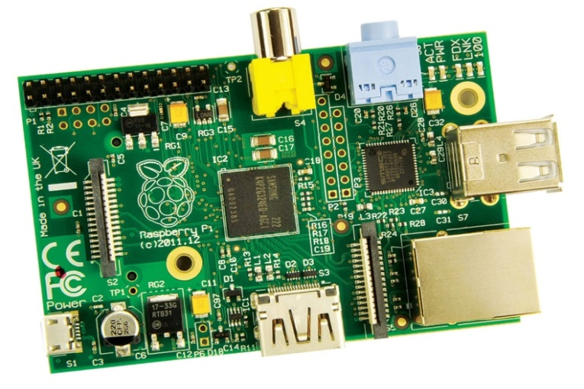

*Figure 3.1: Raspberry Pi Model B*

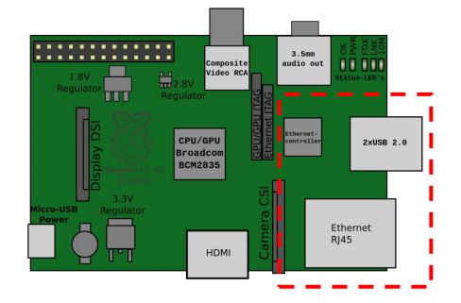

*Figure 3.2: Plan View of Raspberry Pi Model B*

* + 1. ***SD Card***

It is used as a hard drive for the board to install Raspbian Linux operating system and the program for the security system.

* + 1. ***USB Webcam***

USB Logitech Webcam C270 is an inexpensive webcam that capture and feeds its image into a computer upon request. This webcam is connected to Raspberry Pi’s USB port. The tasks of following module are as follows: -

* Sending live stream over internet.
* Automatic activation of the module on Motion Detection.
* Send Photographs on detecting the motion to remote server.
  + 1. ***5V 2A Power Adapter***

The power adapter is used to supply electrical power to the Raspberry Pi boards. The power adapter supplies 2 Amps, which is sufficient for a board attached PIR sensor and Wi-Fi adapter.

* + 1. ***Connectors and Jumper Wires***

Male to Female jumper wires are required to set a direct connection between PIR sensor and Raspberry Pi. A LAN cable (CAT 5e) is required to connect Raspberry Pi to display device (Laptop) or a HDMI - HDMI cable is required to connect Raspberry Pi to smart TV.

* + 1. ***Alarm***

Security alarm can be used to generate warning signals in case of burglary or intrusion in the premises. The alarm will get activated whenever PIR sensor in the High Security Zone gets activated.

***3.4.8 Windows 7***

It is used as a server for the Office Security System. This system is used for storage, storing the captured image of the intruder. The GUI to show captured image is developed on this operating system.

* + 1. ***Raspbian OS***

It is used for the raspberry pi board. It is the official image for raspberry pi, by using the operating system`s image. Software development for the system already included such as python language.

* + 1. ***Python language***

It is a programming language that integrates our systems. By using python, an immediate gain in productivity is achieved and a maintenance cost is lower. python combines remarkable power with very clear syntax. It has modules, classes, exceptions, very high level dynamic data types and dynamic typing.

***3.4.11 File Zilla***

It is a server that supports FTP. File transfer protocol is a standard network protocol used to transfer files from one host to another host over a TCP based network. File Zilla used as server to transfer captured image from Raspberry Pi.

* + 1. ***Notepad & Nano***

They are used as IDE editing tools for Python source code on windows and Linux platform.

* + 1. ***Client Application***

A simple login/register function has to be build. It will use a small table in the database to store, in plain-text, just the name and password of the user. An android GUI and necessary methods for communicating with the server will be written. Then more features will be added to the functions, such as hashing of passwords stored in the database and storing more information about the (email and date of creation). The Android platform is chosen for the client application because of the wide user base and prior experience in programming Android applications.

* + 1. ***Server and Database***

The server-side of the software will be built on 000WebHost (Server and Database) and PHP (programming language). PhpMyAdmin will be used to create and manage the database.

***3.4.15 Tight VNC Viewer***

Tight VNC is a [cross-platform](http://en.wikipedia.org/wiki/Cross-platform) [free and open-source](http://en.wikipedia.org/wiki/Free_and_open-source_software) [remote desktop software](http://en.wikipedia.org/wiki/Remote_desktop_software) application that uses and extends the [RFB protocol](http://en.wikipedia.org/wiki/RFB_protocol) of [Virtual Network Computing](http://en.wikipedia.org/wiki/Virtual_Network_Computing) (VNC) to control another computer's screen remotely.

It is used to view the GUI of Raspberry Pi instead of working only on command line interface.

* + 1. ***VLC***

VLC media player (commonly known as VLC) is a [portable](http://en.wikipedia.org/wiki/Software_portability), [free and open-source](http://en.wikipedia.org/wiki/Free_and_open-source), [cross-platform](http://en.wikipedia.org/wiki/Cross-platform) [media player](http://en.wikipedia.org/wiki/Media_player_(application_software)) and [streaming media](http://en.wikipedia.org/wiki/Streaming_media) [server](http://en.wikipedia.org/wiki/Server_(computing)) written by the [VideoLAN](http://en.wikipedia.org/wiki/VideoLAN) project. VLC is used to view the video streamed from Raspberry Pi on to the client’s android application.

**CHAPTER 4**

**ANALYSIS**

**4.1 DETAILED PROBLEM STATEMENT**

The security of corporate offices during non-working hours is always a concern with increasing number of incidents of theft, robbery etc. As the rates of intrusions, theft, forgery of confidential documents are going too high; there is a need of a security system which can provide the overall security to offices, banks etc. Many of such systems exist but they are somewhere lacking in providing reliable service.

With the development of IT technology, network and automatic control technology, a remote Office security monitoring and alarming system becomes more and more practicable today. The problem is to develop a system which intends to solve all security issues and is cheaper, reliable, flexible and easy to operate. A design of a remote office security monitoring and alarming system that can detect the theft, etc and send alarm message to the concerned person on a registered mobile phone is required.

The aim of the proposed design is to reduce such occurrences by alerting the appropriate quarters while an unauthorized entrance into a room occurs. A user friendly interface allows the user to communicate with the Raspberry Pi server. Passive Infrared Sensor will be used for sensing humans as well as to monitor security zones. Images and videos will be available via a remotely controlled webcam. To make sure no one else but the authenticated user is able to control the system, it is required to have good security both between the server and phone/device.

By combining sensors and wireless communication, a system can detect, collect and deal with the object information in its covering area, and send data to the observer. The system has advantages of wide covering area, able to remotely monitor, high monitoring precision, fast network establishment and reasonable cost. Firstly, wherever the users are, once some dangerous instance happens in office, such as fire or thief intruding, this system can call and send notifications to the users through GCM immediately, informing people the possible dangerous circumstances in Office. It increases the reliability in terms of user being informed about the intrusion immediately because today almost every person carries a mobile phone.

**4.2** **REQUIREMENT GATHERING**

Proper research for this project was conducted. The requirement elicitation methods include: -

1. Research papers to understand the underlying concepts.
2. Need of the project in the current scenario.
3. Comparison of the existing and proposed system and limitations/advantages of one over other.
4. The kind of users affected and benefitted by the project.
5. Environment in which the software would be useful.

**4.3** **DOMAIN ANALYSIS**

***4.3.1 Data Flow Diagrams***

The Context Diagram shows the system as a single high-level process and then shows the relationship that the system has with other external entities (systems, organizational groups, external data stores, etc.). This diagram does not provide any information about the timing, sequencing, or synchronization of processes such as which processes occur in sequence or in parallel.

Camera

Request

Frames

Signals

Signals

Sensor

Alarm

Notification

User Details

Substitute Users

User Details

Notifications

Requests/Queries

Admin

*Figure 4.1: System Context Diagram*

A System Context Diagram for the proposed system is shown in the figure 4.1.

Smart Office Security System has different external entities which include alarm, camera, and different type of sensors, users and unregistered users. The system can be accessed by three types of potential users namely; super admin, admin and substitute users. Super admin is the user which has the access to overall functionality of system.

A complete system is divided into regions and regions are further decided into zones. These zones can be customized by the user as per his/her requirements. Every region can have atmost one admin. A system can have multiple super admin.

Super admin of the system will authenticate unregistered users and these users after registering can be made admin or substitute user by the super admin users. Similarly, an admin can delegate the responsibility of a zone to one or more substitute users. A substitute user can monitor more than one zone.

All the users send different types of queries to the system and a notification will be received by the user depending upon the query requested.

Sensors and alarms will receive some signals from the system and perform some actions based on the signal received. Camera will send the captured images to the system. The system also requests the camera to send pictures on being demanded by the user.

Level 1 Data Flow Diagram describes the main functions of the system. Diagram is shown below in the figure 5.3. The system is decomposed into three main parts namely; Central Server, Data Verifier and Zone Customizer.

Data Verifier will be responsible for verifying and authenticating the credentials of users of the system. This module will generate one time password for first time logging in to the system for super admin. It will take care whether a substitute user has rights for particular zone or not. All other type of data verification in the system will be handled by this module.

Central Server will be responsible for serving the main functionality of the system like taking the request from the users and generating signals to cameras, sensors and alarms. This server will send notifications/emails to the users.

Zone Customizer is the module which contains the functions for changing the settings of a particular zone in a region. These settings include adding a new device in the zone, removing a device from the zone, changing the security level of a zone and assigning substitutes to the zones etc. Admin of a region will have the rights to customize the zones under his/her region. This module can also be accessed by super admin and can customize the zones falling in any region. Using the module, super admin can add an admin to a non-allocated region or can remove and replace the admin of a particular region.

Queries

Username

Password

Response

Admin

Sensor

Camera

User details

Notification

Requests

/Queries

Frame(s)

Signals

Request

User details

Signal

Alert

Alarm

Substitute Users

*Figure 4.2: Level 1 DFD*

Level 2 DFD contains a finer decomposition of the system and involves the database entities also. Diagram for the proposed system is shown in the figure 5.4 below. All the individual modules in Level 1 DFD are further subdivided into smaller modules.

Data Verifier is decomposed into Registration Verifier and Login Verifier. As the name indicates Registration Verifier is responsible for verifying user credentials and generating username and password to newly registered user at the time of registration of the system. Login Verifier will generate one time password for the super admin to login to the system for the first time. This has been added as an extra level of security to the system. This module will also check the rights associated with the user at the time login into the system.

Central Server is further decomposed into three sub modules namely; Query Handler, Notification Handler and Signal Handler. Query Handler will handle all the queries of the users which in turn generate some signals to be handled by the Signal Handler. Signal Handler in turn sends some response to the Query Handler. Notification Handler will receive input from the Query Handler. The Notification Handler is responsible for sending notifications to the substitute users and admin. Signal Handler will also generate signals to the sensors and alarms for the intended tasks.

The system will compose three databases namely; User Data, Device and Region/Zone. User Data database will contain all the details about the users of the system. All the users can update the database by changing his/her password and other details, but none of the user is permitted to change his/her username.

Device database will contain all the details and current status of the device in a zone. Signal Handler will be responsible for changing the entries in the device database.

Zone/Region database will contain the details about the regions in the system and the list of zones configured in that region. Security level and status of the devices is also configured in the same database.

Registration details

Login Data

Username

Password

User Data

D1

Substitute

Username

Password

Notification

Send Queries

Notification

Admin

Handover Requests

Query

Device status

Request

Zone/Region

D3

Update Database

Device status

D2

Device status

Request

Request Device status

Device status

Alarm

Signals

Signals

Sensor

*Figure 4.3: Level 2 DFD*

**4.4 REQUIREMENT ANALYSIS**

For the successful completion of any project implementation, Requirement analysis is must; much of the client’s satisfaction depends on this phase of the project development. If the requirements are gathered and analyzed properly, then final product will come up to the expectation of the clients.

* + 1. ***Functional Requirements***

***4.4.1.1 Log In to Smart Office Web Service***

Login page is provided so as the registered users and admin can enter into the system. The rights field which is set to **“User”** by default is used to distinguish between admin and normal users. User first enters his/her username and password then the system validates the data among the data in the database and if the information provided by the user is authenticated he/she can use the features of the system.

***4.4.1.2 Customize Security Zones***

To manage sensors and motion detectors for more convenient activation and deactivation, the office owner/admin can group sensors and motion detectors as zone. The office owner/admin can create the zone by selecting some sensors and some motion detectors. The office owner/admin can delete the zone defined by the office owner. The office owner/admin can modify the zone. In other words, the office owner/admin inserts a sensor and a motion detector to the zone and also can remove a sensor and a motion detector from the zone. The office owner/admin can know which sensor belong to the zone.

### *Arm/Disarm Security System*

### The operations of each mode is the exactly same as the control panel modes.

* + - 1. ***Access Smart Office Web Service via Multiple Web Browsers***

Multiple Web access user sessions to the same Smart Office control software are not allowed. If one logs into the Web service, a new user session begins, replacing the old one. Moreover, there is a session timeout if there is no action triggered by the logged in user after five minutes.

* + - 1. ***List and Check Zone Status***

Admin will have the authority to list all the security zones within the premises and also to view or change the current status of each zone.

* + - 1. ***Send Commands to Raspberry Pi***

Admin will send the commands to Raspberry Pi remotely from anywhere in the world through Internet. The commands can be retrieving video from the cloud, Arm/Disarm the system, Activate the Alarm etc.

* + - 1. ***Manage Profile***

Admin can also edit his/her profile. The admin is able to change the default password and update his/her picture.

* + - 1. ***Record and Play Video***

Webcam on being activated by PIR sensor will start recording video and will store the recorded video on the server. The recorded video can be viewed on receiving command from the user/admin.

***4.4.1.9 Sending Signals to Cameras, Sensors and Alarms***

Raspberry Pi will send the signals to Cameras, Sensors and Alarms to activate or deactivate them depending upon the situations.

***4.4.1.10 Sending E-Mails to Users***

Once the motion is detected by the PIR sensor in the security zones the Raspberry Pi will prepare a message for the user which will contain the images captured by the webcam during that time along with the timestamp to inform the user about the intrusion.

***4.4.1.11 Sending Signals to Raspberry Pi***

Sensors like Passive Infrared Sensor will get activated and send the signals to the Raspberry Pi for further actions like activating Webcam and sending notifications to the users.

***4.4.1.12 Motion Detection***

The system includes Passive Infrared Sensor to detect motion in the already decided security zones inside the room.

* + - 1. ***Sending Pictures to Raspberry Pi***

The camera upon capturing the images will then send those images to the raspberry pi and also simultaneously to the server.

***4.4.1.14 Image Processing***

The image captured by web cam is processed pixel by pixel to know whether the camera has been tampered or not.

***4.4.1.15 Human Count***

It is required to have a count of number of persons present in the vicinity so that we get to know if any intruder has entered.

***4.4.1.16*** ***In-App messaging***

Associated users of the system should be able to instantly message and receive message to anyone in his/her area of working.

* + 1. ***Non-Functional Requirements***
       1. ***Security***

To make sure no one else but the authenticated user is able to control the appliances and board, the system needs to have good security both between the server and phone/device and between the device and appliances (Wireless solution is being used).

* + - 1. ***Speed***

Speed is of paramount importance for any real-time system, it shall be given a priority comparable to that of the adaptability requirement. This presumably according to the customer needs. Detecting changes in the environment is usually a very time-consuming task, hence hurting speed. Similarly, detection of events could induce significant performance penalty.

* + - 1. ***Modifiability***

If a client wants to add more cameras or sensors, programming effort to achieve it must be less. If a client wants to modify the location of current cameras or sensors, programming effort to achieve it must be less.

* + - 1. ***Availability***

The system must operate 24 hours a day. There must be no system-down caused by program bugs.

* + - 1. ***Reliability***

There must be no malfunction of signing on the web service. For example, if ID or password is not correct, the web service never allows the user to enter the service. Since it must guarantee no system-down, the system adopts exception handling.

* + - 1. ***Performance***

In stay mode, when the motion sensor at windows, doors, and outside detects intruders, the system must report it to users through PC within 500 milliseconds.

In away mode, it must report the trespass to the associated person, located in a range of 5 km, within 1 second.

When a client is watching camera monitoring zone, the delay between capturing image and displaying image must be less than 500 milliseconds.

* 1. **FEASIBILITY ANALYSIS**

***4.5.1 Technical Feasibility***

It considers the technical requirements of the proposed system. This system is considered to be technically feasible as the internal technical capability is sufficient to support the project requirements. The analysis of project helped us in finding out whether current technical resources can be upgraded or added to in a manner that fulfils the request under consideration. In this project, all technology & technical resources to be used are easily available.

Technical feasibility of the product has been studied under following heads:

* **Hardware availability**– This project needs Raspberry Pi, Sensors and Wi-Fi Adapter on hardware part.
* **Software Availability**– This system will be built with the help of python language.

As hardware and software availability is possible to achieve, this system is technically feasible.

***4.5.2 Economic Feasibility***

Economic analysis could also be referred to as cost/benefit analysis. It helps us in evaluating the effectiveness of a new system. The proposed system uses many Hardware components and the prices of those components are as follows:

The cost associated with various hardware components has been studied and it comes out to be approximately Rs. 5000.

* **Raspberry Pi Model B:** This is the larger model of the Raspberry computer system with 700MHz and 512MB Ram. It supports HD video. Cost is about Rs. 3500.
* **Housing for the camera:** It costs about Rs. 50.
* **Power supply:** The Raspberry computer does not come with any power supply. Any power supply with a micro-USB plug can do the job as long as it supplies at least 1A of power. It costs around Rs. 200.
* **SD card:** The Raspberry Pi does not have any storage on board, any SD or micro SDHC should do the job. Cost of 8 GB card is about Rs. 347.
* **Wi-Fi USB Adapter:** To connect this cam to network, some kind of network connection is required. One possibility is to use a LAN connection, A better alternative is such a Wi-Fi USB adapter for only about Rs. 600.
* **Passive Infrared Sensor:** It costs about Rs. 170. The security system will require other sensors as well.
* **USB Webcam:** Real-Time USB Webcam costs around Rs. 200 which is compatible with Raspberry Pi.
* **Alarm:** The cost of warning generating alarm is about Rs. 150 in Indian market.

***4.5.3 Operational Feasibility***

The system is implemented in the user’s environment. It is dependent on the human resources available for the project. It is a measure of how well a proposed system solves the problems, and takes advantages of the opportunities identified during project definition and how it satisfies the requirements identified in the requirements analysis phase of the system development. The system won’t require any special training to the existing staff as it is very easy to operate through simple user interface. The system won’t require any additional experienced members to operate and less maintenance is required during the working of the system. The installation of the system is also very easy. Once the system is booted it is quite simple and flexible for the admin to access/order the Raspberry Pi remotely from anywhere in the world.

***4.5.4 Schedule Feasibility***

A project will fail if it takes too long to be completed before it is useful. Typically this means estimating how long the system will take to develop, and if it can be completed in a given time period. Schedule feasibility is a measure of how reasonable the project timetable is.

This system is being divided into two phases: I and II.

* **Phase - I**– This phase needs completion till design phase as per the pre-defined schedule. Phase I is completed as per the expected schedule.
* **Phase - II**– This system has different modules. All identified modules will need to be clearly defined, divided to team members and will have to be developed as per the schedule of this phase.
  1. **RISK ANALYSIS**

1. ***Security***

To make sure no one else but the authenticated user is able to control the appliances and board, the system needs to have good security both between the server and phone/device and between the device and appliances (Wireless solution is being used).

***Solution****:*

For the Internet traffic between the server and phone/device HTTPS could be used instead of HTTP traffic. It provides server authentication and bidirectional data encryption. Security between raspberry pi and appliances will be guaranteed by establishing WPA2 secure connection.

1. ***Loss of Connectivity***

Wi-Fi or wired internet connection can be tampered or accidentally lost.

***Solution:***

In that case raspberry pi can be interfaced with one SIM enabled dongle which sends message to some registered number about the issue and then set up the internet connectivity. The person can cut the wired internet; can switch off the router, but in order to remove the dongle he/she has to come near PIR sensor. The sensor in turn senses the human and sends email, notifications and messages to the user.

***3. Tampering the camera***

If the intruder puts some obstacle in front of camera then camera will not be able to capture his image.

***Solution:***

To prevent this problem image processing can be done. Incoming image from web cam is processed pixel by pixel and if result crosses some threshold value then it is notified as an intrusion else it is not.

* 1. **RESOURCE REQUIREMENTS**

***4.7.1 Hardware***

*Table 4.1 Minimum Hardware requirements*

|  |  |
| --- | --- |
| Raspberry Pi | Raspberry Pi 1 B Model |
| Memory Card | 4 GB |
| Webcam | 6528 Pixels |
| PIR Sensor | 30 Degree, 2 meter |
| System server | 3 GB Space |
| Client Mobile device | 128 Ram, 2 Mb free space |

***4.7.2 Software***

*Table 4.2 Minimum Software requirements*

|  |  |
| --- | --- |
| System Server | MySQL 3.5 |
| Client Device OS | Android 4.1 |
| Web Browser | IE 7 |

* 1. 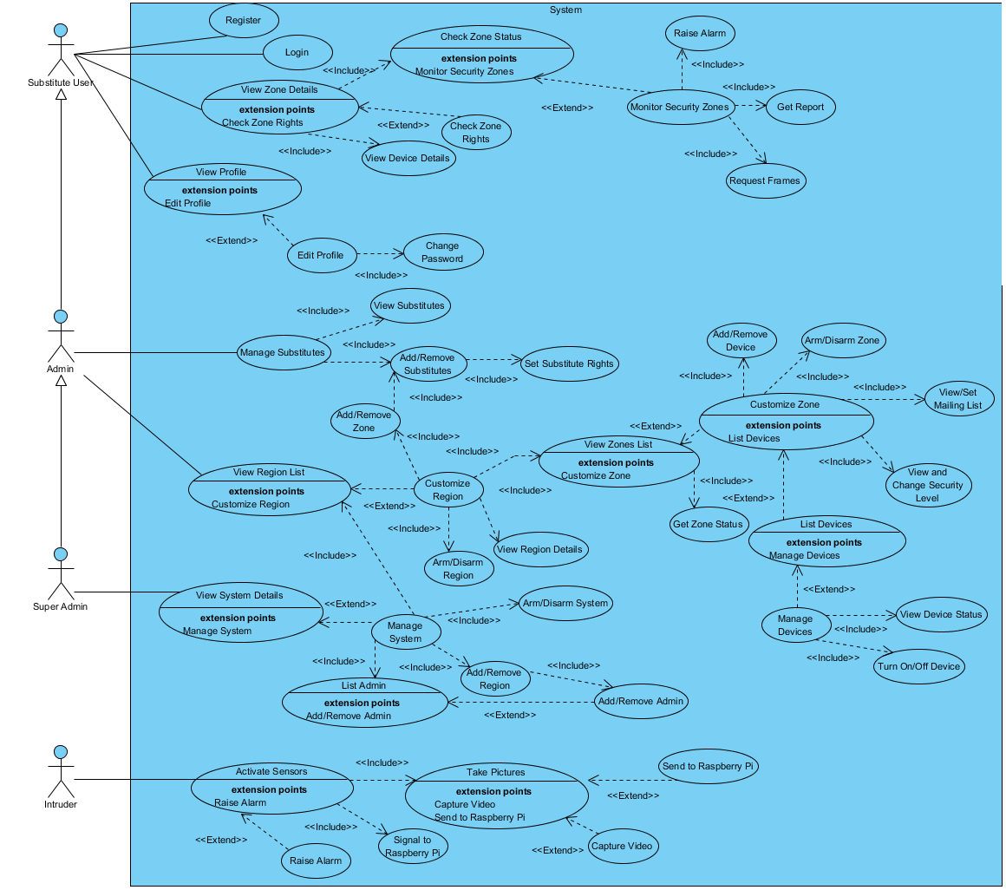**USE CASE DIAGRAM**

*Figure 4.4: Use Case Diagram*

* + 1. ***Use Case Description***

*Table 4.3: Login*

|  |  |
| --- | --- |
| **Use Case Element** | **Description** |
| Use Case Name | Login |
| Use Case Description | The normal user will log in to the system by using his/her ID and password. |
| Primary Actor | Admin, Super Admin and Substitute Users |
| Precondition | The users must already be registered |
| Basic Flow | 1. User credentials like Username and Password will be verified and the user can perform other functions after successful login. |
| Alternate Flow | 1. User authentication failed then the user will be asked to enter the credentials again. |
| Postcondition | 1. User will be shown his/her Office page. |

*Table 4.4: Register*

|  |  |
| --- | --- |
| **Use Case Element** | **Description** |
| Use Case Name | Register |
| Use Case Description | Every user must have to register into the system to access the functionalities of the system. Super Admin will be registered at the time of installation of the system. |
| Primary Actor | Substitute User |
| Precondition | User must have a valid Mobile number and Email Id. |
| Basic Flow | 1. If Username is available and mandatory field are not kept empty then registration is successful. |
| Alternate Flow | 1. Registration unsuccessful. |
| Postcondition | 1. The user will become a valid user of the system and now will be called as either Substitute User or Admin. |

*Table 4.5: View Zone Details*

|  |  |
| --- | --- |
| **Use Case Element** | **Description** |
| Use Case Name | View Zone Details |
| Use Case Description | Substitute User can view the details of the zone under his/her rights. Zone status can be viewed and Devices in that zone can be viewed along with their relevant details. |
| Primary Actor | Substitute User |
| Precondition | Substitute User must have the rights to the zone specified. |
| Basic Flow | 1. Details successfully shown. |
| Alternate Flow | 1. Substitute User will not be able to view the details. |
| Postcondition | 1. Substitute User can monitor the zone. |

*Table 4.6: Monitor Security Zones*

|  |  |
| --- | --- |
| **Use Case Element** | **Description** |
| Use Case Name | Monitor Security Zones |
| Use Case Description | Substitute User can monitor the zone of his/her rights by requesting frames, generating reports and raising alarm on detecting any intrusion in the room. |
| Primary Actor | Substitute User |
| Precondition | Substitute User must possess valid rights for that zone. |
| Basic Flow | Substitute User continuously monitors the premise and generates report, frames for Admin if required or can generate alarm. |
| Alternate Flow | Alarm is not set in the zone specified; Camera or Raspberry Pi is not working. |
| Postcondition | Zone is completely under the surveillance. |

*Table 4.7: View and Edit Profile*

|  |  |
| --- | --- |
| **Use Case Element** | **Description** |
| Use Case Name | View and Edit Profile |
| Use Case Description | All the users are able to view and change the details in their respective profiles. They also can change their passwords. UserID and SystemID will be accessible for change. |
| Primary Actor | Admin, Super Admin and Substitute User |
| Precondition | The user must be a valid user of the system. |
| Basic Flow | User profile updated. |
| Alternate Flow | User Credentials do not match or Cannot modify the field. |
| Postcondition | Update user profile is available for viewing. |

*Table 4.8: View and Manage Substitutes*

|  |  |
| --- | --- |
| **Use Case Element** | **Description** |
| Use Case Name | View and Manage Substitutes |
| Use Case Description | Admin can view the list of his/her subordinate substitutes. Also, Admin have the functionality to manage substitute like add/remove a substitute or set the rights for a substitute user. |
| Primary Actor | Admin |
| Precondition | Admin should have the region rights for that substitute user. |
| Basic Flow | 1. Substitute users list is shown. 2. Substitute user is added or removed. 3. Zone rights for a particular substitute user have been set. |
| Alternate Flow | 1. Substitute user cannot be added/ removed. 2. Zone rights cannot be set. |
| Postcondition | A zone is under surveillance of a substitute user possessing the right for that zone. Substitute user has been added and is now a part of the system. |

*Table 4.9: View and Manage Region*

|  |  |
| --- | --- |
| **Use Case Element** | **Description** |
| Use Case Name | View and Manage Region |
| Use Case Description | Admin can manage the region under his/her control. |
| Primary Actor | Admin |
| Precondition | Admin must be an admin of that region only. |
| Basic Flow | 1. View region details 2. Region is armed or disarmed. |
| Alternate Flow | 1. Admin do not have the access to the region specified. |
| Postcondition | Region details either modified or viewed successfully. |

*Table 4.10: View and Customize Zone*

|  |  |
| --- | --- |
| **Use Case Element** | **Description** |
| Use Case Name | View and Customize Zone |
| Use Case Description | Admin can customize the details of a particular zone as per the system requirement. Admin can View Zone details, Get Zone Status, List Devices in the Zone, Arm/Disarm Zone, Add/Remove Devices, Set mailing list and Change the security level of zone. |
| Primary Actor | Admin |
| Precondition | Admin must have the authority for the region in which this zone fall. |
| Basic Flow | Zone is successfully customized. |
| Alternate Flow | 1. Admin do not have the relevant rights to access the zone. 2. Zone does not exist. |
| Postcondition | Zone details updated. |

*Table 4.11: Activate Sensors*

|  |  |
| --- | --- |
| **Use Case Element** | **Description** |
| Use Case Name | Activate Sensors |
| Use Case Description | When an intruder tries to break into the system, sensor gets activated and will activate different devices and perform motion detection and monitoring. |
| Primary Actor | Intruder |
| Precondition | All the devices must be active and set in the zone in which the activity is being carried out. |
| Basic Flow | 1. Sensor gets activated. 2. Send signals to Raspberry Pi 3. Activate the cameras to capture pictures of the intruder. 4. On being requested cameras is invoked to record video. 5. Camera after capturing the video/photo signals to the Raspberry Pi. |
| Alternate Flow | 1. Devices are not properly set in the zone or are not activated by the Admin. 2. Intruder breaks into the system breaching the protocols to be followed. |
| Postcondition | Update user profile is available for viewing. |

*Table 4.12: View and Manage Devices*

|  |  |
| --- | --- |
| **Use Case Element** | **Description** |
| Use Case Name | View and Manage Devices |
| Use Case Description | Admin is able to vies and change the device status and placement in different zones. Admin can turn on/off the device and also can change the current status of a device. |
| Primary Actor | Admin |
| Precondition | Admin must be valid and device must be installed. |
| Basic Flow | Admin change the device status and turn off/on device. |
| Alternate Flow | Admin do not have sufficient rights. |
| Postcondition | Device status changed successfully. |

*Table 4.13: Manage System*

|  |  |
| --- | --- |
| **Use Case Element** | **Description** |
| Use Case Name | Manage System |
| Use Case Description | Super Admin above all the users have the rights to arm/disarm the complete system and allocate Admin to the regions or create/delete regions as per security requirements. |
| Primary Actor | Super Admin |
| Precondition | SystemID and Super Admin Id must match. |
| Basic Flow | 1. Super Admin changes the region configuration and allocate a new admin to each newly created region. Replace an existing Admin from a region. 2. Arm/Disarm the complete system. |
| Alternate Flow | SystemID and Super Admin ID do not match. |
| Postcondition | System settings updated. |

* 1. **ENTITY RELATIONSHIP DIAGRAM**

*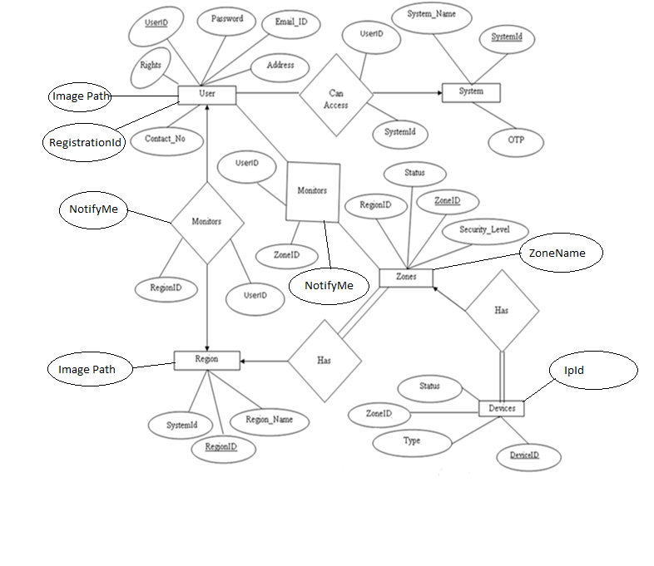Figure 4.5: Entity Relationship Diagram*

**CHAPTER 5**

**DESIGN**

**5.1 ARCHITECTURE DIAGRAM**

**Application Layer**

**Customize Security Zones**

**Video Streaming and Surveillance**

**Monitor Security Zones**

**Zone Customizer/Zone Monitor**

**Data Verifier**

**Query Handler**

**Processing Layer**

**Local Storage**

**Notification Sender**

**Notification Handler**

**Signal Handler**

**Internet Layer**

**TCP/IP Protocol Suite, Browser**

**Communication Layer**

**HTTPS/FTP**

**Data Layer**

**Data Access Components**

**Data Helpers and Utilities**

**Service Agents**

**Data Storage Layer**

**Data Services**

*Figure 5.1: Architecture Diagram of Smart Office Security System*

The architecture diagram for the proposed system consists of six different layers namely; Application Layer, Processing Layer, Internet Layer, Communication Layer, Data Layer and Storage Layer. The architecture diagram is shown above in the figure 5.1.

Application layer defines the user interface provided to the clients. It may be either Android Mobile application or Web application. Processing Layer contains the entire hardware device included in the system and Raspberry Pi. Raspberry Pi is the main processing device in the system. Processing Layer has a local database for locally storing data in Raspberry Pi. It can be SD card. Internet Layer is responsible for connecting the Raspberry Pi and mobile device to the internet. Communication Layer is the interface between the internet and Data Access Layer. It includes protocols like HTTPS and FTP used to transfer data between device and Storage Layer. Data Layer will contain some service agents, helper components and utilities for faster and reliable access of data. Bottommost layer is the Storage Layer which globally stores the data like pictures, user details and other zone or device configuration details.

***5.1.1 Working Architecture of System***

Application layer shows three main modules which will contain all the functionalities being provided by the system. Monitor Security Zones, Video Streaming and Surveillance and Customize Zone will contact to the Data Verifier in the Processing for verification of user credentials. Data Verifier after verifying the credentials send the query to Zone Monitor/Zone Customizer which in turn will be handled by the Query Handler. Query Handler will be in a bi- directional communication with Signal Handler which generates signals to the devices. Signal Handler. Signal Handler replies back the status of query to Query Handler which sends command to the Notification Handler which prepares the message/email to be send to the users. Notification Sender on receiving the message packet from Handler will send the packet to the intended users. These modules will stores the data, pictures, videos in the global storage with the help of Internet and Communication Layer.

***5.1.2 Description of Modules***

***5.1.2.1 Monitor Security Zones***

1. The system will monitor some sensitive areas of the premises like gate of the room, Elmira, locker etc. for unauthorized human intrusion using Passive Infrared Sensor.

2. For example, one could turn off a light in a room if motion is not detected for a period of time, or send an e-mail alert if door is open for a period of time.

3. When the PIR sensor is interrupted then the Wi-Fi camera takes a snapshot and E-mail that attachment to the respective E-mail account and generates a tweet/notification in the twitter/application to notify the authorized person about the visitor with picture.

4. Now, the user will remotely activate the alarm at Office or inform the neighbor using the android application if the image received is of the intruder.

*Figure 5.2: Flowchart for Motion Detection and Monitor Security Zone Modules*

***5.1.2.2 Video Streaming and Video Surveillance***

1. The proposed system will combine one webcam with Raspberry pi and put surveillance easily anywhere in the premises. The system will construct a webcam surveillance monitor that will:

* Stream real-time/recorded video.
* Create e-mail alerts when motion is detected.
* Create stills and video files when motion is detected.

2. The video also recorded for the given duration when the sensors interfaced with the PI is sensed and it is stored in the memory of the RT Raspberry pi.

***5.1.2.3 Customize Security Zones***

* During the system installation, admin will be prompted to create some security zones according to his/her requirement and understanding.
* Once the security zones have been created, the admin will assign the devices, properties etc into those security zones.
* Security zones will decide what actions will take place when an intrusion is detected in that zone.
* Using this module a admin can arm/disarm the whole system, activate and deactivate some devices.
* Admin can also create new security zones, delete and modify the existing security zones.

**5.2 SYSTEM DESIGN**

The Smart Office system composes of a set of sensors and android powered devices. Sensors used in this system are used for controlling lamp switch, monitoring temperature and office surveillance. The sensors will communicate with raspberry pi which is the system server. The protocol that will be used is IEEE 802.11b, g for Wi-Fi. By using this protocol, the communications between sensors to the server will be more robust. A System Design diagram for the proposed system is shown in the below figure 5.3.

For far distance communication, the web based for Smart Office system will be built. Therefore, it will need more data storage. The alternative way is using the web based server. By using this technology, data storage space can be saved. In addition to that, it gives some advancement to the project compared to previous works as it uses recent technology in research. Figure 4.5 shows the flowchart for Smart Office Design.

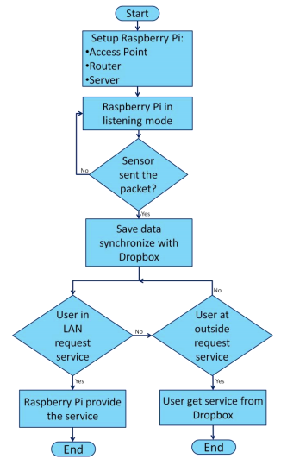The overall design starts by setting up the raspberry pi as the AP, Router and Server. Then, the raspberry pi put in the listening mode and continuously waits for the sensor to send the image packet. When the packet has been received, the raspberry pi saves the data and synchronizes it with web based server. A user in the office network can have a direct access to the raspberry pi to get the image data. However, if the user was in a remote area, the data can also be accessed but through the server.

*Figure 5.3: Flowchart for Smart Office Design*

**5.3 ALGORITHM**

***5.3.1 Human Count and Security Algorithm:***

The algorithm described below will keep track of number of humans currently present in the room/vicinity. The algorithm uses two PIR sensors and is equipped with two protocols to be followed for normal functioning of the algorithm. If any one of the protocols is not followed then there will be a possible intrusion in the office.

**Algorithm:**

Let P1 and P2 be the two PIR sensors attached to the door in the manner as shown in the below figure: -

**Protocol#1**

This protocol will perform the following function: -

* Increment the count of number of people currently present in the room.

P1 - Activated

P2 – Activated

P1 - Deactivated

P2 - Deactivated

**Protocol#2**

This protocol will perform the following function: -

* Decrement the count of number of people currently present in the room.

P2 - Activated

P1 - Activated

P2 - Deactivated

P1 - Deactivated

If the Protocols are not followed then an alarm will be raised indicating the possibility of intrusion in the room. However, the algorithm is intended to count the number of humans in the room at a time but will also add to the security of the system.

**For Example: -** If two or more people together are trying to breach the security of the system like one person remains standing in front of the sensor and simultaneously the other person enters into the room. In this case, the sensor will be activated only once and clicks the picture of first person. But the second will pass through the PIR sensors and camera without being detected. Thus, the placement of two sensors will prevent this using the two protocols described above.

If anyone tries to fool the sensors by standing in front of them then Protocols will not be followed and detects the unwanted activity.

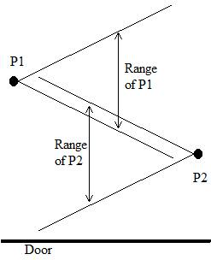

*Figure 5.4: Orientation of PIR Sensors on Door*

* 1. **ACTIVITY DIAGRAM** 
     1. ***Login***

***5.4.1.1 Description and Priority***

Login page is provided so as the registered users and admin can enter into the system. The rights field which is set to “User”by default is used to distinguish between admin and normal users.

User first enters his/her username and password then the system validates the data among the data in the database and if the information provided by the user is authenticated he/she can use the features of the system.

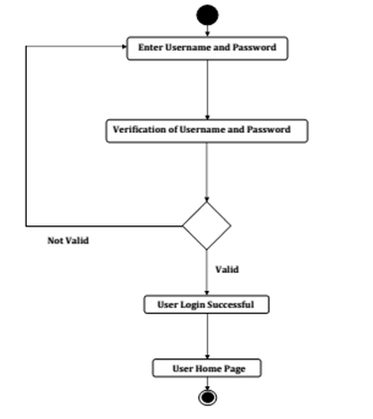

*Figure 5.5: Activity Diagram for Login Activity*

* + 1. ***Send Signals to Raspberry Pi***
       1. ***Description and Priority***

A set of sensors are installed and customized in the office according to the admin requirements. Whenever one or some of these sensors get activated due to some action of intruder a signal is sent to the raspberry pi indicating the occurrence of some event. Raspberry pi in turn receives the signal, identify the tasks to be carried in response to the signal and do the task. This activity occurs very frequently and is of higher priority.

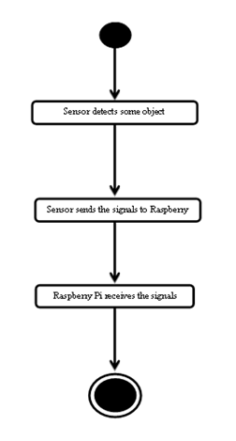

*Figure 5.6: Flowchart for Send Signals to Raspberry Pi*

* + 1. ***Customize Security Zone***
       1. ***Description and Priority***

The proposed system consists of different levels of security zones. Depending upon the level of risk of a particular security zone a series of actions take place. The admin will have the authority to create, delete, list and also change the level of security of a particular zone. The system has three levels of security zones namely; High Security Zone, Medium Security Zone and Low Security Zone. The activity is of medium priority.

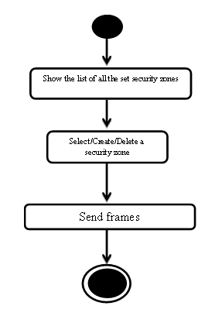

*Figure 5.7: Flowchart for Customize Security Zones*

* + 1. ***Send Signals to Cameras/Sensors and Alarms***
       1. ***Description and Priority***

Raspberry pi on receiving some commands from user will send signals to Cameras, Sensors and Alarms. It may activate or deactivate a device, arm or disarm the system. The module is of higher priority. The diagram is shown below in the figure 5.8.

* + 1. ***Device Send Signals***
       1. ***Description and Priority***

Devices installed in the room are able to send signals to Raspberry Pi in order to activate/ deactivate some other Sensors, Cameras installed in the security zones. The raspberry pi on receiving the signals will perform the desired function. The module is of higher priority. The diagram is shown below in the figure 5.7.

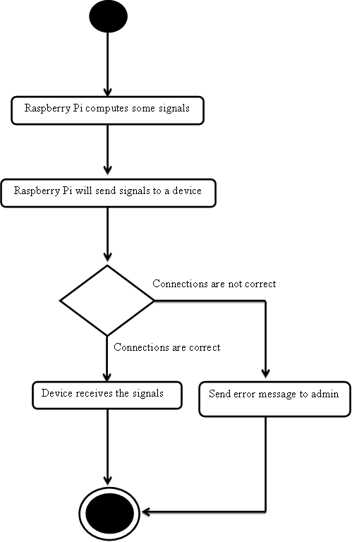

*Figure 5.8: Flowchart for Send Signals to Cameras/Sensors and Alarms*

* + 1. ***Monitor Security Zones***
       1. ***Description and Priority***

The admin is able to monitor the security zones selected using the video recorded at the time of intrusion in the zone. The admin can selectively play the videos (Number of Frames/Sec). The video will be able in the local database created in the user’s phone or in the cloud storage. The module is of lower priority. The user can also start or stop the recording according to his/her will at any time remotely from anywhere. This will enable the user to have the room under surveillance anytime according to his/her wish.

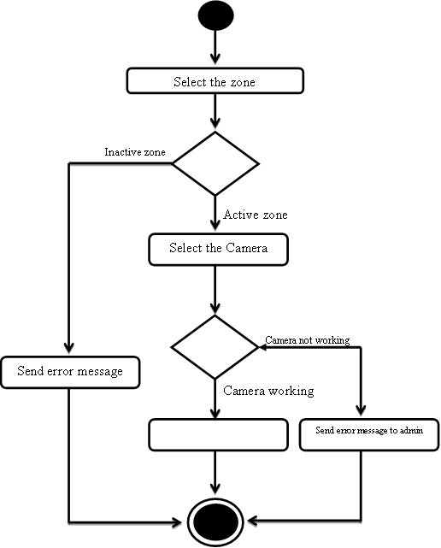

*Figure 5.9: Flowchart for Device Send Signals*

* + 1. ***Send Notifications to Users***
       1. ***Description and Priority***

Raspberry pi on receiving the images from webcam will prepare a packet containing messages and attachment of image captured. The raspberry pi then uses Twython API to send tweets to the admin of the system. Raspberry pi using some other API’s can also send E-Mail to the admin. The module is of higher priority. The admin is able to invoke this module anytime according to his/her needs.

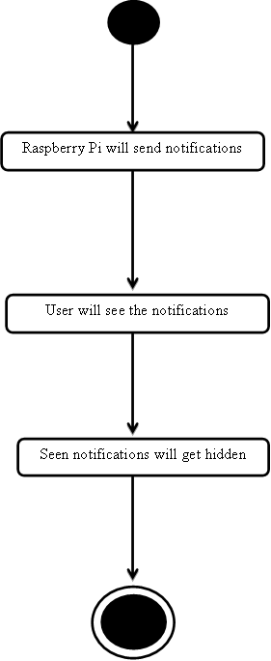

*Figure 5.10: Activity Diagram for Send Notification to Users*

* + 1. ***Send Pictures to Raspberry Pi***
       1. ***Description and Priority***

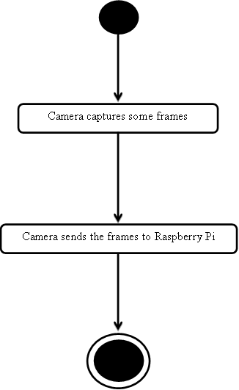The PIR sensor will detect motion and send some signals to Raspberry Pi indicating the need to activate the webcam. Raspberry pi will then send signals to the camera to activate them. Camera after capturing the images of the intruder sends the images to the raspberry pi for local storage. Camera will use some python scripts to capture and send the images to Raspberry Pi.

*Figure 5.11: Activity Diagram for Send Pictures to Raspberry Pi*

* + 1. ***Activate and Deactivate Devices***
       1. ***Description and Priority***

Admin is able to activate or deactivate some devices, arm or disarm the whole system remotely from anywhere and at anytime. The application provided will include the necessary features to perform the same.

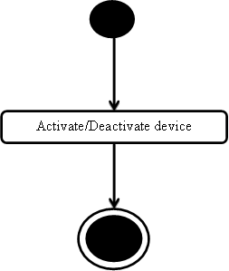

*Figure 5.10: Activity Diagram for Activate /Deactivate Devices*

* + 1. ***Warning By Alarm***
       1. ***Description and Priority***

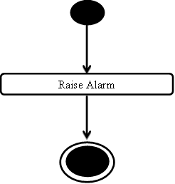The area under High security zone will be protected by an alarm i.e. whenever that zone is activated and someone tries to intrude that zone an alarm will get activated.

*Figure 5.12: Warn By Alarm*

* + 1. ***Sense Objects***
       1. ***Description and Priority***

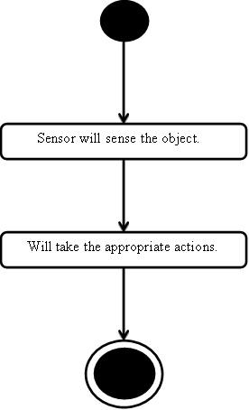The PIR sensor will sense object motion in front of it and inform the same to raspberry pi. The diagram is shown below in the figure 5.11.

*Figure 5.13: Activity Diagram for Sense the Objects*

* + 1. ***Send SMS***
       1. ***Description and Priority***

Raspberry pi can also send SMS to admin as per the requirement of the system. There is a case in which SMS module is required when the internet connectivity of raspberry pi is lost due to some reasons. The diagram is shown below in the figure 5.12.

System generates an alert

Sends SMS to third party

Some Exception Occurs

SMS Sent Properly

*Figure 5.14: Activity Diagram for Sending SMS*

* + 1. ***Sending Commands to Raspberry Pi***
       1. ***Description and Priority***

The user can also command Raspberry Pi remotely using the Android application or the web interface provided. The diagram is shown below in the figure 5.13.

Send command

Command right

Raspberry Pi will receive command and will process it.

Appropriate signals will be transmitted to devices

User get notification

*Figure 5.15: Activity Diagram for Send Commands to Raspberry Pi*

* + 1. ***Record Video***
       1. ***Description and Priority***

The module is used to start and stop recording video as per the admin requirements. The user commands the Raspberry Pi to start the video which in turn send signal to Webcam to start recording the video.

Start video recording

Storage out of space

Message sent to admin

Frames will be sent

*Figure 5.16: Activity Diagram for Record Video*

* + 1. ***View and Edit Account***
       1. ***Description and Priority***

Registered users and admin can view their respective profiles. Admin can also view profiles of users but, confidential information like password will remain hidden from him. Apart from viewing the profiles they can edit their respective profiles as well. They can change their passwords, name any other information provided previously.

Display details

Details valid

Validate Details

Edit Details

Save Details

*-*

*Figure 5.17: Activity Diagram for Edit and View Account*

* + 1. ***List all Security Zones***
       1. ***Description and Priority***

The admin is able to view all the security zones customized during setup of the system. The admin is able to check the status of all the security zones customized during setup of the system. The admin is given options to change the status of the zone according to his/her requirements.

Search the zones for the admin

Show the list to admin

*Figure 5.18: Activity Diagram for List Security Zones*

***5.3.17 Send in-app messages***

***5.3.17.1 Description and Priority***

Any user using the client app designed for the system can send in-app messages to anyone within his/her are of working. For E.g. an Admin can send messages to the substitutes and super admin and not to other admin of the system; a substitute can send messages to the admin and a super admin can send messages to anyone using the system.

Only the list of legal recipients would be available to the user, for sending the messages. There will be a conversation created in the app to see the previous messages.

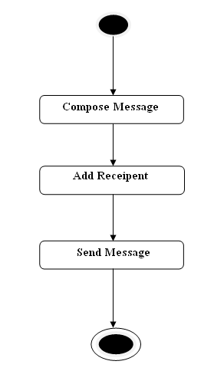

*Figure 5.19: Activity Diagram for in-app messages*

**5.5 CLASS DIAGRAM**

This is the class diagram representing all the classes in the system. **User class** is used to describe basic methods and data of any user using the system, irrespective of hierarchy.

User Class is inherited by SubstituteClass. It describes the zone and region related methods and attributes of the substitute.

As the Admin of at a Region will have all the functionalities and attributes of the substitute, Admin Class inherits Substitute Class with some additional attributes and methods.

Similarly, the Super_Admin Class of the system having all the attributes and methods of the Admin Class will inherit the Admin Class.

The System Class defines all the basic methods and functionalities of a complete system. A System Has Regions here establishes one to many associativity between System Class and Region Class. Similarly, there will be one to many associativity between Region Class and Zone Class.

The Device Class describes entire Input/output device for which the system has a provision for connection to the system, with all the common attributes and methods. Therefore, Device class is inherited by Alarm Class, by Camera Class and by Sensor Class. Class diagram for the proposed system is shown in the below figure 5.20.

**5.6 SEQUENCE DIAGRAM**

***5.6.1 Activate Sensors***

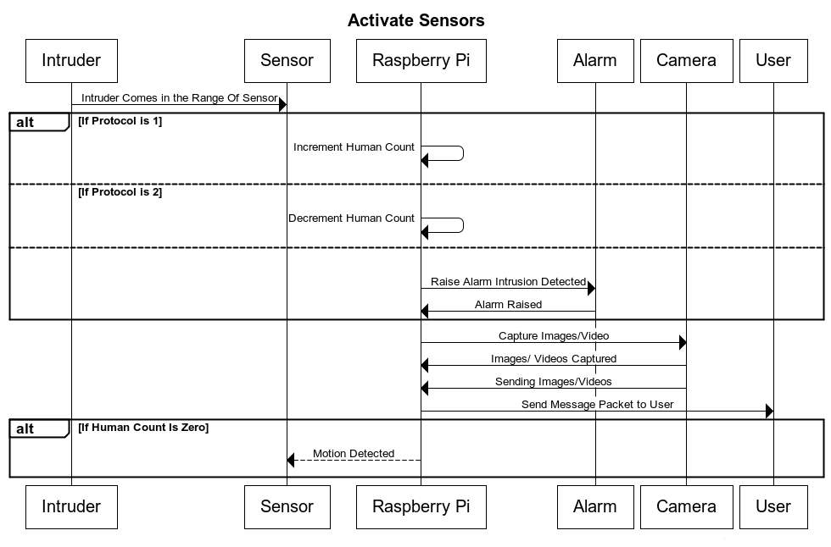

*Figure 5.21: Sequence Diagram for Monitor Security Zone*

***5.6.2 Edit Profile***

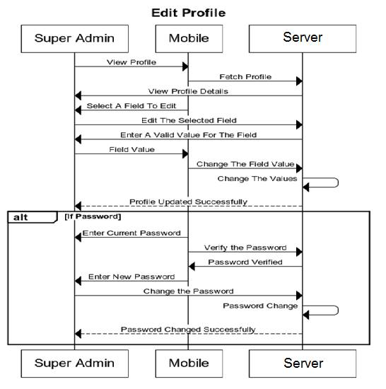

*Figure 5.22: Sequence Diagram for Edit Profile*

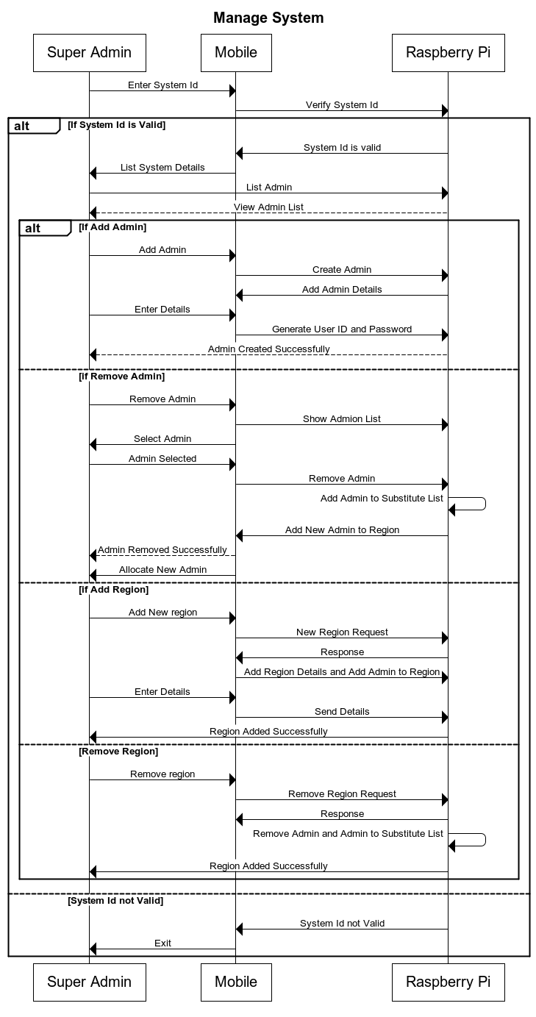***5.6.3 Manage System***

*Figure 5.23: Sequence Diagram for Manage System*

***5.6.4 Manage Substitute***

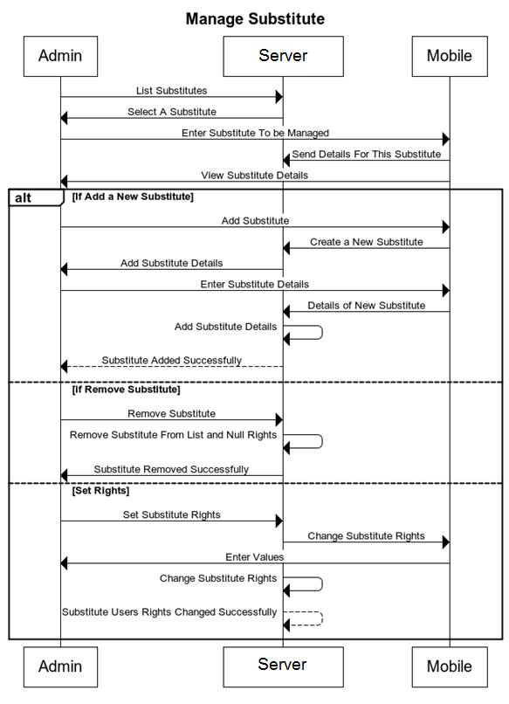

*Figure 5.24: Sequence Diagram for Manage Substitutes*

***5.6.5 Monitor Security Zones***

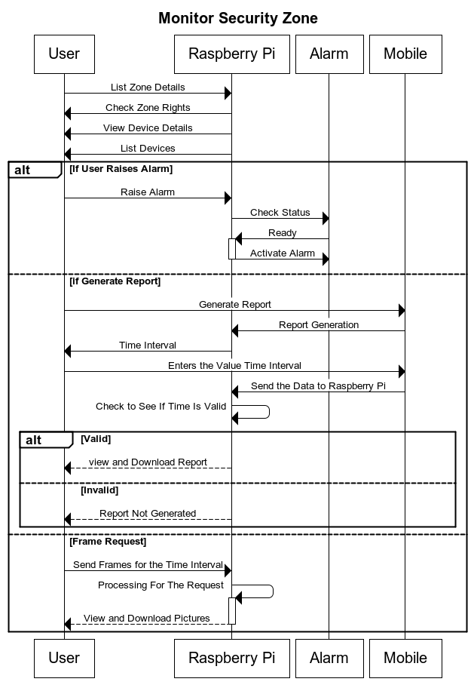

*Figure 5.25: Sequence Diagram for Monitor Security Zones*

***5.6.6 Live Streaming***

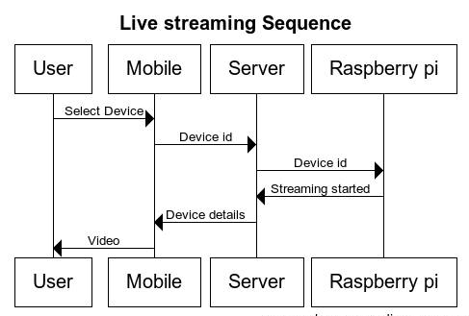

*Figure 5.26: Live Streaming*

***5.6.7 Manage Region***

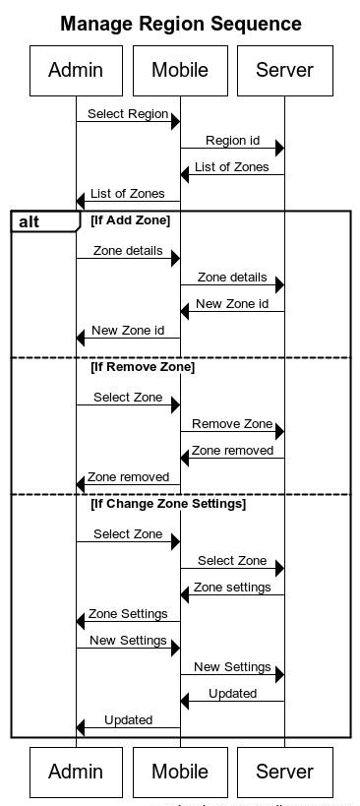

*Figure 5.31: Live Manage Region*

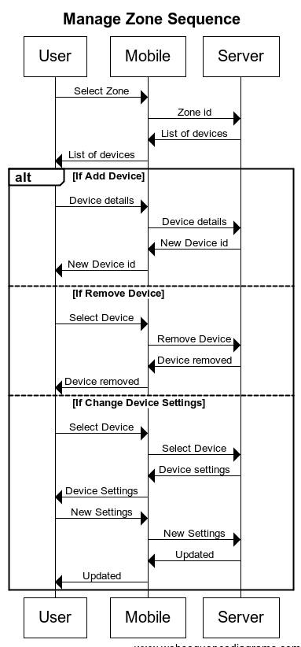***5.6.8 Manage Zone***

*Figure 5.27: Manage Zone*

***5.6.9 Messaging***

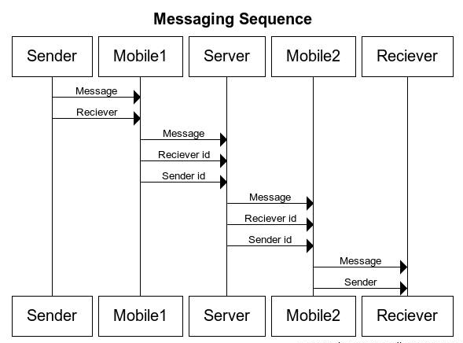

*Figure 5.28: Messaging*

* 1. **COMPONENT DIAGRAM**
     1. ***Component Diagram for Raspberry Pi***

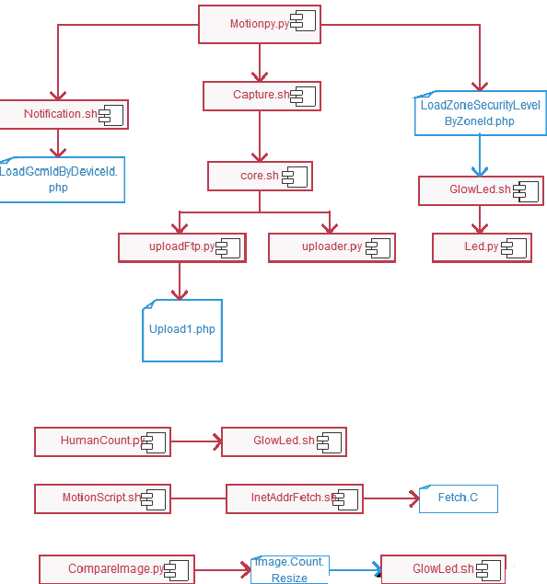

*Figure 5.29: Component Diagram for Raspberry Pi*

* + 1. ***Component Diagrams for Client App***
       1. ***Substitute***

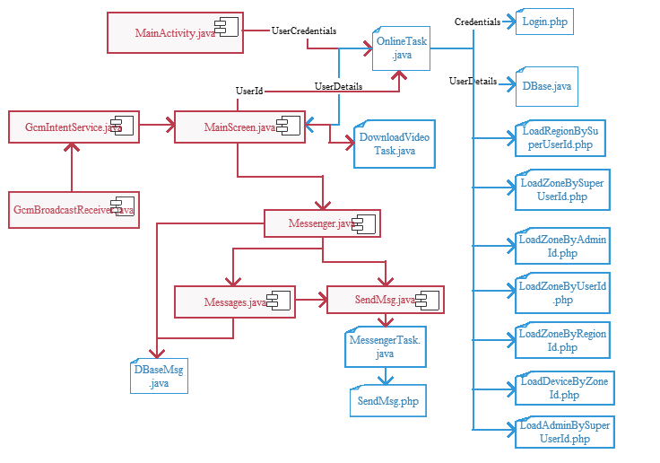

*Figure 5.30: Component Diagram for Client App(a)*

* + - 1. ***Super Admin***

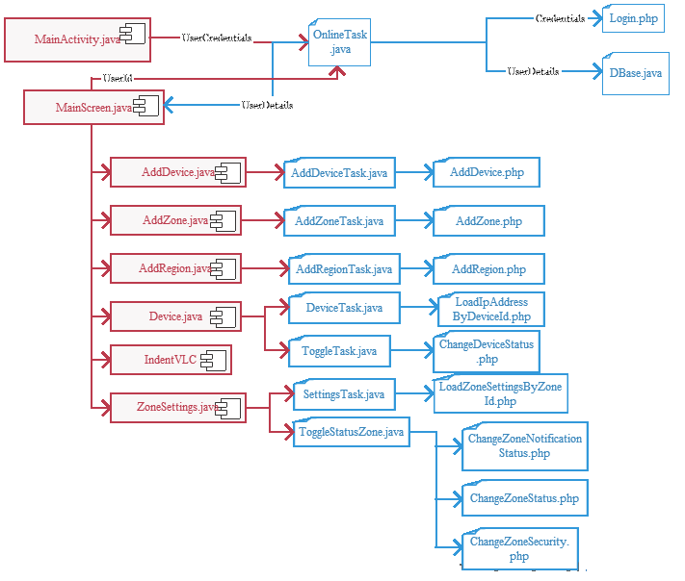

*Figure 5.31: Component Diagram for Client App(b)*

**5.8 DATABASE DESIGN**

*Table 5.1: System*

|  |  |  |  |  |
| --- | --- | --- | --- | --- |
| **#** | **Field Name** | **Field Type** | **Description** | **Key description** |
| 1. | SystemID | VarChar | System’s Identity | Primary Key |
| 2. | System Name | VarChar | Name of system |  |
| 3. | OTP | VarChar | One time password |  |

*Table 5.2: User*

|  |  |  |  |  |
| --- | --- | --- | --- | --- |
| **#** | **Field Name** | **Field Type** | **Description** | **Key description** |
| 1. | UserID | VarChar | User’s Identity | Primary Key |
| 2. | RegistrationId | VarChar | GCM unique id |  |
| 3. | Name | VarChar | Name of user |  |
| 4. | Password | VarChar | Password |  |
| 5. | Rights | Integer | Rights of the user |  |
| 6. | Email ID | VarChar | Email ID of user |  |
| 7. | Address | VarChar | Address of user |  |
| 8. | Contact No. | Integer | User’s contact number |  |
| 9. | Image Path | String | Path of user’s image in system |  |

*Table 5.3: Region*

|  |  |  |  |  |
| --- | --- | --- | --- | --- |
| **#** | **Field Name** | **Field Type** | **Description** | **Key description** |
| 1. | RegionID | VarChar | Region’s identity | Primary Key |
| 2. | SystemID | VarChar | System’s identity | Foreign key(System) |
| 3. | Region Name | VarChar | Name of region for users to make region meaningful |  |
| 4. | Image Path | String | Path of user’s image in system |  |

*Table 5.4: Zone*

|  |  |  |  |  |
| --- | --- | --- | --- | --- |
| **#** | **Field Name** | **Field Type** | **Description** | **Key description** |
| 1. | ZoneID | VarChar | Zone’s identity | Primary Key |
| 2. | RegionID | VarChar | Region’s identity | Foreign key(Region) |
| 3. | Status | Integer | Status of zone.  Like armed, unarmed |  |
| 4. | ZoneName | String | Name of the zone |  |
| 5. | Image_Path | String | Path of user’s image in system |  |
| 6. | Security Level | Integer | Level of zone.  Like high, low. |  |

*Table 5.5: Device*

|  |  |  |  |  |
| --- | --- | --- | --- | --- |
| **#** | **Field Name** | **Field Type** | **Description** | **Key description** |
| 1. | DeviceID | VarChar | Device’s identity | Primary Key |
| 2. | ZoneID | VarChar | Zones’ identity | Foreign key(Zone) |
| 3. | Type | VarChar | Type of device.  Like camera, sensor. |  |
| 4. | Status | Integer | Status of device.  Like active, recording. |  |
| 5. | IpId | VarChar | IP of the device |  |

*Table 5.6: SuperAdmin*

|  |  |  |  |  |
| --- | --- | --- | --- | --- |
| **#** | **Field Name** | **Field Type** | **Description** | **Key description** |
| 1. | SystemID | VarChar | System’s identity | Foreign key(System) |
| 2. | UserID | VarChar | Super Admin ID | Foreign key(User) |

*Table 5.7: RegionMonitor*

|  |  |  |  |  |
| --- | --- | --- | --- | --- |
| **#** | **Field Name** | **Field Type** | **Description** | **Key description** |
| 1. | RegionID | VarChar | Region’s identity | Foreign key(Region) |
| 2. | UserID | VarChar | Admin ID | Foreign key(User) |
| 3. | NotifyMe | Boolean | To notify user about region or not |  |

*Table 5.8: ZoneMonitor*

|  |  |  |  |  |
| --- | --- | --- | --- | --- |
| **#** | **Field Name** | **Field Type** | **Description** | **Key description** |
| 1. | ZoneID | VarChar | Zone’s identity | Foreign key(Zone) |
| 2. | UserID | VarChar | Substitute ID | Foreign key(User) |
| 3. | NotifyMe | Boolean | To notify user about region or not |  |

*Table 5.9: Ip*

|  |  |  |  |  |
| --- | --- | --- | --- | --- |
| **#** | **Field Name** | **Field Type** | **Description** | **Key description** |
| 1. | IpId | VarChar | ID associated with IP address | Foreign key(System) |
| 2. | IpAddress | VarChar | Ip Address of the device |  |

**CHAPTER 6**

**IMPLEMENTATION**

* 1. **DESCRIPTION OF CLASSES AND FUNCTIONS** 
     1. ***Login***
* User credentials are sent to the server for validation where php scripts are used to validate user.
* If credentials are valid server replies with user details and user details are saved locally in database. Mobile phone is registered with GCM Server and that unique ID is stored in database located at server followed by launching of Home Screen.
  + 1. ***GCM* Receiver**
* This service runs infinitely in the background. It waits for all types of messages that are sent to the particular device and displays that message as notification. If the message is intrusion then the intrusion image gets downloaded to local device and video can be downloaded on demand.
* If the message is sent by another user than the message gets inserted in local messenger database.
  + 1. ***Main* *Screen***
* This is the main user interface. It contains the different operations that the user can perform.
* Login screen passes user details to it. List of regions, zones and devices are shown by it.
* Setting of zones and devices can be altered by it.
* Different asynchronous tasks are used to run php scripts.
* User details can be seen and altered.
  + 1. ***Messaging***
* This is message handling interface that interacts with local database only. When user sends a message that message is sent via asynchronous task which calls a php script to send message. That message also gets saved to local database.
  + 1. ***Asynchronous Task***
* It contains the code to call the php scripts and process the result returned by the scripts.
  + 1. ***Download Task***
* It contains the code to download the images and videos stored on the server by FTP.
  + 1. ***PHP scripts***
* PHP scripts contain the code to interact with database present at server.
* All the data fetching and alteration codes are present in PHP scripts.
  + 1. ***Motion Detection***
* Setting up GPIO for Raspberry Pi. The file is running in an infinite loop.
* First, the security level of zone is identified using a PHP script from database. Then the status is passed to *notification.sh*.If high security zone has encountered an intrusion, Alarm is raised along with the notification. Otherwise, the notification is send.
* Returning from *notification.sh****,*** it cleans all the images captured and movies lapsed previously from Raspberry Pi memory.
* Then, the motion script is stopped in between and ‘n’ numbers of images are captured for a predefined value of n, then motion script is run again.
* Then, the recently clicked images in this session are brought into a text file and passed to the encoder module for time lapsing.
* After that, an email is sent to the user and the sequence of images in the form of movie is uploaded to the ftp server from where it can be downloaded anytime using the client application.
  + 1. ***Human Count***
* This process runs infinitely in the background.
* GPIO pins setup for raspberry Pi. Two PIR sensors are used. There are four variables used in this script namely, success, in_out, shared and count.
* The following loop is run for the unity value of the ‘Shared’ variable.
* First, the decision of whether the person is coming inside or going outside the room is made according to the activation sequence of the PIR Sensors.
* Then, after some fixed time delay, the other PIR sensor is checked for activation.
* According to this, the decision of success is made.
* If the success case occurs, the counter value is updated by incrementing and decrementing for incoming and outgoing person respectively. Anything other than success generates an alert.
  + 1. ***Live Streaming***
* Starting the motion script.
* On end event, the cleanup is performed i.e. deleting the previous images and movies.
* On start event, a python script fetches the current IP and port of the webcam and user can view the live video on demand. As the 10 minutes of stream is played, again cleanup is performed and stream is played yet again.
  + 1. ***Image*** ***comparison***
* Running periodically in cron tab file.
* Clicks one test image. There is one reference to black image.
* Now, a conversion of the original images into grey scale images is done.
* Images are resized from RGB values into its intensity value rather than color. Now, the image is downscaled to some lower pixels in order to speed up the pixel comparison.
* Now, each pixel is compared to some threshold value for white and black image i.e. if value is less than 50 the pixel value is changed to zero, if value is between 50 to 190, pixel value is changed to 1, otherwise it is zero.
* Now, the total number of zeros are counted and compared to a threshold. If it is less than 20, the image is classified as black image. And if it is greater than 65, image is classified as white image. In both the cases, alarm is raised.
* Now, after identifying the image a black or white image, another measure is performed and document vector of both the images are calculated and cosine value is found out. If cosine value is greater than 80%, the image is classified as black image and alarm is raised.

**CHAPTER 7**

**TESTING AND RESULTS**

**7.1 UNIT TESTING**

**7.1.1 Login.php and OnlineTask.java**

*Table 7.1 Login.php & OnlineTask.java*

|  |  |  |  |  |  |  |
| --- | --- | --- | --- | --- | --- | --- |
| S.No. | Details | UserId (I/P 1) | Password (I/P 2) | Expected output | Actual output | Pass/Fail |
| 1. | Valid user name and password | usr3 | abc123 | Valid Credentials | Valid Credentials | Pass |
| 2. | Invalid user name and password | zn2 | Xyz567 | Invalid Credentials | Invalid Credentials | Pass |
| 3. | Invalid user name and valid password | Sourabh9 | abc123 | Invalid Credentials | Invalid Credentials | Pass |
| 4. | Valid user name and invalid password | usr1 | ABC123 | Invalid Credentials | Invalid Credentials | Pass |
| 5. | Valid user name and password | usr1 | abc123 | Valid Credentials | Valid Credentials | Pass |

**7.1.2** **addDevice.php & AddDeviceTask.java**

*Table 7.2 addDevice.php & AddDeviceTask.java*

|  |  |  |  |  |  |  |  |
| --- | --- | --- | --- | --- | --- | --- | --- |
| S.No. | Details | ZoneId (I/P 1) | Type (I/P 2) | Status (I/P 3) | Expected output | Actual Output | Pass/ Fail |
| 1. | Add device in existing zone | zn1 | Camera | on | Unique DeviceId | dv7 | Pass |
| 2. | Add device in existing zone | zn2 | PIR Sensor | off | Unique DeviceId | dv8 | Pass |
| 3. | Add device in non-existing zone | zn8 | Camera | off | Error | dv9 | Fail |
| 4. | Add device in existing zone | zn4 | Alarm | off | Unique DeviceId | dv8 | Pass |
| 5. | Add device in existing zone | zn3 | Camera | on | Unique DeviceId | dv7 | Pass |

**7.1.3 addZone.php & AddZoneTask.java**

*Table 7.3 addZone.php & AddZoneTask.java*

|  |  |  |  |  |  |  |
| --- | --- | --- | --- | --- | --- | --- |
| S.No. | Details | RegionId (I/P 1) | Zone Name (I/P 2) | Expected output | Actual output | Pass/ Fail |
| 1. | Add zone in existing region | rg1 | IOS | Unique ZoneId | zn2 | Pass |
| 2. | Add zone in existing region | rg2 | Android | Unique ZoneId | zn3 | Pass |
| 3. | Add zone in non-existing region | rg7 | Dell | Error | zn4 | Fail |
| 4. | Add zone in non-existing region | rg8 | PHP | Error | zn5 | Fail |
| 5. | Add zone in non-existing region | rg0 | JAVA | Error | zn5 | Fail |

**7.1.4 addRegion.php & AddRegionTask.java**

*Table 7.4 addRegion.php & AddRegionTask.java*

|  |  |  |  |  |  |  |
| --- | --- | --- | --- | --- | --- | --- |
| S.No. | Details | UserId (I/P 1) | Region Name (I/P 2) | Expected output | Actual output | Pass/ Fail |
| 1. | Add region under an Super Admin user | usr1 | Indore 2 | Unique regionId | rg2 | Pass |
| 2. | Add region under an Super Admin user | usr1 | Ujjain 1 | Unique regionId | rg3 | Pass |
| 3. | Add region under non Super Admin user | usr2 | Ujjain 2 | Error | Error | Pass |
| 4. | Add region under non Super Admin user | usr3 | Indore 1 | Error | Error | Pass |
| 5. | Add region under an Super Admin user | usr1 | Dewas | Unique regionId | rg5 | Pass |

**7.1.5 changeDeviceStatus.php & ToggleStatusTask.java**

*Table 7.5 changeDeviceStatus.php & ToggleStatusTask.java*

|  |  |  |  |  |  |  |
| --- | --- | --- | --- | --- | --- | --- |
| S.No. | Details | DeviceId (I/P 1) | Status (I/P 2) | Expected output | Actual output | Pass/ Fail |
| 1. | Changing status of an existing device to ON | dv1 | on | Status of device must change to ON | Status of device changed to ON | Pass |
| 2. | Changing status of a non-existing device to ON | dv7 | on | Error | Error (no such device) | Pass |
| 3. | Changing status of a non-existing device to OFF | dv8 | off | Error | Error (no such device) | Pass |
| 4. | Changing status of an existing device to OFF | dv3 | off | Status of device must change to OFF | Status of device changed to OFF | Pass |
| 5. | Changing status of an existing device to ON | dv4 | on | Status of device must change to ON | Status changed of device to ON | Pass |

**7.1.6 changeZoneNotifiactionStatus.php & ToggleStatusZone.java**

*Table 7.6 changeZoneNotifiactionStatus.php & ToggleStatusZone.java*

|  |  |  |  |  |  |  |  |
| --- | --- | --- | --- | --- | --- | --- | --- |
| S.No. | Details | UserId (I/P 1) | ZoneId (I/P 2) | NotifyMe (I/P 3) | Expected output | Actual output | Pass/ Fail |
| 1. | Turn on notification of a Admin for a zone | usr2 | zn1 | true | User will get notifications of zone | null | Fail |
| 2. | Turn off notification of a substitute for a zone | usr4 | zn1 | false | User will not get notifications of that zone | Success | Pass |
| 3. | Turn on notification of a substitute for a zone | usr5 | zn2 | true | User will get notifications of that zone | Success | Pass |
| 4. | Turn off notification of a user for a zone | usr6 | zn1 | false | Error | null | Fail |
| 5. | Turn on notification of a user for a zone | usr1 | zn2 | true | Error | null | Fail |

**7.1.7 changeZoneSecurity.php & ToggleStatusZone.java**

*Table 7.7 changeZoneSecurity.php & ToggleStatusZone.java*

|  |  |  |  |  |  |  |
| --- | --- | --- | --- | --- | --- | --- |
| S.No. | Details | ZoneId (I/P 1) | Security (I/P 2) | Expected output | Actual output | Pass/ Fail |
| 1. | Change security level of an existing zone to OFF | zn1 | 0 | Change zone security status to off | Zone security status changed to off | Pass |
| 2. | Change security level of an existing zone to ON | zn4 | 1 | Change zone security status to on | Zone security status changed to on | Pass |
| 3. | Change security level of a non-existing zone to ON | zn5 | 1 | Error(Zone does not exists) | null | Fail |
| 4. | Change security level of an existing zone to OFF | zn3 | 0 | Change zone security status to off | Zone security status changed to off | Pass |
| 5. | Change security level of an existing zone to ON | zn2 | 1 | Change zone security status to on | Zone security status changed to on | Pass |

**7.1.8 changeZoneStatus.php & ToggleStatusZone.java**

*Table 7.8 changeZoneStatus.php & ToggleStatusZone.java*

|  |  |  |  |  |  |  |
| --- | --- | --- | --- | --- | --- | --- |
| S.No. | Details | ZoneId (I/P 1) | Status (I/P 2) | Expected output | Actual output | Pass/ Fail |
| 1. | Turn on a non-existing zone | zn5 | on | Error(Invalid zone) | null | Fail |
| 2. | Turn off an existing zone | zn1 | off | Turn off zone | Zone turned off | Pass |
| 3. | Turn off an existing zone | zn4 | off | Turn off zone | Zone turned off | Pass |
| 4. | Turn on an existing zone | zn3 | on | Turn on zone | Zone turned on | Pass |
| 5. | Turn on an existing zone | zn4 | on | Turn on zone | Zone turned on | Pass |

**7.1.9 changeRegionNotifiactionStatus.php**

*Table 7.9 changeRegionNotifiactionStatus.php*

|  |  |  |  |  |  |  |  |
| --- | --- | --- | --- | --- | --- | --- | --- |
| S.No. | Details | UserId (I/P 1) | RegionId (I/P 2) | NotifyMe (I/P 3) | Expected output | Actual output | Pass/ Fail |
| 1. | Turn on notification of a region for its Admin | usr2 | rg1 | true | User will get notifications of that zone | Success | Pass |
| 2. | Turn off notification of a region for its Admin | usr2 | rg1 | false | User will not get notifications of that zone | Success | Pass |
| 3. | Turn off notification of a region for an user | usr4 | rg2 | false | Error | null | Fail |
| 4. | Turn off notification of a region for an user | usr1 | rg1 | false | Error | null | Fail |
| 5. | Turn on notification of a region for an user | usr3 | rg2 | true | Error | null | Fail |

**7.1.10 loadAdminBySuperUserId.php & OnlineTask.java**

*Table 7.10 loadAdminBySuperUserId.php & OnlineTask.java*

|  |  |  |  |  |  |
| --- | --- | --- | --- | --- | --- |
| S.No. | Details | UserId (I/P 1) | Expected output | Actual output | Pass/Fail |
| 1. | Display list of admin under a super admin | usr1 | Admin list under given super admin | Admin list {usr2} | Pass |
| 2. | Display list of admin under an invalid user | zn1 | Error | Error | Pass |
| 3. | Display list of admin under a super admin | usr1 | Admin list under given super admin | Admin list {usr2} | Pass |
| 4. | Display list of admin under a non-super admin user | usr2 | Error | Error | Pass |
| 5. | Display list of admin under a non-super admin user | usr3 | Error | Error | Pass |

**7.1.11 loadDeviceByZoneId.php & OnlineTask.java**

*Table 7.11 loadDeviceByZoneId.php & OnlineTask.java*

|  |  |  |  |  |  |
| --- | --- | --- | --- | --- | --- |
| S.No. | Details | UserId (I/P 1) | Expected output | Actual output | Pass/Fail |
| 1. | Display list of devices in an existing zone | zn1 | List of devices in given zone | Device list {dv1, dv2} | Pass |
| 2. | Display list of devices in a non-existing zone | zn20 | Error | Error | Pass |
| 3. | Display list of devices in an existing zone | zn3 | List of devices in given zone | Device list {dv5} | Pass |
| 4. | Display list of devices in an existing zone | zn4 | List of devices in given zone | Device list {dv6} | Pass |
| 5. | Display list of devices in an invalid zone | rg1 | Error | Error | Pass |

**7.1.12 loadGcmIdByDeviceId.php & OnlineTask.java**

*Table 7.12 loadGcmIdByDeviceId.php & OnlineTask.java*

|  |  |  |  |  |  |
| --- | --- | --- | --- | --- | --- |
| S.No. | Details | DeviceId (I/P 1) | Expected output | Actual output | Pass/Fail |
| 1. | Load GcmId of users related with an existing device | dv1 | List of user related with given device | List of user related with given device | Pass |
| 2. | Load GcmId of users related with an existing device | dv2 | List of user related with given device | List of user related with given device | Pass |
| 3. | Load GcmId of users related with a non-existing device | dv8 | Error | Error | Pass |
| 4. | Load GcmId of users related with an existing device | dv3 | List of user related with given device | List of user related with given device | Pass |
| 5. | Load GcmId of users related with an invalid device | rg1 | Error | Error | Pass |

**7.1.13 loadIpAddressByDeviceId.php & OnlineTask.java**

*Table 7.13 loadIpAddressByDeviceId.php & OnlineTask.java*

|  |  |  |  |  |  |
| --- | --- | --- | --- | --- | --- |
| S.No. | Details | DeviceId (I/P 1) | Expected output | Actual output | Pass/Fail |
| 1. | Load ip addresses of an existing device | dv2 | List of ip address of given device | List of ip address of given device | Pass |
| 2. | Load ip addresses of an existing device | dv4 | List of ip address of given device | List of ip address of given device | Pass |
| 3. | Load ip addresses of an existing device | dv5 | List of ip address of given device | List of ip address of given device | Pass |
| 4. | Load ip addresses of a non-existing device | dv3 | Error | Error | Pass |
| 5. | Load ip addresses of an invalid device | usr1 | Error | Error | Pass |

**7.1.14 loadZoneByRegionId.php & OnlineTask.java**

*Table 7.1.14 loadZoneByRegionId.php & OnlineTask.java*

|  |  |  |  |  |  |
| --- | --- | --- | --- | --- | --- |
| S.No. | Details | RegionId (I/P 1) | Expected output | Actual output | Pass/ Fail |
| 1. | Display list of zones in an existing region | rg1 | List of zones in region | List of zones {zn1, zn2, zn3, zn4} | Pass |
| 2. | Display list of zones in a non-existing region | rg3 | Error | null | Fail |
| 3. | Display list of zones in an invalid region | dv5 | Error | null | Fail |
| 4. | Display list of zones in an existing region | rg2 | List of zones in region | List of zones {zn5} | Pass |
| 5. | Display list of zones in an invalid region | usr1 | Error | null | Fail |

**7.1.15 loadRegionBySuperUserId.php & OnlineTask.java**

*Table 7.15 loadRegionBySuperUserId.php & OnlineTask.java*

|  |  |  |  |  |  |
| --- | --- | --- | --- | --- | --- |
| S.No. | Details | UserId (I/P 1) | Expected output | Actual output | Pass/ Fail |
| 1. | Display list of regions under a super admin | usr1 | List of regions under super admin | List of regions {rg1} | Pass |
| 2. | Display list of regions under an admin | usr3 | Error | Error | Pass |
| 3. | Display list of regions under an invalid user | dv1 | Error | Error | Pass |
| 4. | Display list of regions under an admin | usr2 | Error | Error | Pass |
| 5. | Display list of regions under a substitute | usr5 | Error | Error | Pass |

**7.1.16 loadZoneBySuperUserId.php & OnlineTask.java**

*Table 7.16 loadZoneBySuperUserId.php & OnlineTask.java*

|  |  |  |  |  |  |
| --- | --- | --- | --- | --- | --- |
| S.No. | Details | UserId (I/P 1) | Expected output | Actual output | Pass/Fail |
| 1. | Display list of zone under a super admin | usr1 | List of zones under super admin | List of zones {zn1, zn2, zn3, zn4} | Pass |
| 2. | Display list of regions under a non-existing user | usr23 | Error | Error | Pass |
| 3. | Display list of regions under an invalid user | rg5 | Error | Error | Pass |
| 4. | Display list of regions under an invalid user | sys2 | Error | Error | Pass |
| 5. | Display list of regions under a substitute | usr5 | Error | Error | Pass |

**7.1.17 loadZoneByAdminId.php & OnlineTask.java**

*Table 7.17 loadZoneByAdminId.php & OnlineTask.java*

|  |  |  |  |  |  |
| --- | --- | --- | --- | --- | --- |
| S.No. | Details | UserId (I/P 1) | Expected output | Actual output | Pass/ Fail |
| 1. | Display list of zones under a super admin | usr1 | Error | Error | Pass |
| 2. | Display list of zones under an invalid user | rg3 | Error | Error | Pass |
| 3. | Display list of zones under an invalid user | dv5 | Error | Error | Pass |
| 4. | Display list of zones under an admin | usr2 | List of zones under admin | List of zones {zn1, zn2, zn3, zn4} | Pass |
| 5. | Display list of zones under a substitute | usr5 | Error | Error | Pass |

**7.1.18 loadZoneByUserId.php & OnlineTask.java**

*Table 7.18 loadZoneByUserId.php & OnlineTask.java*

|  |  |  |  |  |  |
| --- | --- | --- | --- | --- | --- |
| S.No. | Details | UserId (I/P 1) | Expected output | Actual output | Pass/ Fail |
| 1. | Display list of zones under a super admin | usr1 | Error | Error | Pass |
| 2. | Display list of zones under a substitute | usr6 | List of zones under substitute | List of zones {zn3} | Pass |
| 3. | Display list of zones under a substitute | usr4 | List of zones under substitute | List of zones {zn1} | Pass |
| 4. | Display list of zones under an admin | usr2 | Error | Error | Pass |
| 5. | Display list of zones under a substitute | usr5 | List of zones under substitute | List of zones {zn2} | Pass |

**7.1.19 loadZoneLevelByZoneId.php & SettingsTask.java**

*Table 7.19 loadZoneLevelByZoneId.php & SettingsTask.java*

|  |  |  |  |  |  |
| --- | --- | --- | --- | --- | --- |
| S.No. | Details | ZoneId (I/P 1) | Expected output | Actual output (Zone level) | Pass/ Fail |
| 1. | Display zone level of an existing zone | zn1 | Zone level of zone | 0 (low) | Pass |
| 2. | Display zone level of a non-existing zone | zn6 | Error | Error | Pass |
| 3. | Display zone level of an existing zone | zn4 | Zone level of zone | 0 (low) | Pass |
| 4. | Display zone level of an existing zone | zn2 | Zone level of zone | 1 (high) | Pass |
| 5. | Display zone level of an existing zone | zn3 | Zone level of zone | 0 (low) | Pass |

**7.1.20 loadZoneSettingsByZoneId.php & SettingsTask.java**

*Table 7.20 loadZoneSettingsByZoneId.php & SettingsTask.java*

|  |  |  |  |  |  |  |
| --- | --- | --- | --- | --- | --- | --- |
| S.No. | Details | ZoneId (I/P 1) | UserId (I/P 2) | Expected output | Actual output | Pass/ Fail |
| 1. | Display zone settings of one of its substitute | zn1 | usr4 | Zone settings | Zone settings | Pass |
| 2. | Display zone settings of an invalid zone | zn6 | usr4 | Error | null | Fail |
| 3. | Display zone settings of one of its substitute | zn4 | usr7 | Zone Settings | Zone Settings | Pass |
| 4. | Display zone settings of its admin | zn2 | usr2 | Zone Settings | Zone Settings | Pass |
| 5. | Display zone settings of its admin | zn3 | usr3 | Error | null | Fail |

**7.1.21 loadUserProfileByUserId.php & SettingsTask.java**

*Table 7.21 loadUserProfileByUserId.php & SettingsTask.java*

|  |  |  |  |  |  |
| --- | --- | --- | --- | --- | --- |
| S.No. | Details | UserId (I/P 1) | Expected output | Actual output | Pass/Fail |
| 1. | Display user profile of an existing user | usr1 | User profile | User profile | Pass |
| 2. | Display user profile of an invalid user | zn6 | Error | null | Fail |
| 3. | Display user profile of an existing user | usr4 | User profile | User profile | Pass |
| 4. | Display user profile of an existing user | usr2 | User profile | User profile | Pass |
| 5. | Display user profile of a non-existing user | usr9 | Error | null | Fail |

**7.1.22 sendMsg.php & MessengerTask.java**

*Table 7.22 sendMsg.php & MessengerTask.java*

|  |  |  |  |  |  |  |  |
| --- | --- | --- | --- | --- | --- | --- | --- |
| S.No. | Details | SenderId (I/P 1) | RecieverId (I/P 2) | Message (I/P 3) | Expected output | Actual output | Pass/ Fail |
| 1. | Send message from user to zone | usr1 | zn1 | hi | Each member of group must get message | “hi” is sent to all members of zn1 | Pass |
| 2. | Send message from user to zone | usr3 | zn4 | hi | Each member of group must get message | “hi” is sent to all members of zn4 | Pass |
| 3. | Send message from user to zone | usr4 | zn5 | hi | Each member of group must get message | Error (zn5 does not exist) | Pass |
| 4. | Send message from zone to user | zn2 | usr3 | hi | User must get message | “hi” is sent to usr3 | Pass |
| 5. | Send message from one user to another | usr9 | usr2 | hi | User must get message | “hi” is sent to usr2 | Pass |

**7.1.23 MainActivity.java**

If Local database is not empty, show main user interface and load user details from local details.

If Local database is empty:

*Table 7.23 MainActivity.java*

|  |  |  |  |  |  |  |
| --- | --- | --- | --- | --- | --- | --- |
| S.No. | Details | UserId(I/P 1) | Password(I/P 2) | Expected output | Actual output | Pass/Fail |
| 1. | Valid Credentials | usr3 | abc123 | Make entry of user details in local database | Make entry of user details in local database | Pass |
| 2. | Invalid Credentials | zn2 | Xyz567 | Error | Invalid Credentials | Pass |
| 3. | Invalid Credentials | Sourabh9 | abc123 | Error | Invalid Credentials | Pass |
| 4. | Invalid Credentials | usr1 | ABC123 | Error | Invalid Credentials | Pass |
| 5. | Valid Credentials | usr1 | abc123 | Make entry of user details in local database | Make entry of user details in local database | Pass |

**7.1.24 MainScreen.java**

*Table 7.24 ManiScreen.java*

|  |  |  |  |  |  |  |
| --- | --- | --- | --- | --- | --- | --- |
| S.No. | Details | UserId(I/P 1) | UserType(I/P 2) | Expected output | Actual output | Pass/ Fail |
| 1. | Display main user interface of super admin | usr1 | 0 | List of regions | List of regions | Pass |
| 2. | Display main user interface of super admin | usr2 | 1 | List of zones | List of zones | Pass |
| 3. | Display main user interface of super admin | usr4 | 2 | List of zones | List of zones | Pass |
| 4. | Display main user interface of super admin | usr5 | 2 | List of zones | List of zones | Pass |
| 5. | Display main user interface of super admin | usr6 | 2 | List of zones | List of zones | Pass |

**7.1.25 GcmIntentService.java**

*Table 7.25 GcmIntentService.java*

|  |  |  |  |  |  |  |
| --- | --- | --- | --- | --- | --- | --- |
| S.No. | Details | Message (I/P 1) | Link (I/P 2) | Expected output | Actual output | Pass/ Fail |
| 1. | Notification of a message | hello | flag | User gets notification about message.  Message insertion in local database. | User gets notification about message.  Message insertion in local database. | Pass |
| 2. | Notification of an intrusion with a link of video | Intrusion | video link | User gets notification about message.  User can download video. | User gets notification about message.  User can download video. | Pass |
| 3. | Notification of a message | hi | flag | User gets notification about message.  Message insertion in local database. | User gets notification about message.  Message insertion in local database. | Pass |
| 4. | Notification of an intrusion with a link of video | Intrusion | video link | User gets notification about message.  User can download video. | User gets notification about message.  User can download video. | Pass |
| 5. | Notification of an intrusion with a random link | Intrusion | [www. google.com](http://www.google.com) | Error | User gets notification about message.  [www.google.com](http://www.google.com) gets open when user prompts to open video. | Fail |

**7.1.26 GCMBroadcastReceiver.java**

*Table 7.26 GCMBroadcastReceiver.java*

|  |  |  |  |  |
| --- | --- | --- | --- | --- |
| S.No. | Details | Expected output | Actual output | Pass/ Fail |
| 1. | GCM message received | GcmIntentService must start | GcmIntentService get started | Pass |
| 2. | Screen locked | Do nothing | Does nothing | Pass |
| 3. | GCM message received | GcmIntentService must start | GcmIntentService get started | Pass |
| 4. | GCM message received | GcmIntentService must start | GcmIntentService get started | Pass |
| 5. | Back button pressed | Do nothing | Does nothing | Pass |

**7.1.27 Messenger.java**

*Table 7.27 Messenger.java*

|  |  |  |  |  |  |
| --- | --- | --- | --- | --- | --- |
| S.No. | Details | UserId(I/P 1) | Expected output | Actual output | Pass/ Fail |
| 1. | Display list of groups and users user chatted with | usr1 | List of groups and users user chatted with | User usr1 talked with through this device {usr5, usr2, usr1} | Pass |
| 2. | Display list of groups and users user chatted with | usr7 | null | null | Pass |
| 3. | Display list of groups and users user chatted with | usr9 | null | null | Pass |
| 4. | Display list of groups and users user chatted with | usr5 | List of groups and users user chatted with | Users and zones usr5 talked with through this device {usr5, zn2, usr1} | Pass |
| 5. | Display list of groups and users user chatted with | usr3 | null | null | Pass |

**7.1.28 DownloadImageTask.java**

*Table 7.28 DownloadImageTask.java*

|  |  |  |  |  |  |
| --- | --- | --- | --- | --- | --- |
| S.No. | Details | URL(I/P 1) | Expected output | Actual output | Pass/ Fail |
| 1. | Download an image file from FTP server |  | Image must get download to specific folder | Image.jpg file gets downloaded in folder /SecurityMonitor/Images | Pass |
| 2. | Download an image file from FTP server | A | Image must get download to specific folder | S1Image.jpg file gets downloaded in folder /SecurityMonitor/Images | Pass |
| 3. | Download an image file from FTP server | A | Image must get download to specific folder | S2Image.jpg file gets downloaded in folder /SecurityMonitor/Images | Pass |
| 4. | Download a random image file | <http://crackberry.com/sites/crackberry.com/files/styles/large/public/topic_images/2013/ANDROID.png> | Error | Error | Pass |
| 5. | Download an image file from FTP server | A | Image must get download to specific folder | S3Image.jpg file gets downloaded in folder /SecurityMonitor/Images | Pass |

**7.1.29 DownloadVideoTask.java**

*Table 7.29 DownloadVideoTask.java*

|  |  |  |  |  |  |
| --- | --- | --- | --- | --- | --- |
| S.No. | Details | URL(I/P 1) | Expected output | Actual output | Pass/ Fail |
| 1. | Download an video file from FTP server |  | Video must get download to specific folder | Video.avi file gets downloaded in folder /SecurityMonitor/Videos | Pass |
| 2. | Download an video file from FTP server | a | Video must get download to specific folder | S1Video.avi file gets downloaded in folder /SecurityMonitor/Videos | Pass |
| 3. | Download an video file from FTP server | a | Video must get download to specific folder | S2Video.avi file gets downloaded in folder /SecurityMonitor/Videos | Pass |
| 4. | Download a random image file | <http://crackberry.com/sites/crackberry.com/files/styles/large/public/topic_images/2013/ANDROID.png> | Error | Error | Pass |
| 5. | Download an video file from FTP server | a | Video must get download to specific folder | S3Video.avi file gets downloaded in folder /SecurityMonitor/Videos | Pass |

**7.1.30 Dbase.java**

*Table 7.30 DBase.java*

|  |  |  |  |  |
| --- | --- | --- | --- | --- |
| S.No. | Details | Expected output | Actual output | Pass/ Fail |
| 1. | Insert(s1, s2, s3) | Insert the given items in three rows | Inserted | Pass |
| 2. | read() | Read the contents of table | Contents of table {s1, s2, s3} | Pass |
| 3. | delete(s2) | Delete row containing s2 | Deleted | Pass |
| 4. | Insert(s5, s6, s3) | Insert the given items in three rows | Inserted | Pass |
| 5. | read() | Read the contents of table | Contents of table {s1, s3, s5, s6, s3} | Pass |

**7.1.31 DBaseMsg.java**

*Table 7.31 DBaseMsg.java*

|  |  |  |  |  |
| --- | --- | --- | --- | --- |
| S.No. | Details | Expected output | Actual output | Pass/ Fail |
| 1. | Insert(s1, s2, s3) | Insert the given item in same row | Inserted | Pass |
| 2. | read() | Read the contents of table | Contents of table {s1, s2, s3) | Pass |
| 3. | delete(s2) | Delete the row containing s2 | Deleted | Pass |
| 4. | Insert(s5, s6, s3) | Insert the given items in same row | Inserted | Pass |
| 5. | read() | Read the contents of table | Contents of table {s5, s6, s3} | Pass |

***7.1.32 GlowLED.sh***

*Table 7.32 GlowLED.sh testing*

|  |  |  |  |  |  |
| --- | --- | --- | --- | --- | --- |
| Case No. | Case name | Description | Expected output | Original output | Result |
| 1. | File is executed by some other file | LED glow shows an alert condition. | LED should glow and then turn off | LED glows for ‘t’ seconds and then goes off. | Pass |
| 2. | File is not executed | Normal condition | LED should not glow | LED does not glow | Pass |
| 3. | File is executed by some other file and then execution is interrupted in the middle | Alert condition | LED should continue to glow | LED glows and do not turns off | Pass |

***7.1.33 FetchIP.sh***

*Table 7.33 FetchIP.sh testing*

|  |  |  |  |  |  |
| --- | --- | --- | --- | --- | --- |
| Case No. | Case name | Description | Expected output | Original output | Result |
| 1. | IP is required by motion script | Dynamic loading of IP address for Live Streaming | Current IP address must be sent to client application. | Correct IP is sent to the Client application | Pass |

***7.1.34 InetAddr.c***

*Table 7.34* InetAddr.c *testing*

|  |  |  |  |  |  |
| --- | --- | --- | --- | --- | --- |
| Case No. | Case name | Description | Expected output | Original output | Result |
| 1. | Internet is connected | Executes ifconfig command to read IP address given by DHCP to Raspberry Pi | Current IP address must be updated into the database at server | Correct IP is updated | Pass |

***7.1.35 Uploader.py***

*Table 7.35 Uploader.py testing*

|  |  |  |  |  |  |
| --- | --- | --- | --- | --- | --- |
| Case No. | Case name | Description | Expected output | Original output | Result |
| 1. | Images have been captured for one intrusion event | Email to the concerned person and uploading the images on to the server. | Email should be send and images must be uploaded. | Same as the expected result | Pass |
| 2. | Two Consecutive intrusion events in between the execution of the script for the first intrusion event | After one intrusion event, another event has occurred and this is parallel to the email sending and image uploading process for the first event. | Normal behavior | Same as the expected result | Pass |
| 3. | Images are not captured | No images are captured yet | It should wait | Same as the expected result | Pass |

***7.1.36 Core.sh***

*Table 7.36 Core.sh testing*

|  |  |  |  |  |  |
| --- | --- | --- | --- | --- | --- |
| Case No. | Case name | Description | Expected output | Original output | Result |
| 1. | Images have been captured | Webcam has captured images for intrusion event | Images are fetched from the saved location to a file and then after creating sequence of images, they are deleted. | Same as expected result | Pass |
| 2. | Images are not yet captured | Webcam has not captured images for intrusion event | Normal linux command output | Normal linux command output | Pass |

***7.1.37 Notification.sh***

*Table 7.37 Notification.sh testing*

|  |  |  |  |  |  |
| --- | --- | --- | --- | --- | --- |
| Case No. | Case name | Description | Expected output | Original output | Result |
| 1. | Intrusion occurred or images have been uploaded | Notification message regarding the intrusion | Client receives a notification on installed application | Same as the expected result | Pass |
| 2. | Intrusion occurred or images have been uploaded and client is not logged on. | Notification message regarding the intrusion | Client must not receive any notification on installed application | Same as the expected result | Pass |
| 3. | Images are not captured | No images are captured yet | It should wait | Same as the expected result | Pass |

***7.1.38 CompareImages.py***

*Table 7.38 CompareImages.py testing*

|  |  |  |  |  |  |
| --- | --- | --- | --- | --- | --- |
| Case No. | Case name | Description | Expected output | Original output | Result |
| 1. | Program is executed | The program is executed to compare image with a reference image. | Image comparison should happen and image must have to be classified either as genuine or alert is generated. | In 50% cases output is same as the expected result | Not sure |

**7.2 INTEGRATION TESTING**

***7.2.1 Image processing***

*Table 7.38: Image Processing Testing*

|  |  |  |  |  |  |
| --- | --- | --- | --- | --- | --- |
| Case No. | Case name | Description | Expected output | Original output | Result |
| 1 | Black close-up | Bringing a black paper close to camera | Alert | Alert | Pass |
| 2. | Thick object | Bringing a thick object close to camera | Alert | Alert | Pass |
| 3. | Black and white close-op | Bringing a black paper and white paper behind it to get a gray image. | Alert | Alert | Pass |
| 4. | Light | Throwing light to camera to make is difficult to capture image. | Alert | Alert | Pass |
| 5. | Normal scene | Letting the camera function normally | No alert | No alert | Pass |
| 6. | Colored paper | Bringing colored paper close to the camera. | Alert | Alert | Pass |
| 7. | Semi transparent | Bringing a semitransparent paper close to the camera | Alert |  |  |
| 8. | Flash off at night | Switching off the flash of camera when the lights are off |  |  |  |
| 9. | Moving object | Placing a moving object or image in front of camera to give a false impression of a normal case. | Alert |  |  |

*Figure 7.1: Pie Chart showing accuracy of Image processing Module*

***7.2.2 Human count***

Here the time ‘t’ has a predefined value, hard coded during the time of implementation. The person has to move from one PIR sensor to another.

*Table 7.39: Human Count Testing*

|  |  |  |  |  |  |
| --- | --- | --- | --- | --- | --- |
| Case No. | Case name | Description | Expected output | Original output | Result |
| 1. | Normal | When the person covers distance between one PIR sensor to another in time < t | No alert | No alert | Pass |
| 2. | Lower boundary | When the person covers the distance between the two PIR sensors very fast i.e. closes to lower boundary. | Count updated | Count updated | Pass |
| 3. | Lazy case | When the person is unable to cover the distance between the two PIR sensors in time greater than t. | Alert | Alert | Pass |
| 4. | Two at one time | Two persons trying to cover the distance between the two PIR sensors simultaneously | Alert | No alert | Fail |
| 5. | To and fro | When the person comes back again after activating the first sensor. | Alert | Alert | Fail |
| 6. | One after one | When a person tries to enter the room just after the entrance of the first one, without leaving any time | Count updated | No updating | Fail |

*Figure 7.2: Pie Chart showing accuracy of Human Count Module*

***7.2.3 Motion detection***

There are 240 documented records of testing of Motion detection module. These records are from the beginning of unit testing to the integration of module to the system. The result of testing is as follows.

* 210 (87.5% of 240) times the script ran normally.
* For 17 times (7% of 240), there was a loss of connectivity and it was unable to upload the video and send to notification to client.
* For 13 times, there was memory allocation problem and it was unable to upload the video but the notification was sent to the client.
* When the motion was fast the script performed normally.

*Figure 7.3: Pie Chart showing accuracy of Motion Detection Module*

***7.2.4 Live Streaming***

* The Live streaming module works normally in approximately 90% of the cases
* It showed the similar patterns, in percentage terms, like the motion detection module.
* When the demand for resource occurs during the running of live streaming module, it fails to allocate the resource.

*Figure 7.4: Pie Chart showing accuracy of Live Streaming Module*

**7.2.5 Messenger.java**

*Table 7.40 Messenger.java*

|  |  |  |  |  |  |  |
| --- | --- | --- | --- | --- | --- | --- |
| S.No. | Details | UserId (I/P 1) | UserId (I/P 2) | Expected output | Actual output | Pass/ Fail |
| 1. | Display message between two users | usr1 | usr1 | List of messages between users | All messages received or sent by usr1 {hi, hi, hi, hi, hi, hello, hello, me ,me, you} | Pass |
| 2. | Display message between two users | usr1 | usr5 | List of messages between users | All messages exchanged between usr1 and usr5 {hi, hi, hi, hello, hello} | Pass |
| 3. | Display message between two users | usr1 | usr9 | null | null | Pass |
| 4. | Display message between two users | usr5 | usr1 | List of messages between users | All messages exchanged between usr5 and usr1 {hi, hi, hi, hello, hello} | Pass |
| 5. | Display message between user and zone | usr5 | zn2 | List of messages between users | All messages exchanged between usr5 and zn2 {hi} | Pass |

***7.2.6 Customization***

1. ***Login***

*Table 7.42: Login testing*

|  |  |  |  |  |
| --- | --- | --- | --- | --- |
| S. No. | Detail | Actual result | Expected | Pass/Fail |
| 1. | Input valid credentials | User interface of that user appeared | User must get his/her user interface | Pass |
| 2. | Invalid credentials | Toast appeared with message “wrong user name or password” | User should get message that credentials are not valid | Pass |

1. ***Customize Region***

*Table 7.43: Region testing*

|  |  |  |  |  |
| --- | --- | --- | --- | --- |
| S. No. | Detail | Actual result | Expected | Pass/Fail |
| 1. | User selects option to see list of regions | List of regions displayed | User must get list of regions | Pass |
| 2.1. | User selects to add new region | Interface appeared to enter name of region | User must get interface to enter region details | Pass |
| 2.2. | User added region | Region created.  Message is displayed with region id.  Interface appeared to add information about admin. | Region must be created and region id must be conveyed.  User must get interface to attach admin with the region created. | Pass |
| 2.3.1. | Attach admin | Admin must be attached to the region and admin id is displayed to user | User must be created and id must be conveyed | Pass |
| 2.3.2. | Back button pressed | Previous screen appeared | Region must be deleted and error message must be displayed | Fail |
| 4. | User selects a region | List of regions under that region showed | User must get list of zones under that region | Pass |
| 5.1. | User selects to add new substitute | Interface to add new substitute appeared | Interface to add new substitute must appear | Pass |
| 5.2. | User added new user with all details filled | User created and message is displayed with user id. | User must be created and user id must be conveyed | Pass |
| 5.3. | User added new user without all details filled | User prompted to fill all details | User must be prompted to fill all details | Pass |
| 6. | User selects to delete region | Region and zones under that region gets deleted | Region and zones in that region must get deleted | Pass |
| 7. | User selects a region | List of zones in that region is displayed | List of zones in that region must be displayed | Pass |

***3) Customize Device***

*Table 7.44: Customize Device Testing*

|  |  |  |  |  |
| --- | --- | --- | --- | --- |
| S. No. | Detail | Actual result | Expected | Pass/Fail |
| 1. | User selects to activate device | Device activated and message is displayed to inform user | Device must get activated and message must be displayed to inform user | Pass |
| 2. | User selects to deactivate device | Device deactivated and message is displayed to inform user | Device must get deactivated and message must be displayed to inform user | Pass |
| 2.2. | User selects to stream video | Streaming window appeared | Streaming window must appear | Pass |

***4) Notifications***

*Table 7.45: Notification testing*

|  |  |  |  |  |
| --- | --- | --- | --- | --- |
| S. No. | Detail | Actual result | Expected | Pass/Fail |
| 1. | Notification arrived | Details added in database and user is notified | Details must be added in database and user must be notified | Pass |
| 2. | User selects notification icon | List of notifications appeared | List of notifications must appear | Pass |
| 3. | User selects intrusion notification when application is closed | Intrusion image is displayed and button is available to download intrusion video | Intrusion image must be displayed and also way to download video | Pass |
| 4. | User selects intrusion notification  when application is opened | Does nothing | Intrusion image must be displayed and also way to download video | Fail |

***5) Customize Zone***

*Table 7.46: Customize zone testing*

|  |  |  |  |  |
| --- | --- | --- | --- | --- |
| S. No. | Detail | Actual result | Expected | Pass/Fail |
| 1. | User selects option to see list of zones | List of zones in that region is displayed | List of zones in that region must be displayed | Pass |
| 2.1. | User selects to add new device | Interface appeared to enter device details | User must get interface to enter device details | Pass |
| 2.2. | User added device | Device created.  Message is displayed with device id. | Device must be created and device id must be conveyed. | Pass |
| 3. | User selects a device | Device interface appeared | User must get device interface | Pass |
| 4.1. | User selects zone settings | Interface of zone settings appeared | Interface of zone settings must appear | Pass |
| 4.2. | User changes zone settings | Zone settings changed and message is displayed | Zone settings must change and message should be displayed | Pass |
| 6. | User selects to delete zone | Zone gets deleted | Zone must get deleted | Pass |

*Figure 7.5: Graph showing accuracy vs modules in the system*

**7.3 SYSTEM TESTING**

The whole system was integrated and all the modules were made run simultaneously. The testing was performed as follows.

1. By viewing live streaming on the mobile device. This processing was running normally except when the there was resource allocation problem at raspberry pi or at Mobile device.
2. By simultaneous intrusions at both the PIR sensors. Both the intrusions were detected but the alert for the one was generated after a delay.

Moreover, all the frames were uploaded at the system server and then were removed every time from the local database. Hence the process ran normally.

**CHAPTER 8**

**CONCLUSION**

Today, with advancement in science and technology, office security has become one of the fastest developing application-based technologies in the world. The idea of secure working has since changed for the past decade as digital, vision and wireless technologies are integrated into it. Intelligent offices, in simple terms, can be described as offices that are fully automated in terms of carrying out a pre determined task, providing feedback to the users, and responding accordingly to situations. In other words, it simply allows many aspects of the office security system like surveillance, counting the number of humans present in the vicinity, Customized security zones, detecting motion and preventing the installed system as well, especially from remote locations.

Automated security systems play an important role of providing an extra layer of security through user authentication to prevent break-ins at entry points and also to track illegal intrusions or unsolicited activities within the vicinity of the office. There has been much research done in the design of various types of automated security systems. Sensor-based systems that rely on contact or movement sensors or contact-based systems such as fingerprint and palm print scan or keypad activation that require substantial amount of contact with an input device.

The project we have undertaken has helped us gain a better perspective on various aspects related to our course of study as well as practical knowledge of electronic equipments. We became familiar with software analysis, designing, implementation, testing and maintenance concerned with our project. The extensive capabilities of this system are what make it so interesting. From the convenience of a simple cell phone, a user is able to control and monitor virtually any devices in the office bifurcated into smaller divisions such as Zones.

The implemented system contain modules for Customized Zones, Human Count in vicinity and other security measures like preventing webcam tampering and network loss.

Requirements have been gathered from different means like research papers, comparison of existing system and proposed system. Requirements are analyzed for identifying functional and non-functional requirements of the system. System analysis and system design diagrams like Use Case diagram, Activity diagrams, Class diagrams, E-R diagram have been designed keeping an eye towards the traceability of requirements.

The system is implemented as an experiment to demonstrate its possible application in the area of office security and intrusion detection. The system can be used in an operational environment with minor limitations and fault tolerance.

Each and every module has been tested on the basis of unit, integration and system testing so as to identify an overall accuracy of the system along with tolerance values for individual modules.

The future implications of the project are very great considering the amount of time and resources it saves. The project we have undertaken can be used as a reference or as a base for realizing as scheme to be implemented in other projects of greater level such as Home and Office automation etc. The project itself can be modified to achieve a complete Office security System which will then create a platform for the user to have a secure working environment in his/her absence in the office.

In order to provide complete security, the system can be extended to contain Glass Integrity Sensor, Temperature Sensor, Fire Sensor and Magnetic Proximity for Doors and Windows.

**REFERENCES**

1. Md. Nasimuzzaman Chowdhury, Md. Shiblee Nooman, Srijon Sarker “Access Control of Door and Home Security by Raspberry Pi Through Internet”, International Journal of Scientific & Engineering Research, Volume 4, 2013 Retrieved: 26/08/2014.
2. Jan Gebhardt, Michael Massoth, Stefan Weber and Torsten Wiens, University of Applied Science Darmstadt, Germany “Ubiquitous Smart Home Control on a Raspberry Pi Embedded System”. Retrieved 26/08/2014.
3. Jayashri Bangali1 and Arvind Shaligram “Design and Implementation of Security Systems for Smart Home based on GSM technology”, International Journal of Smart Home Vol.7, No.6 (2013) Retrieved: 25/08/2014
4. Y. Zhao and Z. Ye, “Low cost GSM/GPRS BASED wireless home security system”, IEEE Trans. Consumer Electron, vol. 56, no. 4, (2007)January, pp. 546-567. Retrieved: 6/09/2014
5. Z. Bing, G. Yunhung, L. Bo, Z. Guangwei and T. Tian, “Home Video Security Surveillance”, Info-Tech and Infonet, 2001,Proceedings,ICII 2001-Beijing. 2001 International Conference, vol. 3, pp. 202-208. Retrieved: 16/09/2014
6. M. Meyer, M. Hotter and T. Ohmacht, “A new system for Video-based Detection of moving objects and its integration into digital networks”, Security Technology 1996, 30th Annual 1996 International Carnahan Conference, **(1996)**, pp. 105-110. Retrieved: 18/09/2014
7. Mae , Y,; Sasao , N .; INNoue ,K. ; Arai,T.; “Person Detection by Mobile Manipulator for Monitoring”,SICE 2003 Annual Conference, pages-2801-2806.
8. “SMS Based Wireless Global Range Automation & Security System”, Sudipan Saha, Sutasom Bhaumik. Retrieved: 16/09/2014
9. “Analysis and Performance of a Low Cost SMS Based Home Security System”, Sheikh Izzal Azid, Sushil Kumar, International Journal of Smart Home, vol. 5, no. 3, **(**2011)July. Retrieved: 23/08/2014
10. Shaiju Paul, Ashlin Antony, Aswathy B “Android Based Home Automation Using Raspberry Pi”, IJCAT - International Journal of Computing and Technology Volume 1, Issue 1, February 2014 Retrieved: 26/08/2014
11. “Detecting and Counting People in Surveillance Applications”, X. Liu P. H. Tu J. Rittscher A. G. A. Perera N. Krahnstoever GE Global Research Niskayuna, NY 12309, USA.
12. R.Shaalini & C.Shanmugam “Human Motion Detection and Tracking for Real-Time Security System” Volume 3, Issue 12,December 13. Retrieved 26/08/2014.
13. N.Manikandaprabu, R.Niranjan Kumar, “Human Motion Detection and Tracking for Real-Time Security System” Volume 3, Issue 12,December 13. Retrieved 26/08/2014.

**APPENDIX A: USER MANUAL**

**Login**

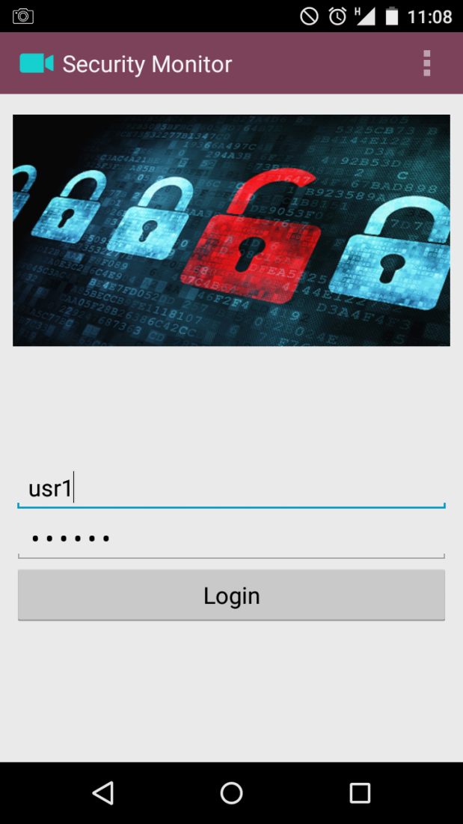

Enter User Id

Enter Password

Press login button

**Notifications**

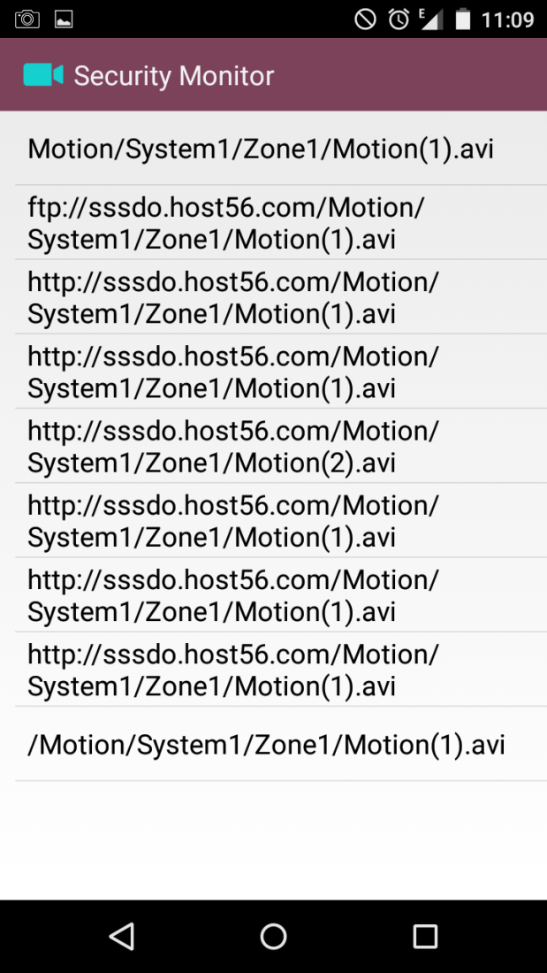

**Substitute Panel**

User Id = usr4

Password = abc123

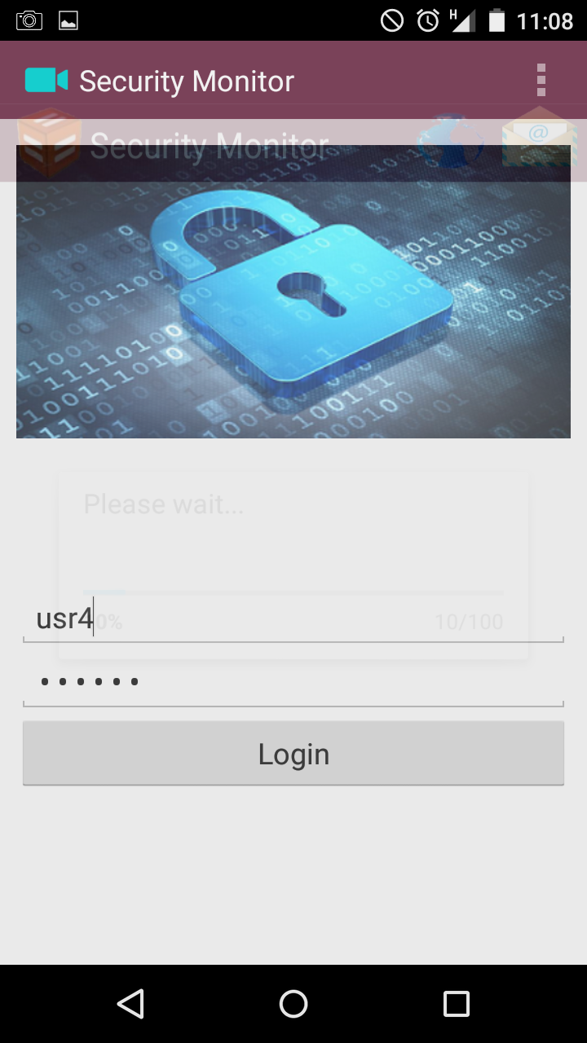

**Zones List**

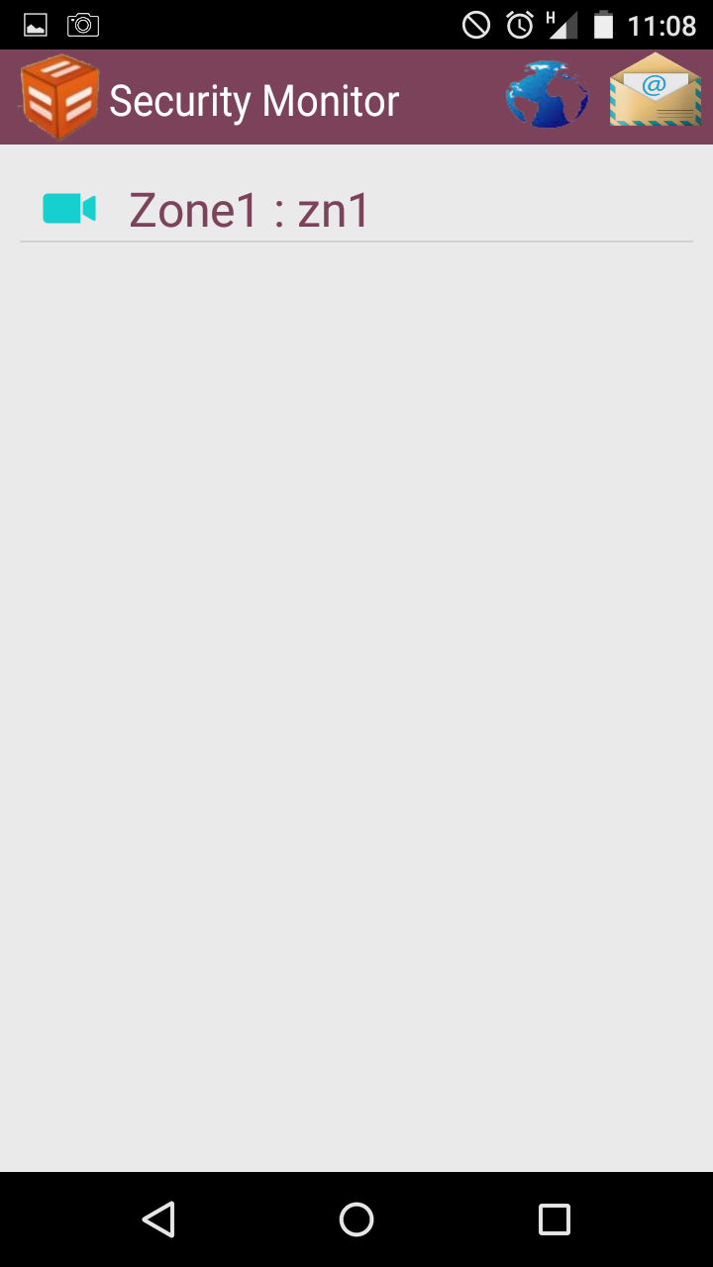

User can select the desired zone he wants to monitor.

Side bar option menu for substitute

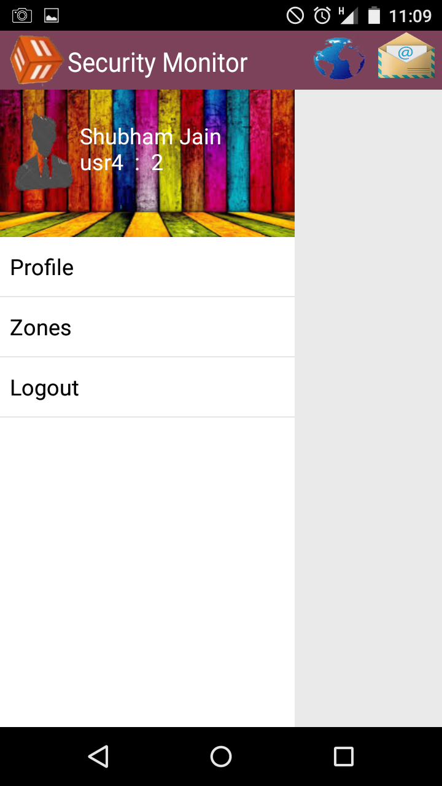

Here user can select one of the options shown in above picture.

**Profile**

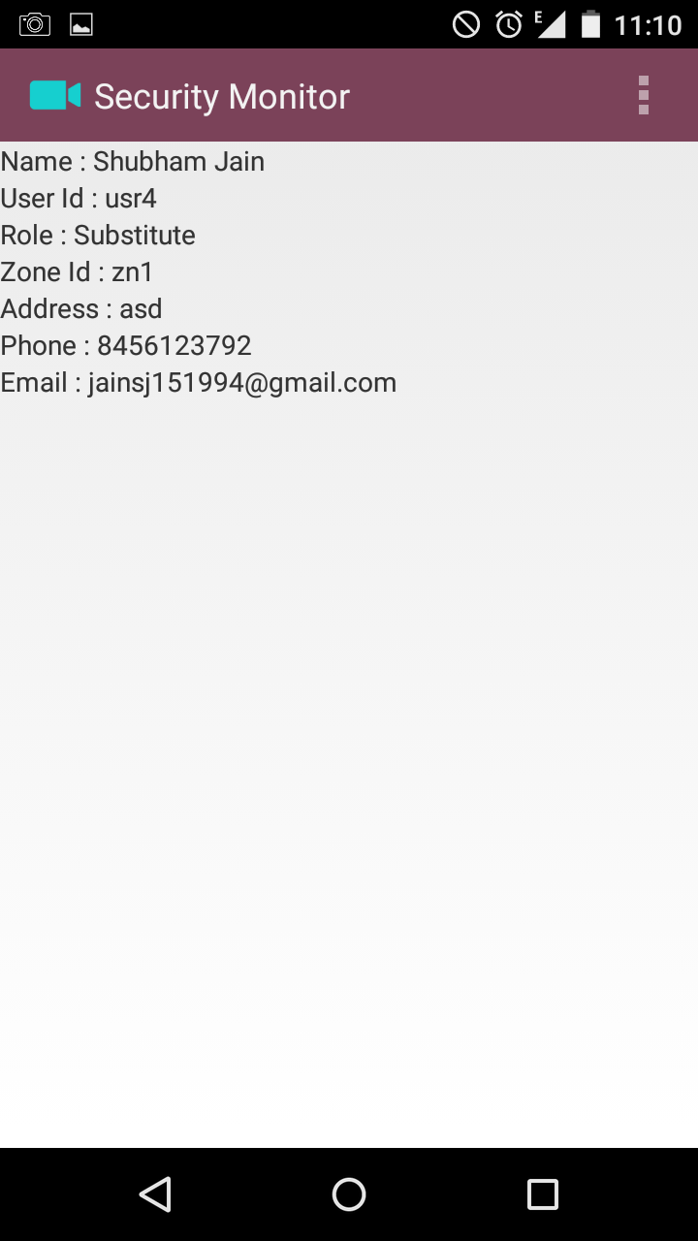

User can monitor zone by selecting that zone like zn1

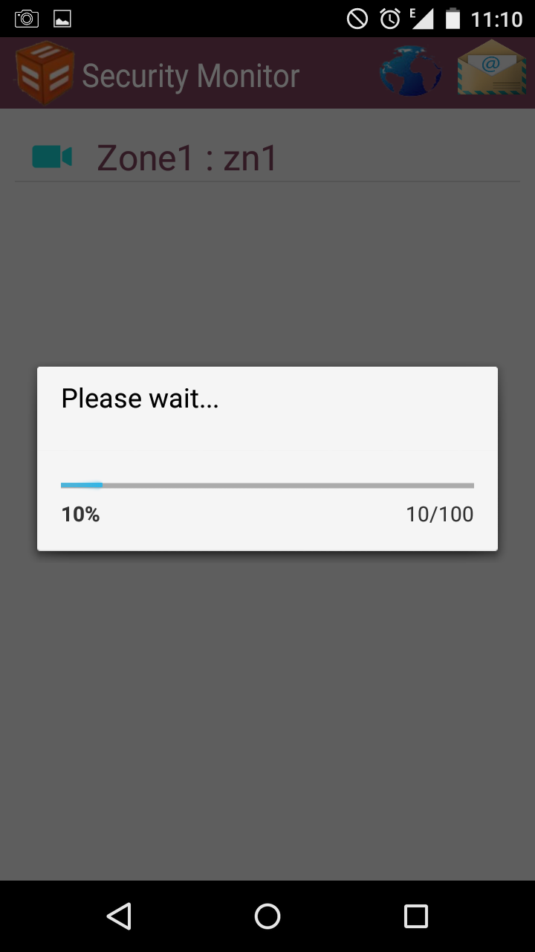 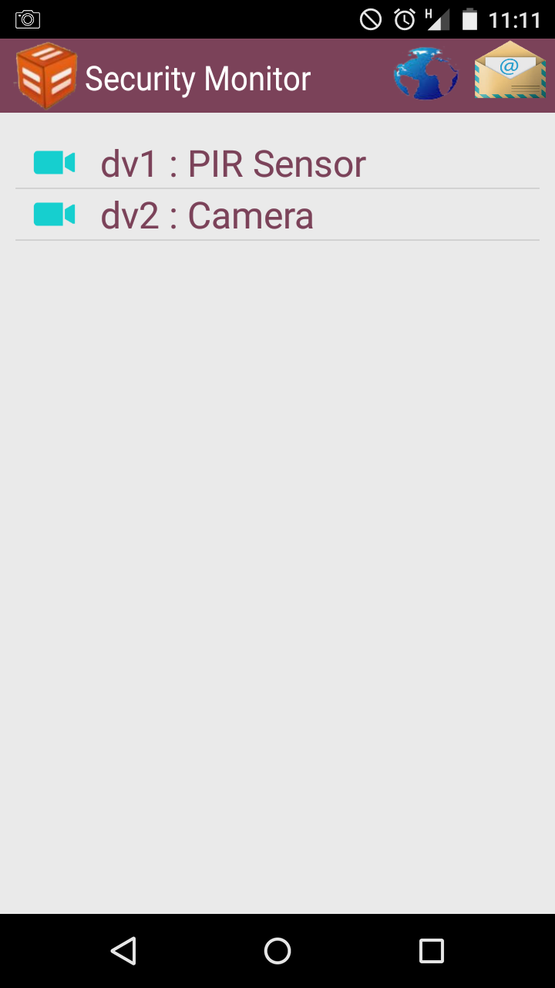

User can select either PIR sensor, alarm or camera

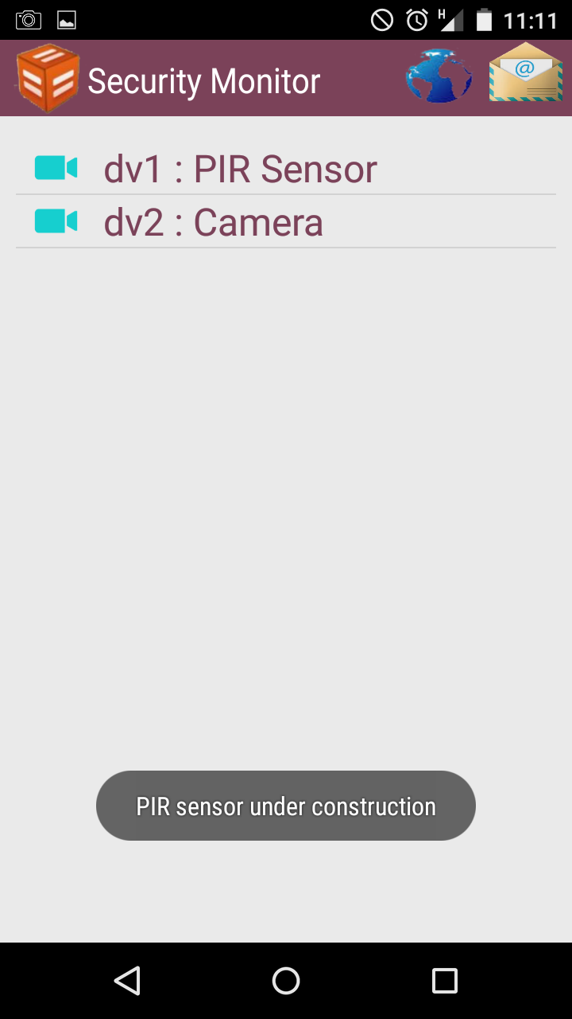**PIR Sensor**

**Camera**

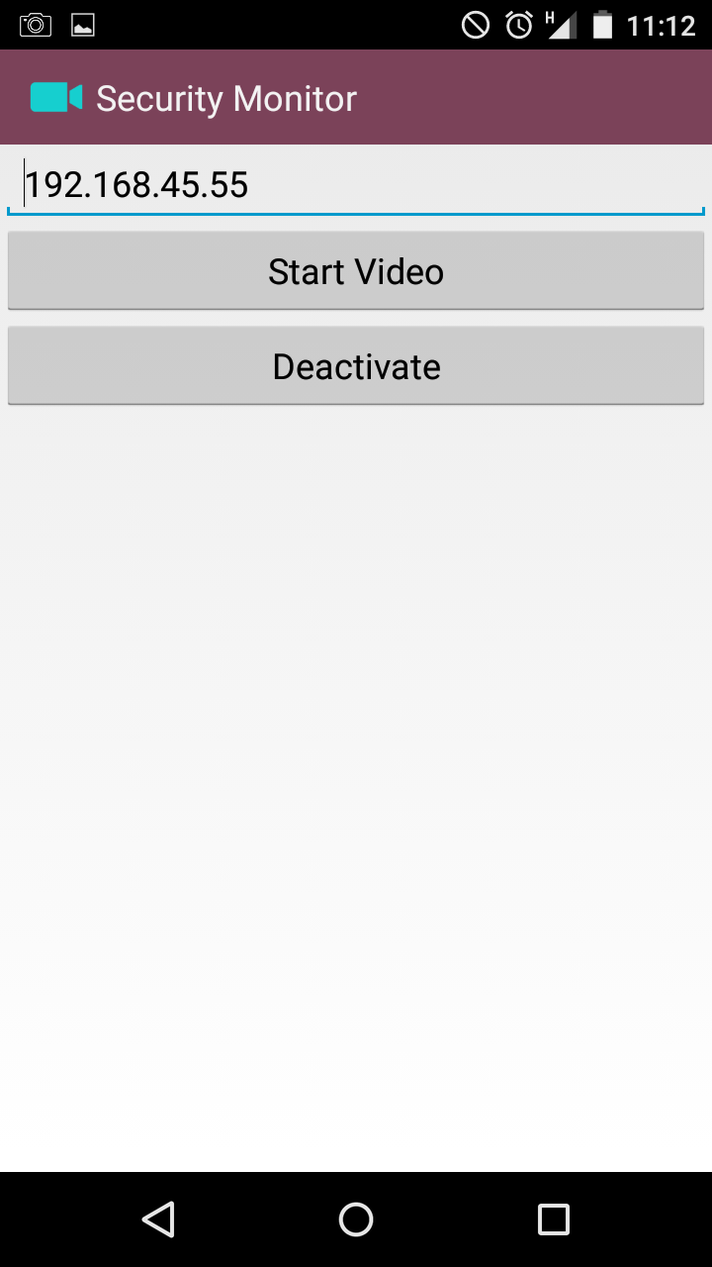

User can activate or deactivate the camera.

User can also change the settings of zone.

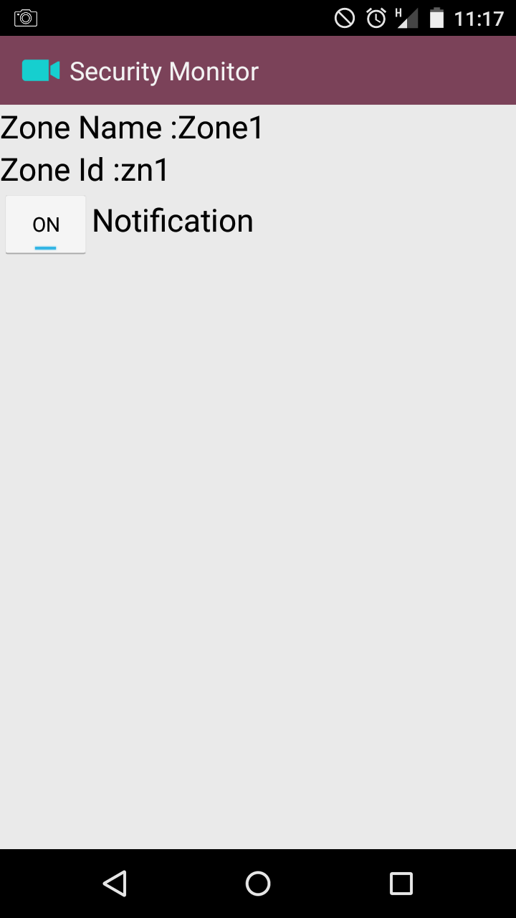 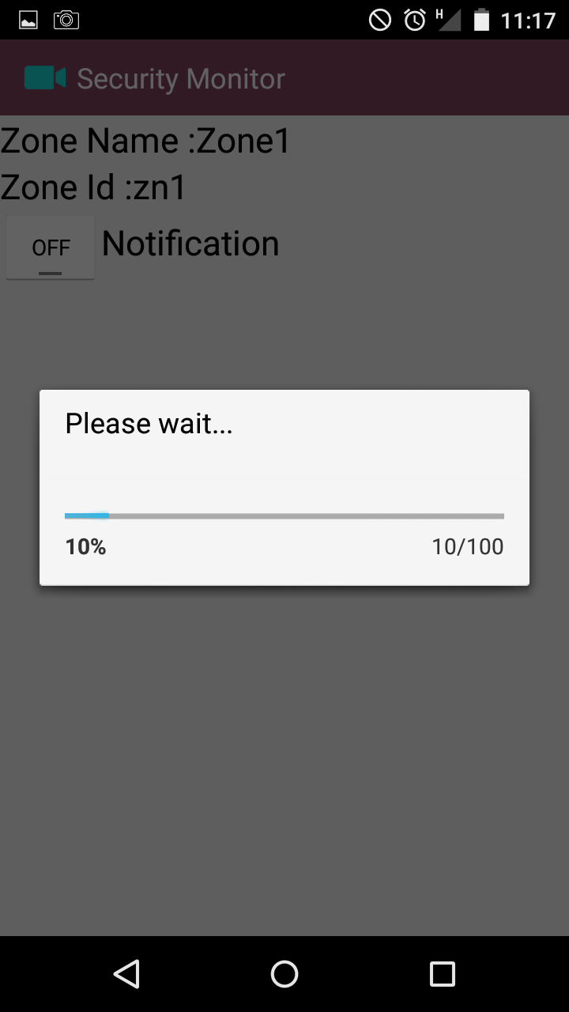

Substitute can only change his notification status for that zone.

**Admin Interface**

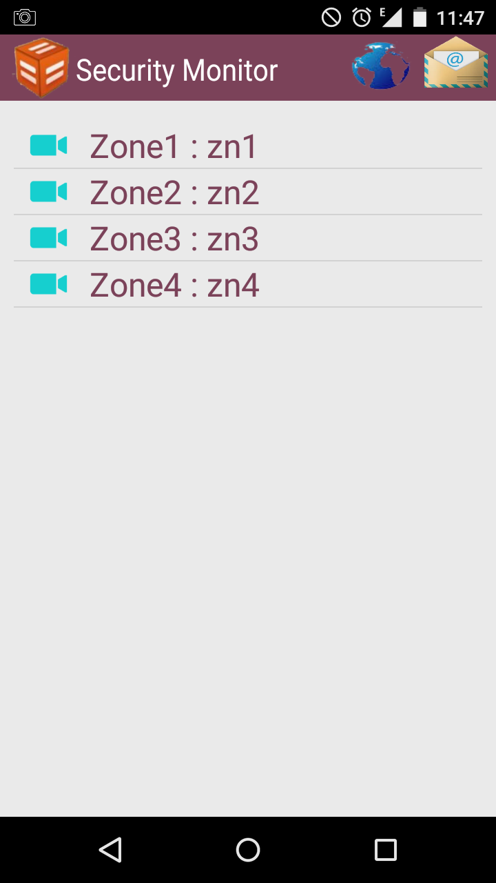

Admin will also see list of zones.

Side bar option menu for Admin

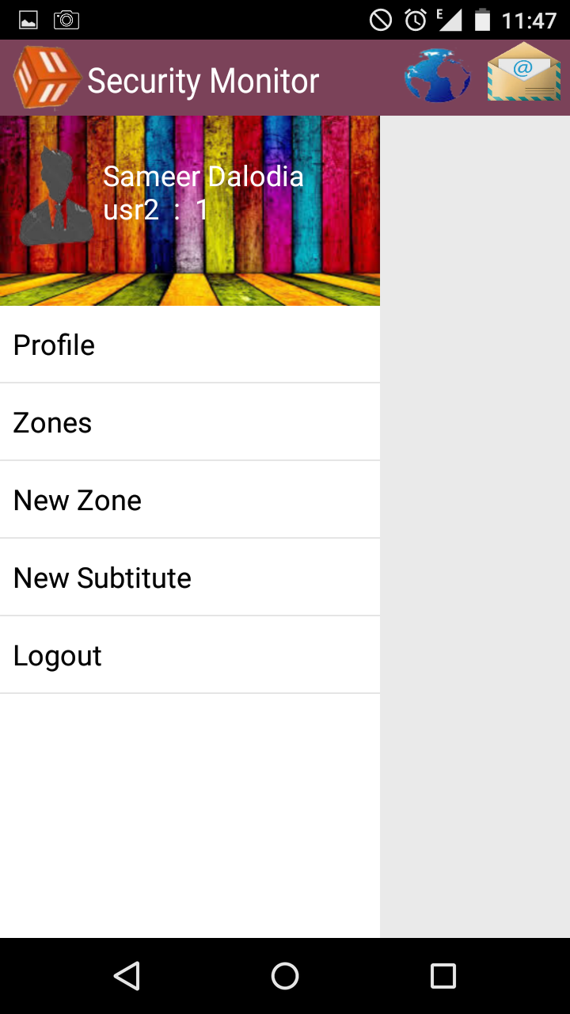

Admin can perform following operations

View Profile

List of zones

Create new zone

Create new substitute

**Profile**

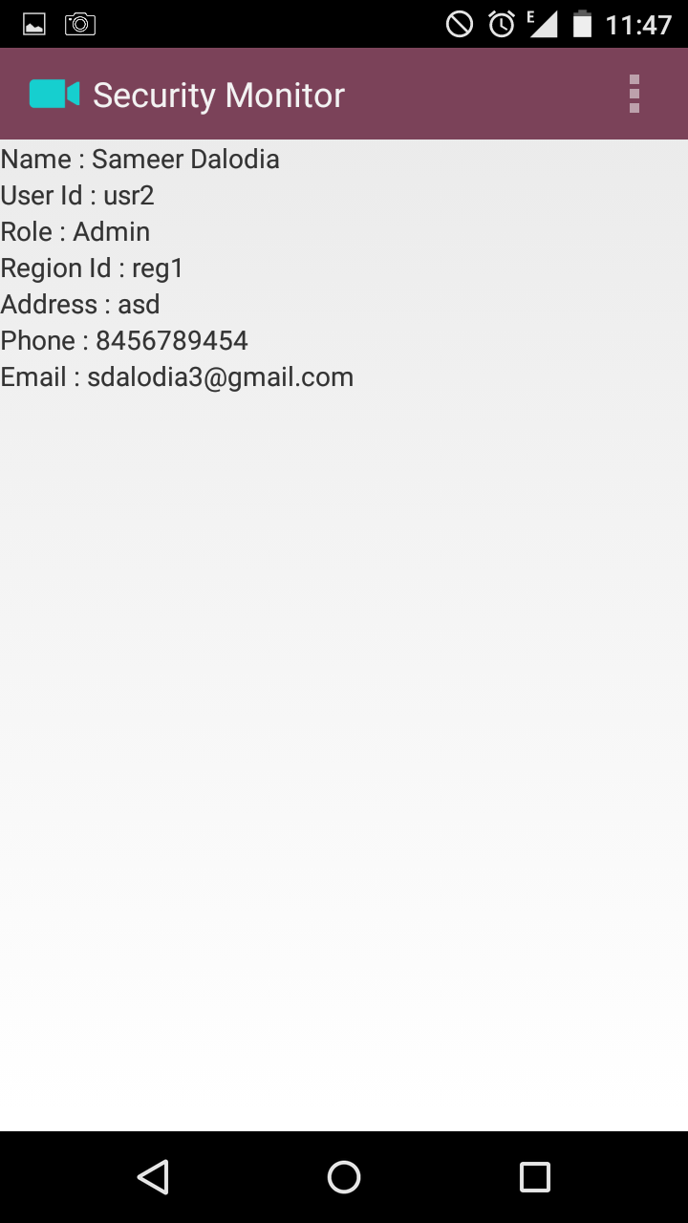

**New Zone**

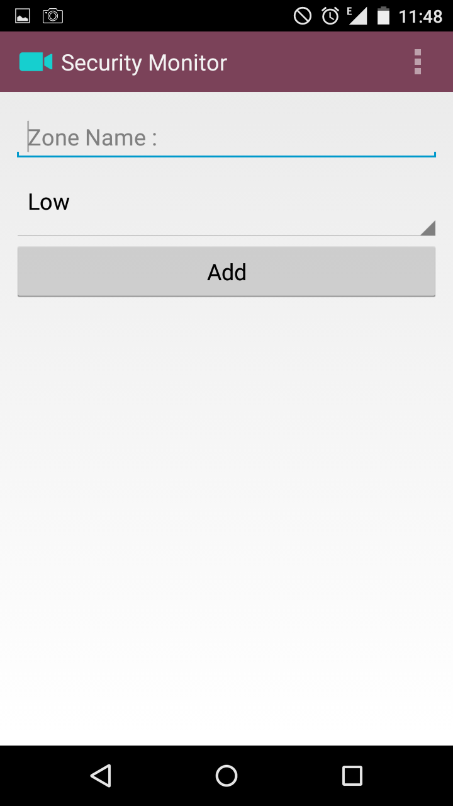 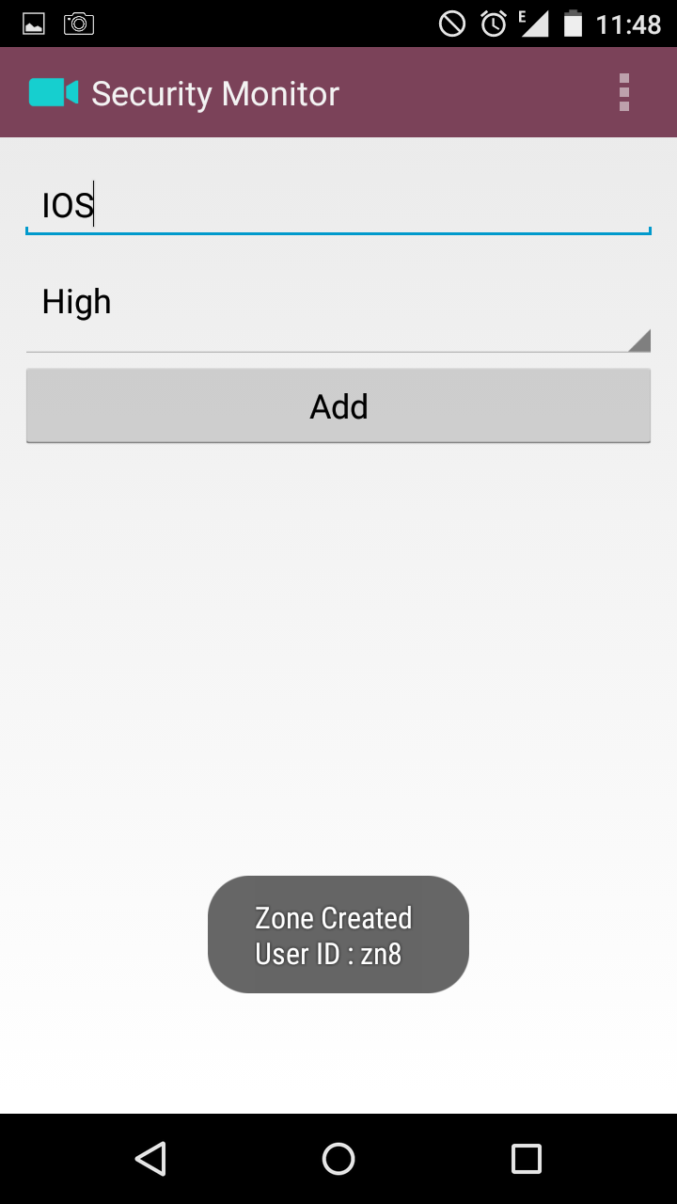

Enter zone name

Enter zone security level (low or high)

Press Add button

zn8 is Zone Id of zone

New substitute

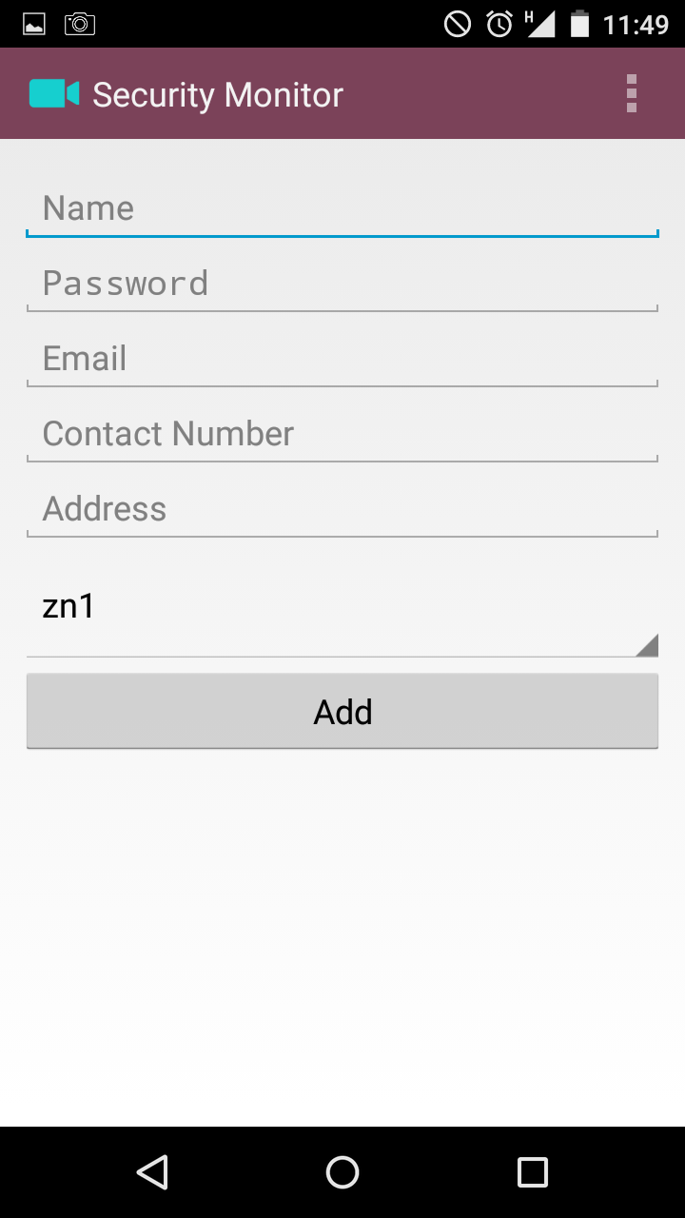 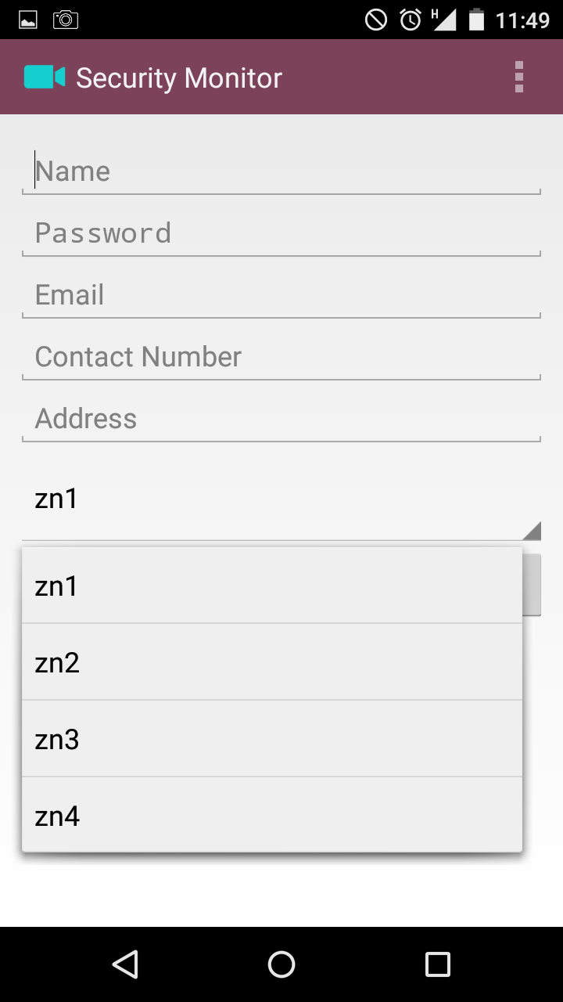

Select the zone id that the substitute has to monitor

**New substitute**

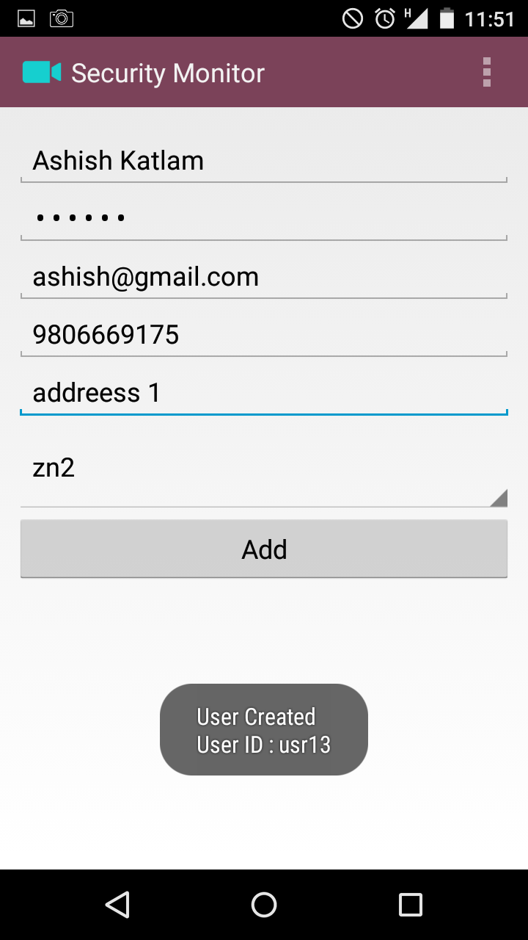 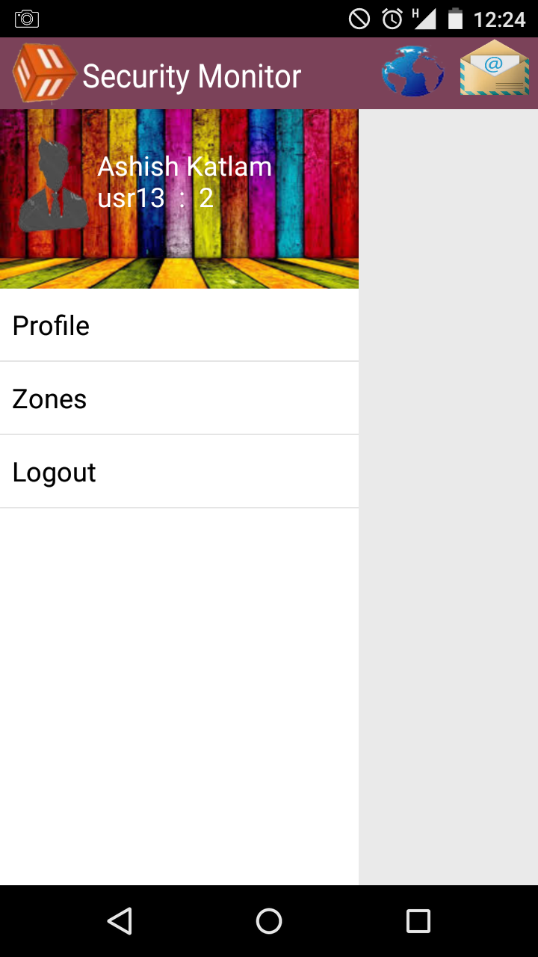

usr13 is user id of new substitute

**Super Admin interface**

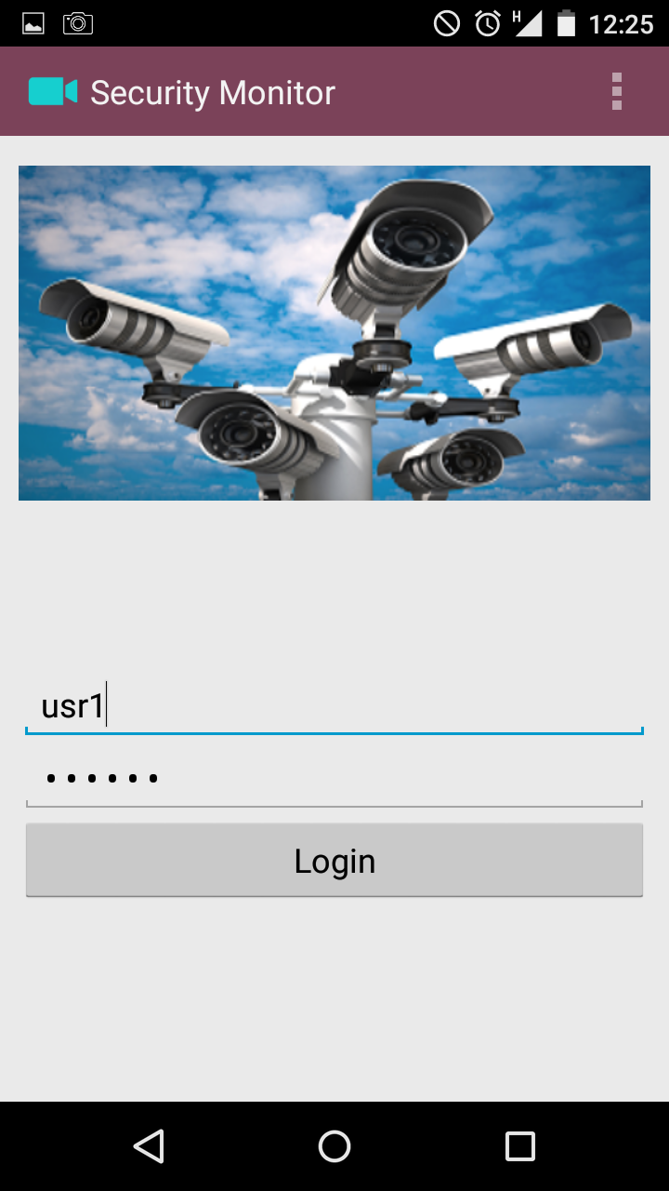 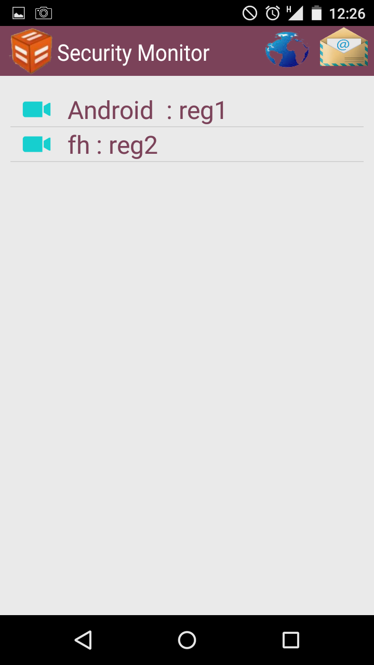

Super Admin side bar options when list of regions are visible

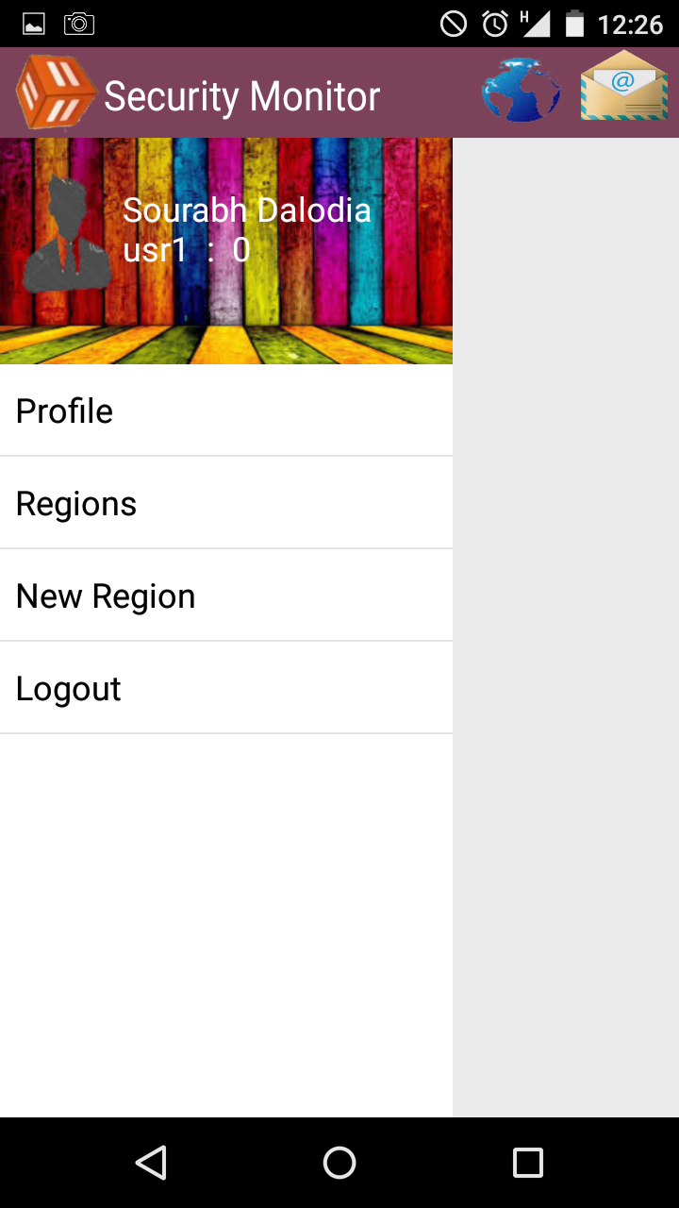

**Super Admin profile**

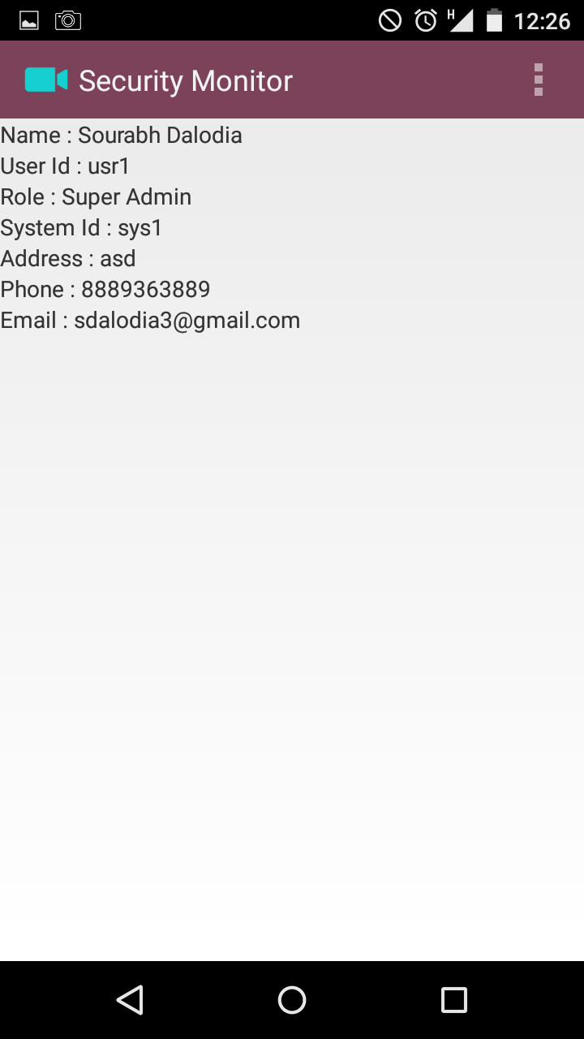

**Create new region**

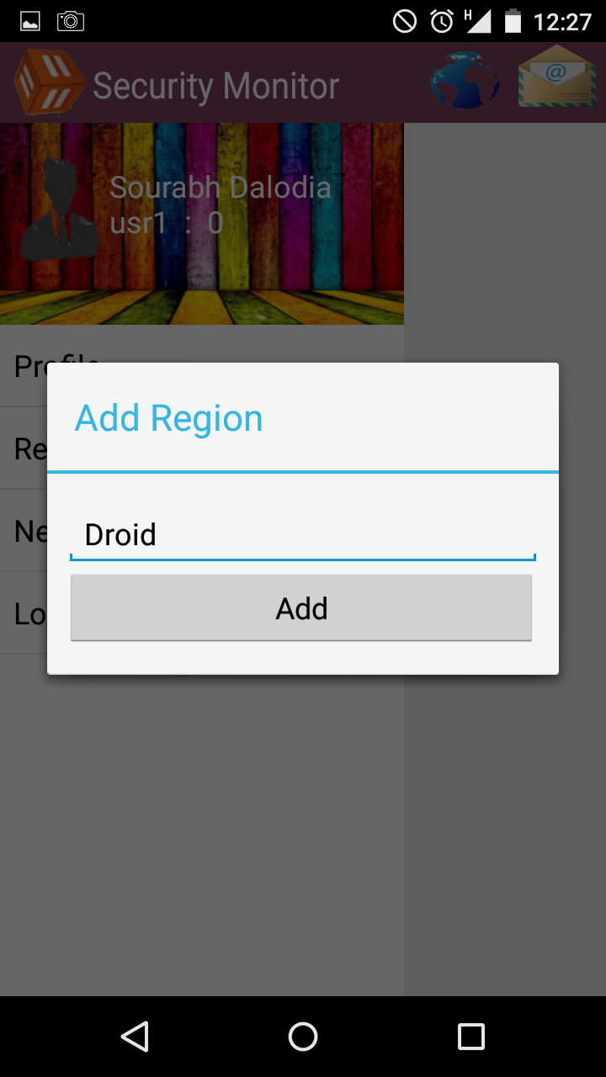 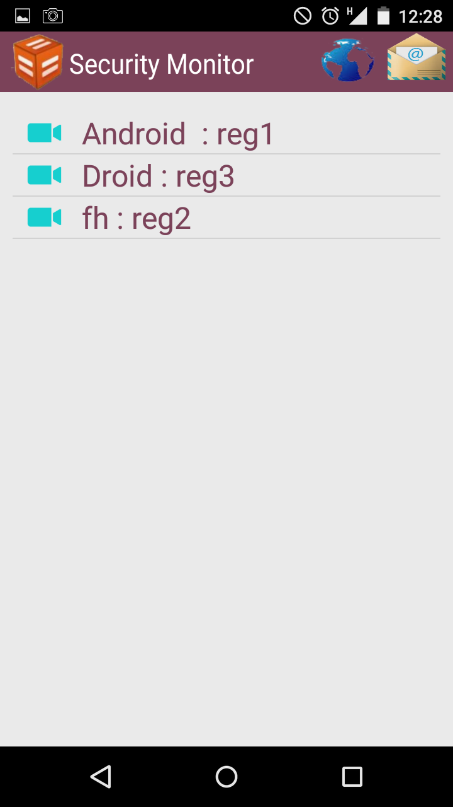

Enter the name of region

Press Add button

**Empty region**

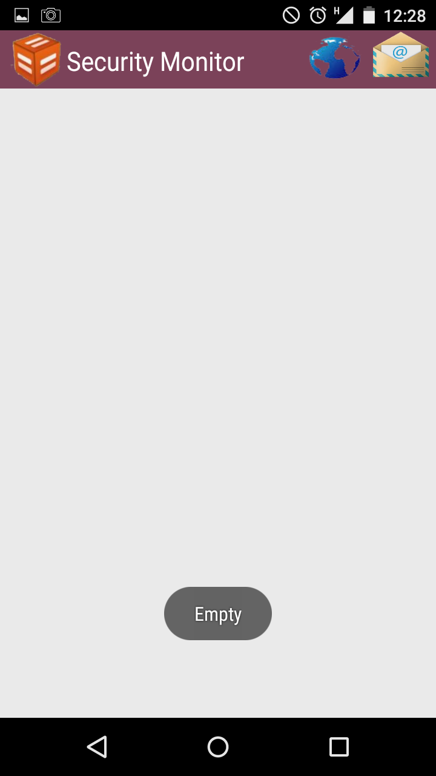

Zone settings for Admin and super admin

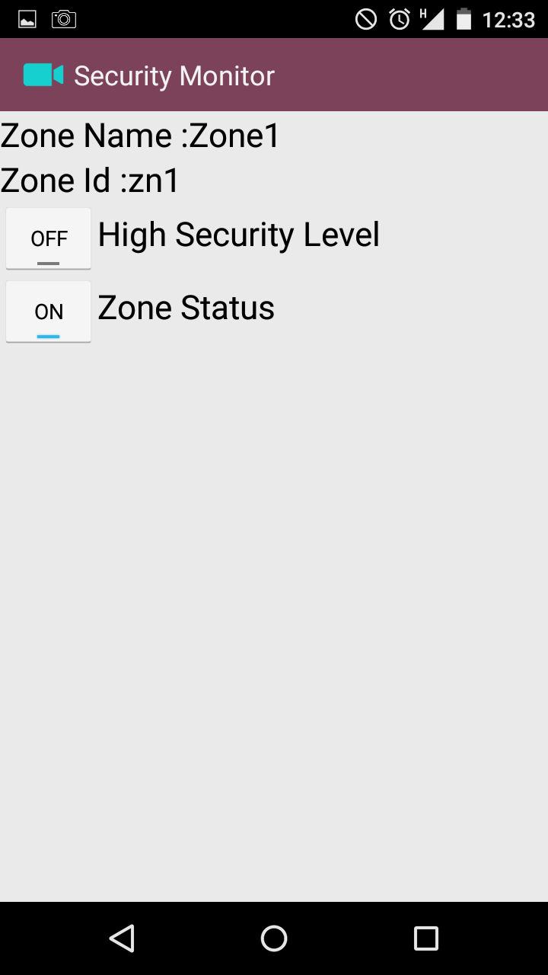

**Delete Zone**

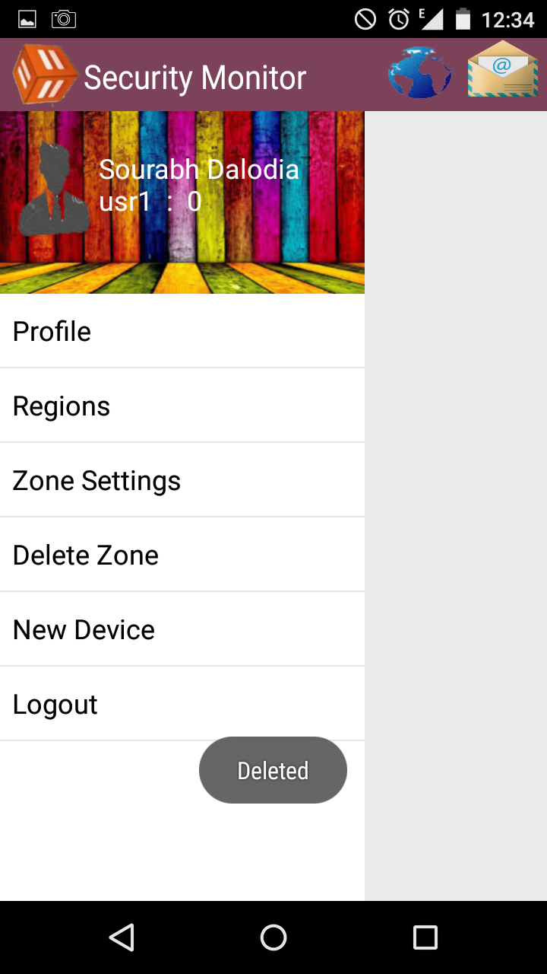

**Delete Region**

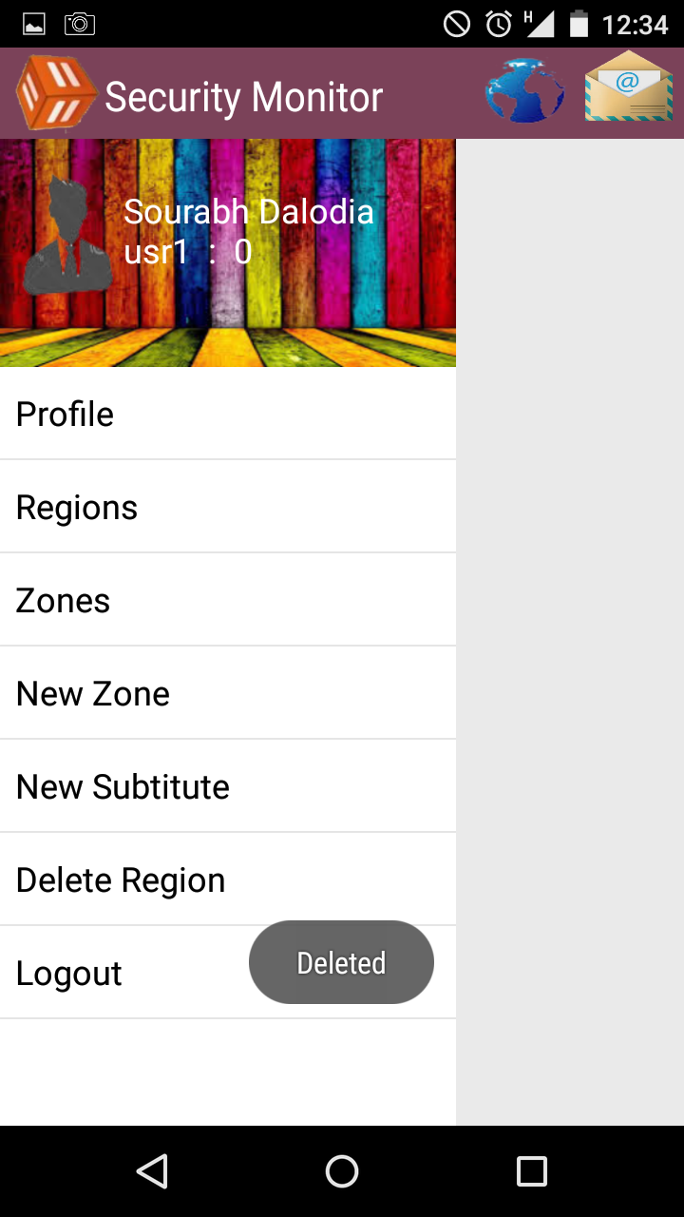

**Messenger**

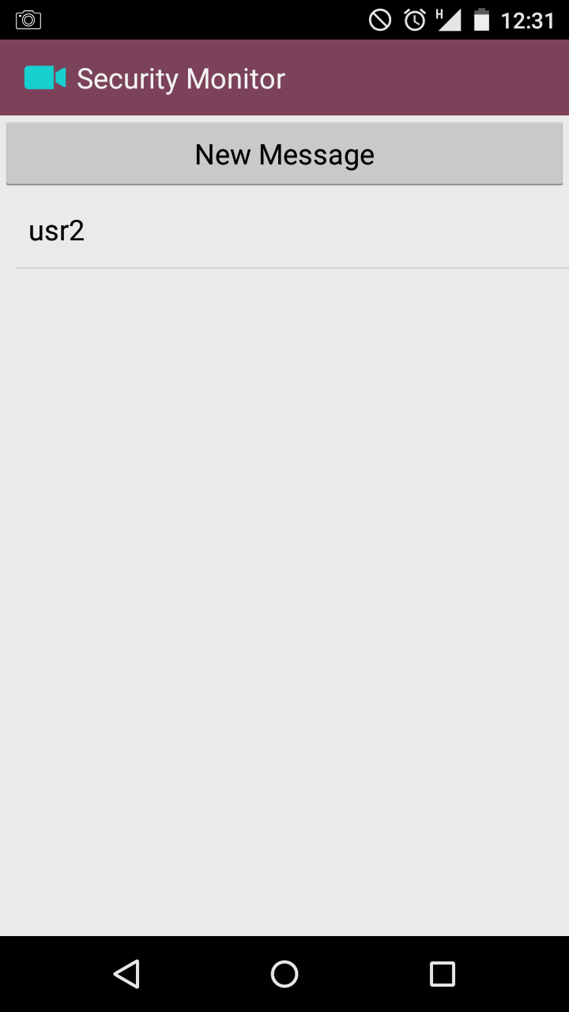

Here is list of users with whom usr1 has talked

These are messages between usr1 and usr2

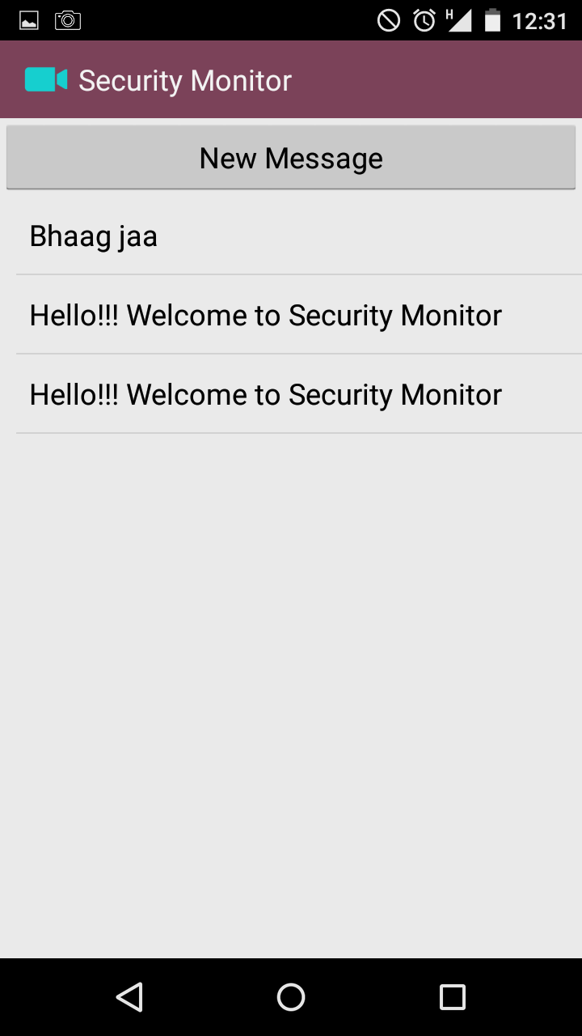

**New message**

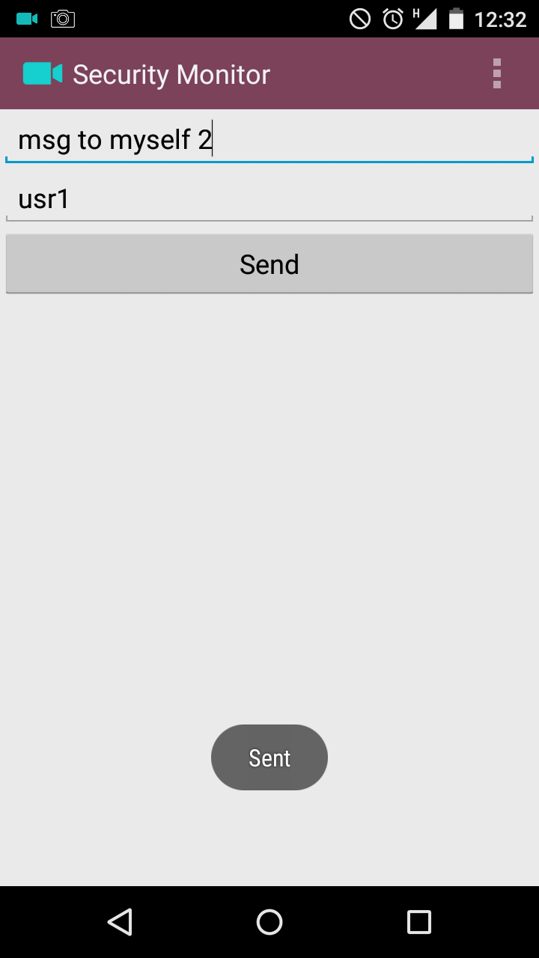

Enter message to be sent

Enter the id of recipient

Notification of new message

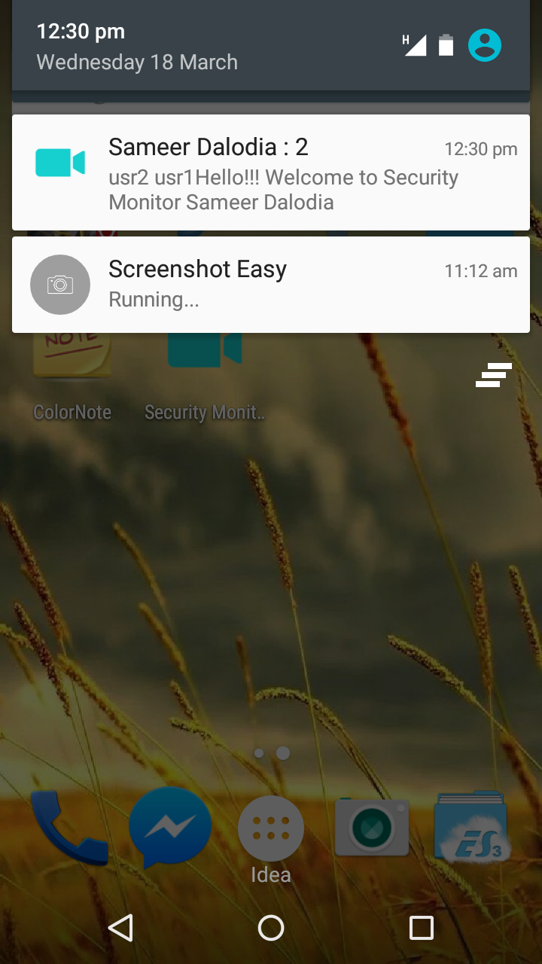

**System**

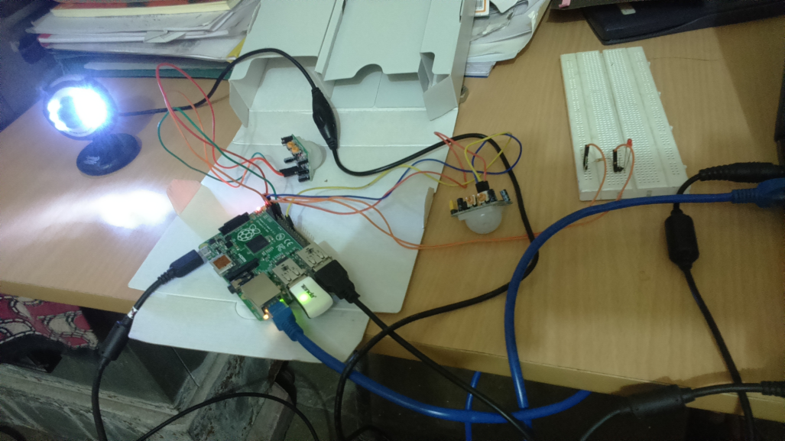

**Live Streaming**

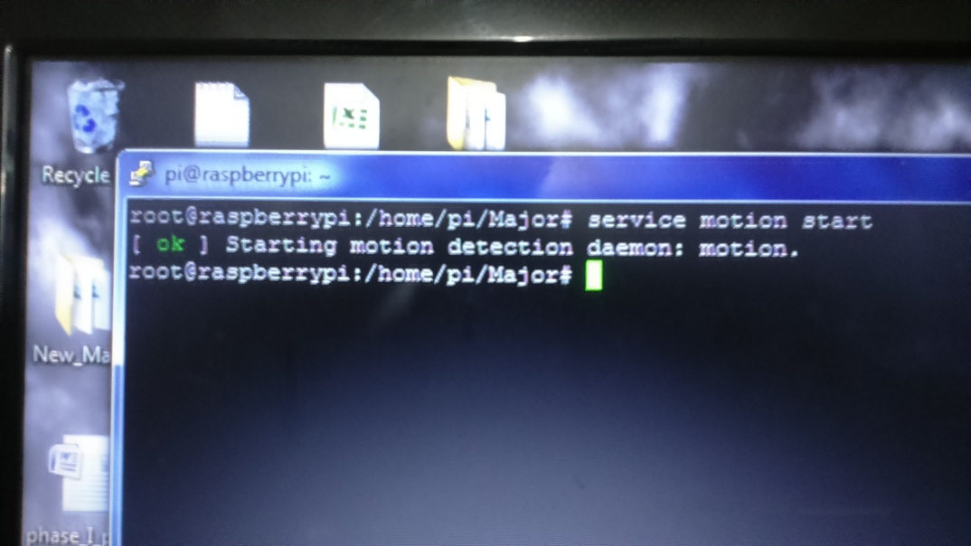

**Image Comparison**

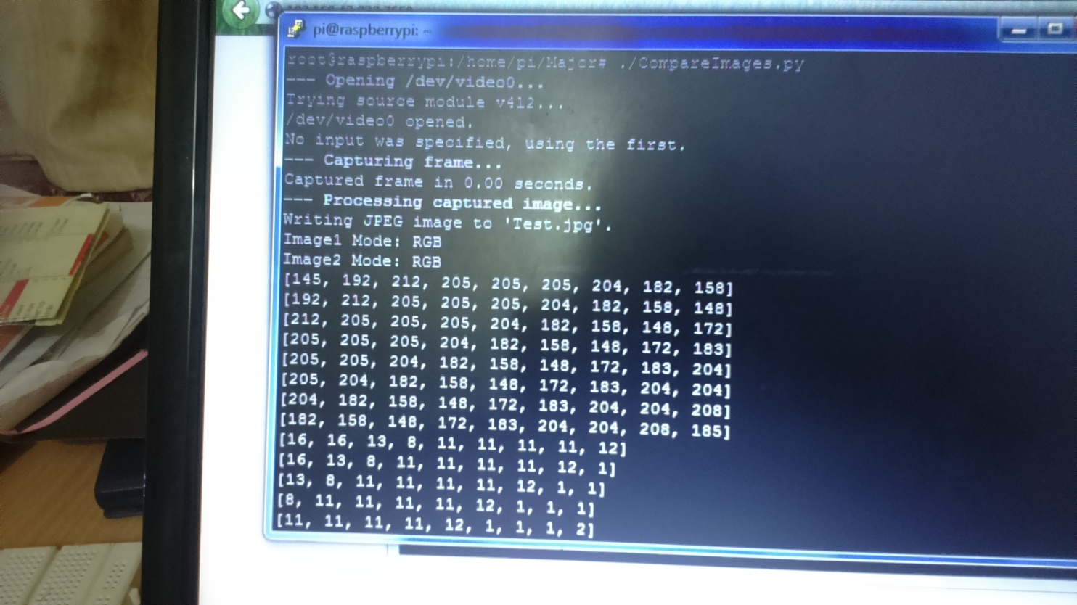

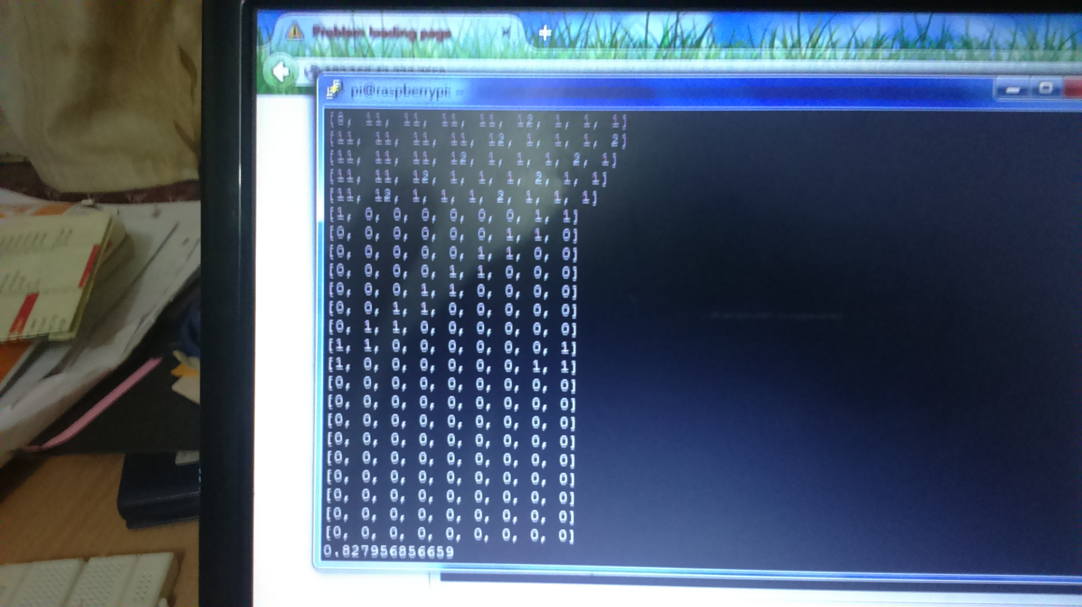

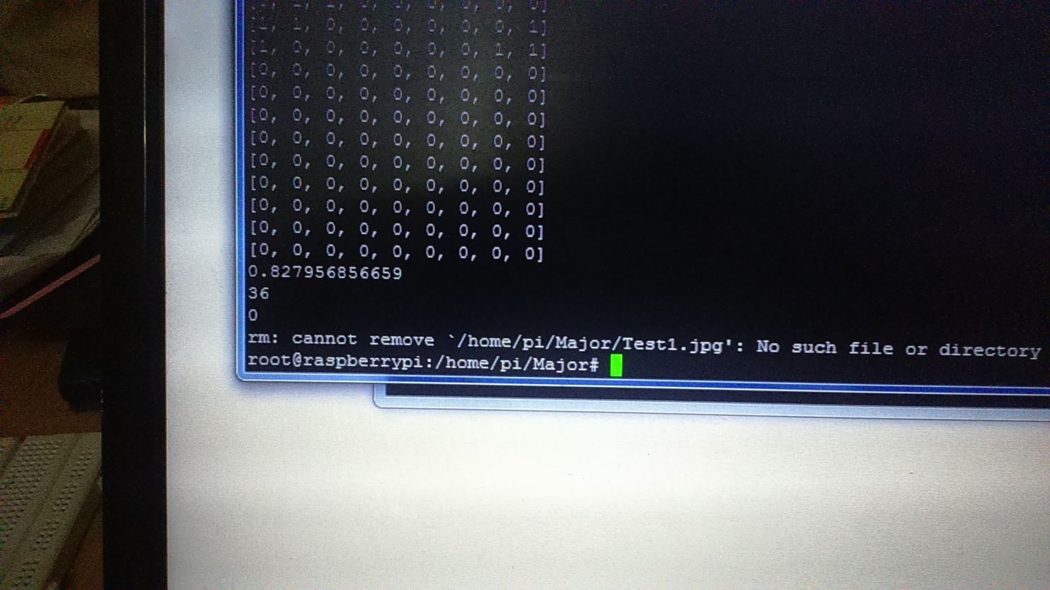

**Motion Detection Module**

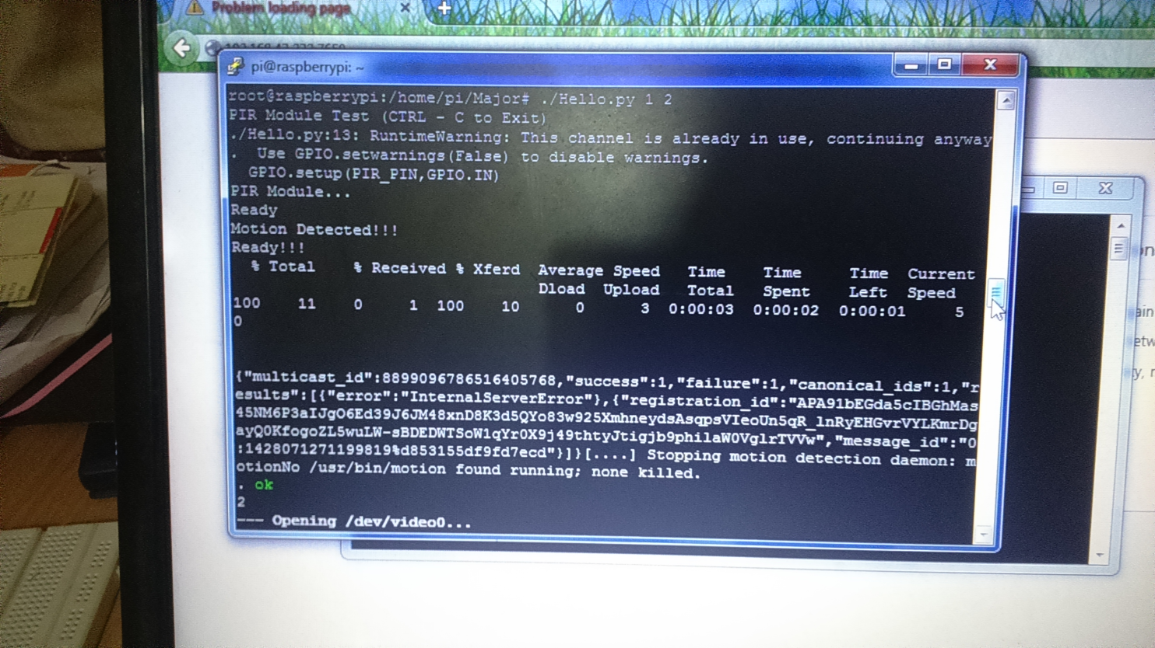

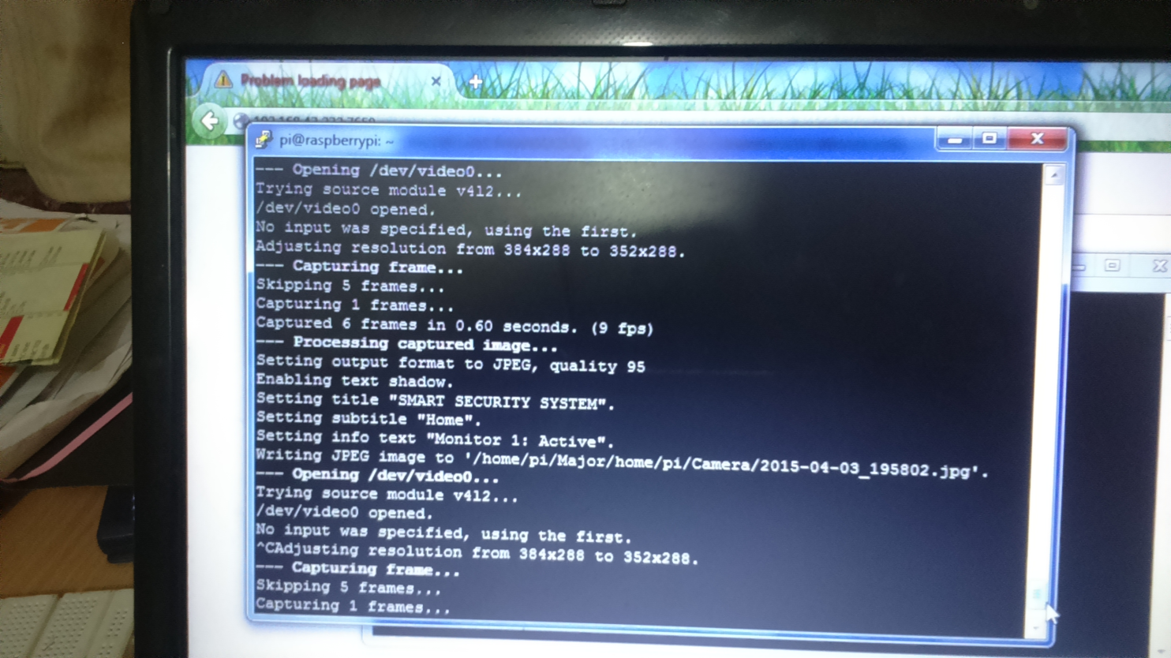

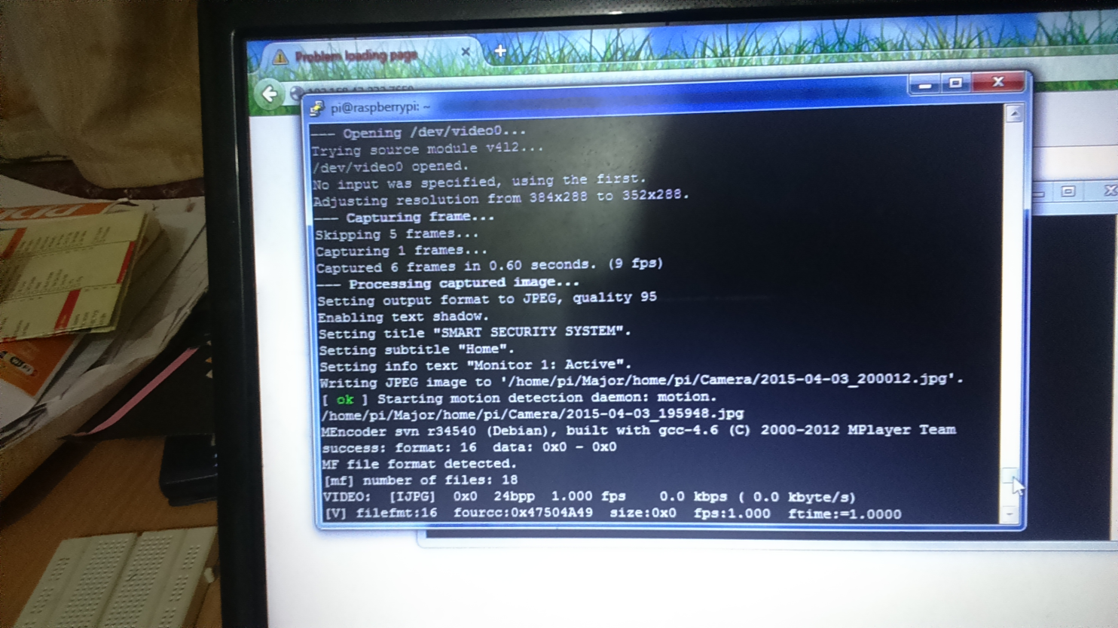

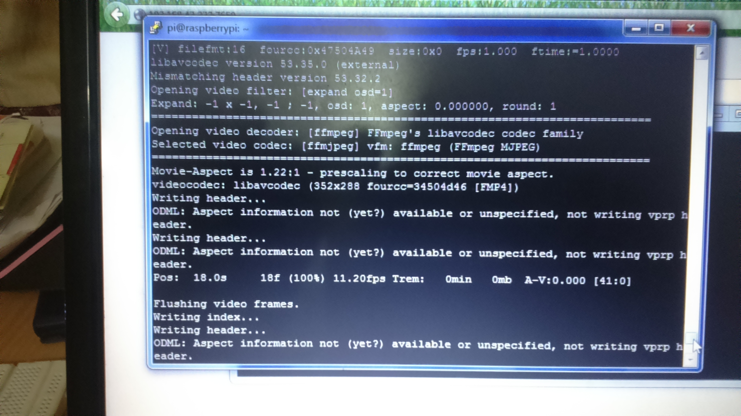

**Human Count**

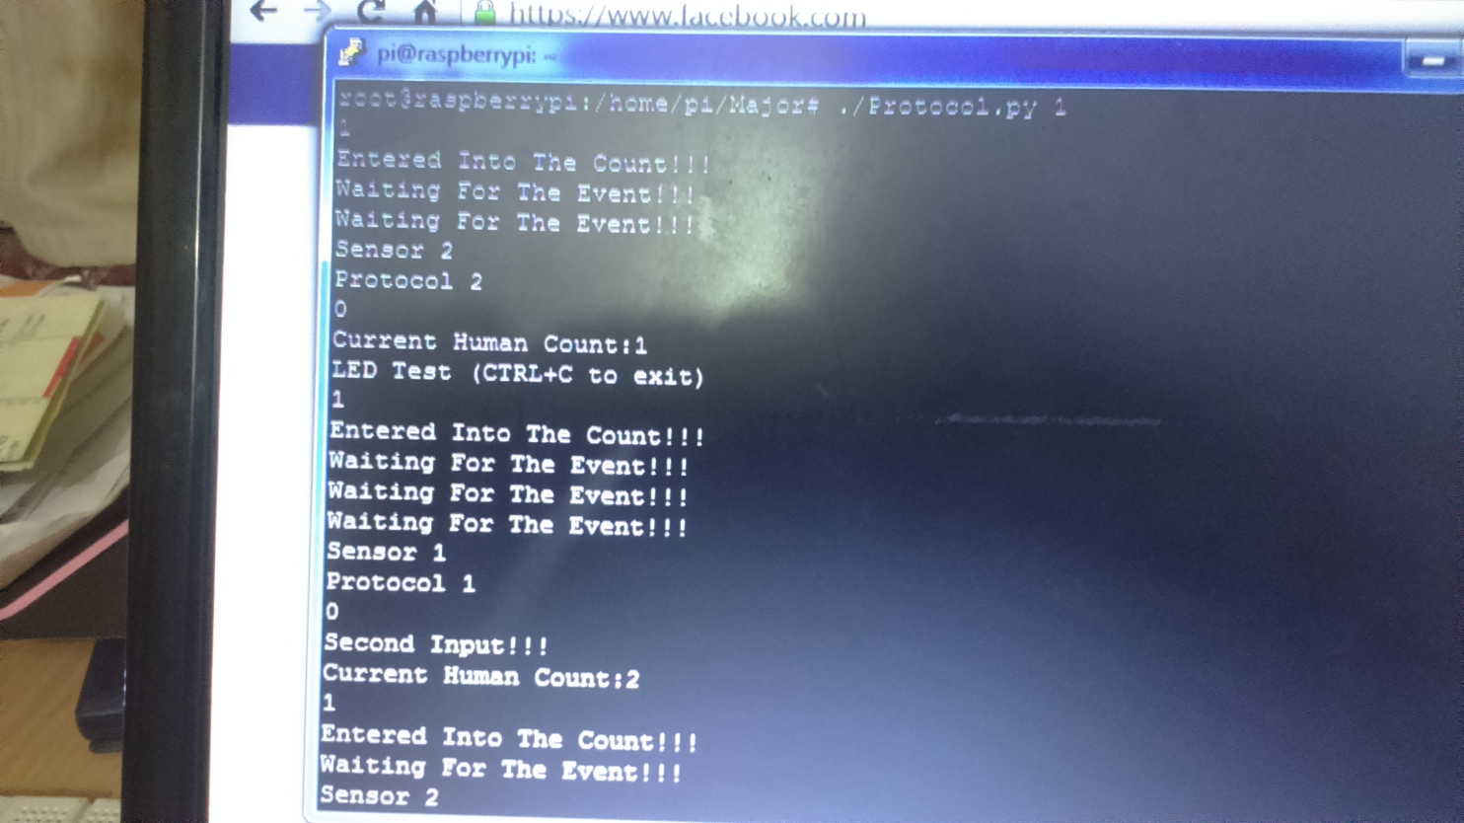

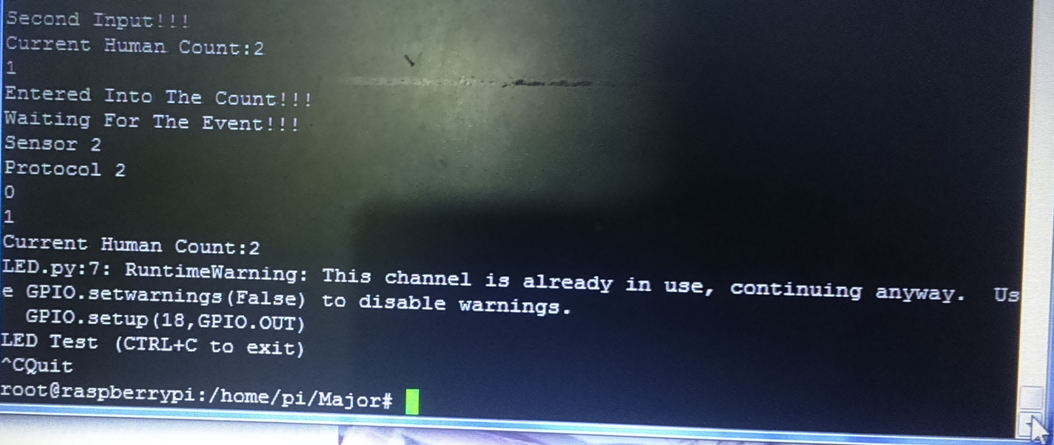

**APPENDIX B: GLOSSARY**

* **System:** The whole set of places where the single system has been installed.
* **Installation:** The manual process by which the whole system has been putted in place at for the first time.
* **Registration:** The manual process by which a user profile is been created in a system.
* **Super Admin:** The user who has installed the system in his/her offices and has the maximum rights.
* **Region:** A sub-part of System which has been created by Super Admin.
* **Admin:** Admin is the user who has highest list of rights in the system, after Super Admin, but the rights are limited only to the Region he/she is associated with.
* **Zone:** The smallest unit of area under surveillances. It is created by Admin of the Region it falls in to.
* **Substitute:** The user who has the rights belonging only to a zone and has been created by Admin.
* **Notification:** The alerts on mobile app which tells the user about the possible intrusion and also lets the user get an image of it.
* **Device:** It is a hardware component of the system apart from the raspberry pi. It compromises of PIR sensor, alarm, cameras or any other types of sensors which may me possible to attach with the system in the future.
* **Local Database:** It is a database creates on the client mobile device and is used to store the personal data the user receives from the client app.
* **Messenger:** It is an in app messaging module which enables the users to message the other persons using the system in his/her are of influence.